ENERGY AUDIT AND EFFICIENCY IMPROVEMENT -INSTITUTIONAL BUILDINGS

A PROJECT REPORT
For

INNOVATION LAB / MINI PROJECT / DESIGN PROJECT / MULTIDISCIPLINARY PROJECT
Submitted by

CECELIA MARIA SELVI J

DHANUSH KUMAR S.M

DINAKAR S.M

JOYSON GUNA SELVAN P

VIJAY BHARATHI P
in partial fulfillment for the award of the degree of

BACHELOR OF ENGINEERING
in

ELECTRICAL AND ELECTRONICS ENGINEERING


EASWARI ENGINEERING COLLEGE, RAMAPURAM

(Autonomous Institution)
affiliated to

ANNA UNIVERSITY, CHENNAI 600 025

AUGUST, 2026


EASWARI ENGINEEING COLLEGE

BONAFIDE CERTIFICATE

Certified that this project report “ENERGY AUDIT AND EFFICIENCY IMPROVEMENT -INSTITUTIONAL BUILDINGS” is the bonafide work of CECELIA MARIA SELVI J, DHANUSH KUMAR S.M, DINAKAR S.M, JOYSON GUNA SELVAN P,VIJAY BHARATHI who carried out the
project work under my supervision.

SIGNATURE

Dr. J Lydia, M.E., Ph.D.
HEAD OF THE DEPARTMENT

Department of Electrical and Electronics Engineering,
Easwari Engineering College, Ramapuram, Chennai-89.
SIGNATURE

Dr. Raghavendran C R, M.E., Ph.D. LAB INCHARGE
ASSISTANT PROFESSOR
Department of Electrical and Electronics Engineering,
Easwari Engineering College, Ramapuram, Chennai-89.


EASWARI ENGINEEING COLLEGE

Certificate of Viva-voce-Examination

This is to certify that the Viva Voce Examination of the /Innovation Lab / Mini Project / Design Project / Multidisciplinary Project Work entitled “ENERGY AUDIT AND EFFICIENCY IMPROVEMENT – INSTITUTIONAL BUILDINGS” submitted by “CECELIA MARIA SELVI J (310623105006), DHANUSH KUMAR S.M (310623105009), DINAKAR S.M (310623105013), JOYSON GUNA SELVAN P (310623105019), VIJAY BHARATHI P (310623105057)” in partial fulfillment of the requirements for the award of the degree of Bachelor of Engineering was conducted on 11-04-2026 (Date) in the Department of Electrical And Electronic Engineering , Easwari Engineering College, Ramapuram – Chennai..

Internal Examiner External Examiner
Name : Name :

Designation: Designation :
Address : Address :

Date :

Electronics Block-1, Adminstrative Block, Block-3

ABSTRACT
Energy consumption in educational institutions has increased significantly due to the widespread use of electrical equipment such as lighting systems, HVAC units, computing devices, and laboratory instruments. This project presents a detailed energy audit conducted for selected campus blocks, namely the Admin Block, EB Block-1, and Block-3, with the objective of analyzing energy usage patterns and identifying opportunities to improve overall energy efficiency. The audit was carried out through systematic data collection of electrical components distributed across multiple floors and blocks, considering important parameters such as component count, power ratings, operating distribution, and usage behavior. The collected data was further analyzed to understand the consumption characteristics of different types of electrical loads within the campus environment. Special focus was given to high-energy-consuming equipment such as air conditioners, motors, and computing systems, as these loads contribute a major portion of the total energy demand. The analysis revealed that air conditioning systems and motors account for the highest share of electricity consumption, while lighting systems and ceiling fans also contribute significantly due to their large numbers and extended operating hours. A comparative block-wise assessment showed that Block-3 records the highest energy consumption, followed by EB Block-1, whereas the Admin Block exhibits comparatively lower consumption levels. Based on these findings, several energy-saving measures are recommended, including the replacement of conventional lighting systems with LED-based solutions, the adoption of energy-efficient appliances, the integration of smart monitoring and control systems, and the optimization of equipment usage schedules. Implementing these recommendations can potentially reduce campus energy consumption by approximately 25–30%, thereby enhancing operational efficiency, reducing electricity costs, and promoting environmental sustainability within the institution.

CHAPTER 1

BACKGROUND AND SIGNIFICANCE
The demand for electricity in educational institutions has increased significantly due to infrastructure growth and the addition of modern facilities. Classrooms, laboratories, administrative offices, libraries, and seminar halls rely heavily on electrical loads such as lighting systems, fans, air conditioners, computers, and laboratory equipment, leading to higher overall energy consumption.
The significance of this study is to provide a clear understanding of how energy is consumed within the campus. By identifying the major contributors to electricity usage, the institution can take effective steps to reduce energy wastage, improve operational efficiency, lower electricity costs, and support sustainable energy management practices.

NEED FOR ENERGY AUDIT
An energy audit is essential to identify areas where electrical energy is wasted or used inefficiently. In large institutions, many electrical appliances operate beyond required hours, resulting in unnecessary power consumption. Inefficient lighting systems, outdated air conditioners, continuously running fans, and underutilized laboratory equipment contribute significantly to increased electricity demand.
The need for an energy audit arises to optimize power usage, reduce operational costs, and improve the performance of electrical systems. It helps in identifying excessive load points, analyzing peak consumption patterns, and recommending efficient alternatives such as LED lighting, energy-efficient appliances, and smart monitoring systems. This enables better load management and promotes sustainable energy usage within the institution.

OVERVIEW OF ENERGY CONSUMPTION
The energy consumption in the selected campus blocks mainly depends on the type and number of electrical equipment installed in each floor and room. The major loads considered in this project include lighting systems, fans, air conditioners, computers, motors, and laboratory devices.
Among these, air conditioning systems consume the highest amount of electrical energy due to their higher wattage ratings and prolonged operation. Computing systems and laboratory instruments also contribute significantly in blocks where practical sessions are conducted regularly. Lighting systems and fans, although lower in individual power ratings, collectively consume a large amount of energy because of their quantity and continuous daily usage.

A block-wise overview shows that Block-3 has the highest power consumption, followed by EB Block-1, while the Admin Block has comparatively lower consumption. This variation is mainly due to the differences in room occupancy, equipment density, and operating hours.

OBJECTIVES OF THE STUDY
The main objectives of this energy audit study are:
    - To analyze the energy consumption pattern of selected campus blocks
    - To identify major electrical loads and their contribution
    - To perform block-wise and floor-wise load comparison
    - To detect possible areas of energy wastage
    - To recommend suitable energy-saving measures
    - To improve the overall efficiency of electrical usage
    - To reduce electricity cost and support sustainable energy practices

CHAPTER 2 LITERATURE REVIEW
Energy auditing has been widely studied in both industrial and institutional sectors as an effective approach for improving energy efficiency and reducing electricity costs. Previous studies show that educational campuses and office buildings consume a significant amount of energy due to HVAC systems, lighting loads, and plug-connected devices. Literature also highlights that regular monitoring and efficient load management can reduce unnecessary energy losses and improve sustainability.

OVERVIEW OF ENERGY AUDIT
An energy audit is a systematic study of how electrical energy is consumed within a facility. It involves identifying major electrical loads, measuring their consumption, and analyzing operating patterns to locate possible wastage points. Several studies indicate that HVAC systems contribute nearly 40–50% of total energy usage, while lighting systems account for 25–30%, and plug loads such as computers and laboratory devices contribute around 15–20%.
The literature emphasizes that energy auditing provides a strong foundation for energy conservation planning and helps institutions adopt better operational practices.

EXISTING METHODS
Existing energy audit methods mainly involve manual data collection, equipment rating analysis, load calculation, and comparison of daily usage patterns. Traditional methods include physical inspection of electrical components, measurement using energy meters, and preparation of load schedules for each floor or department.

These methods are effective for identifying major loads and estimating consumption trends, but they may require more time and manual effort, especially in large institutions with multiple blocks and floors.

MODERN TECHNIQUES
Modern energy audit techniques focus on smart and automated monitoring methods. Recent studies highlight the use of smart metering, IoT-based monitoring systems, wireless sensors, and data analytics tools for real-time tracking of energy usage. These techniques help in identifying abnormal load behavior, peak demand periods, and equipment inefficiencies more accurately.
The literature reports that the adoption of modern techniques can provide 20–30% energy savings, reduce carbon emissions, and significantly improve the overall efficiency of institutional power systems.

CHAPTER 3 OBJECTIVES
The main objective of this project is to perform a detailed energy audit of selected campus blocks to understand the pattern of electricity consumption and identify areas where energy can be used more efficiently. The study focuses on analyzing the electrical loads present in the Admin Block, EB Block-1, and Block-3, including lighting systems, fans, air conditioners, computers, motors, and laboratory equipment. By examining the quantity, power ratings, and usage behavior of these components, the project aims to determine the major contributors to overall energy consumption. Another important objective is to identify inefficient equipment usage and possible areas of energy wastage within the campus environment. Based on the collected data and analysis, suitable energy-saving measures are proposed to improve operational efficiency, reduce electricity costs, and promote sustainable energy practices.

Objectives of the Study
    - To analyze energy consumption in selected campus blocks
    - To identify high-energy-consuming electrical components

    - To evaluate inefficiencies and possible energy losses
    - To compare block-wise and floor-wise load distribution
    - To suggest suitable energy-saving measures

    - To improve overall energy efficiency of the campus
    - To reduce electricity costs and support sustainability

CHAPTER 4 METHODOLOGY
The methodology adopted for this energy audit project follows a systematic four-phase approach to ensure proper planning, accurate data collection, effective analysis, and clear reporting of results. The study is carried out in the selected campus blocks to understand load distribution and identify opportunities for improving energy efficiency.

PLANNING
The planning phase forms the base of the energy audit process. In this stage, the scope and study area are defined, and the required preliminary information is collected.

Activities carried out:
    - Define the scope of the audit
    - Select campus blocks for study
    - Collect previous electricity and building data
    - Identify parameters such as component count and ratings

FIELD INVESTIGATION
This phase involves conducting a detailed physical survey of the selected blocks. Each floor and room is inspected to record all electrical loads.

Activities carried out:
    - Survey buildings and floors
    - Count electrical components

    - Record power ratings
    - Note usage duration and operating condition

ANALYSIS
The collected data is analyzed to calculate the total energy consumption and identify major load contributors. Comparisons are made block-wise and floor-wise.

Activities carried out:
    - Calculate energy consumption
    - Compare block-wise loads
    - Identify high-energy-consuming equipment
    - Detect usage patterns and inefficiencies

REPORTING
In the final phase, the results are documented in a structured report. Observations, tables, and recommendations are included for better decision-making.

Activities carried out:
    - Prepare the audit report

    - Present tables and graphs
    - Suggest energy-saving improvements
    - Recommend smart monitoring measures

CHAPTER 5 DATA COLLECTION
The data collection phase is an important part of the energy audit process, as it provides the base information required for accurate analysis of energy consumption. In this project, data was collected from the selected campus blocks through direct field observation and component counting. Each floor and room was surveyed to record the installed electrical equipment and their ratings. The collected data helps in understanding the load distribution and identifying major energy-consuming components within the campus.

Data Collected Includes
    - Number of electrical components
    - Type of components installed
    - Power rating of each component
    - Floor-wise and block-wise distribution
    - Approximate operating usage

Components Identified
    - PCs and computing systems
    - Ceiling fans
    - LED lighting systems

    - Air conditioning units
    - Motors and laboratory equipment
The collected information is further used for block-wise, floor-wise, and component-wise energy consumption analysis in the next chapter.

CHAPTER 6 DATA ANALYSIS
The collected data from the selected campus blocks was systematically analyzed to understand the energy consumption pattern and identify the major contributing loads. The analysis was carried out based on component type, block distribution, and floor-wise arrangement. The above flowchart represents the structured process followed for examination, measurement, evaluation, and reporting during the audit study.

COMPONENT-WISE ANALYSIS
The component-wise analysis focuses on identifying the contribution of each electrical load to the total energy consumption. From the collected data, PCs were found to be the highest among plug loads, contributing significantly due to their continuous use in laboratories and office spaces. Fans and LED lighting systems were also present in large quantities across all blocks.

Key observations:
    - PCs are the highest and act as the major plug load
    - Fans are widely distributed across classrooms and offices
    - LED lights dominate the total component count
    - AC units contribute higher power despite lower count

BLOCK-WISE ANALYSIS
The block-wise analysis compares the daily energy consumption of the Admin Block, Block-3, and EB Block-1. Among them, Block-3 records the highest consumption at 976.36 kWh/day, indicating the use of more high-power equipment and extended laboratory operations. EB Block-1 follows with 792.57 kWh/day, mainly due to classroom and lab usage. The Admin Block shows the lowest consumption at 207.15 kWh/day, owing to fewer electrical loads and shorter working hours.
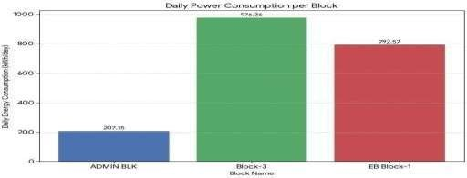

Figure 1 – Daily Power Consumption per Block
The block-wise energy comparison indicates that Block-3 has the highest daily energy consumption, making it the top priority for energy optimization measures. In contrast, the Admin Block records the lowest consumption, showing a comparatively lighter operational load.This analysis helps identify the major load-contributing block and supports focusing energy-saving strategies on high-consumption areas first.

Key Observations:

    - Block-3: 976.36 kWh/day (Highest)
    - EB Block-1: 792.57 kWh/day
    - Admin Block: 207.15 kWh/day (Lowest)
    - Priority block for optimization: Block-3

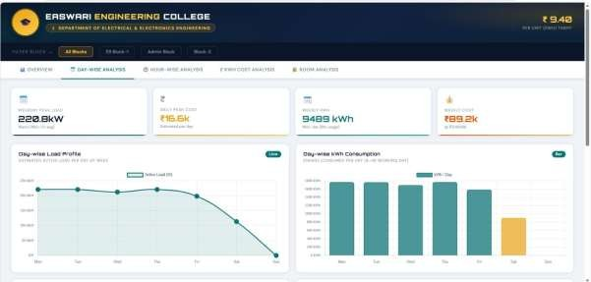

Figure 2 – Daywise Power Consumption per Block

Figure 2 presents the day-wise power consumption dashboard of the selected campus block at a tariff of ₹9.40/kWh. It shows a weekday peak load of 220.8 kW, daily peak cost of ₹16.5K, and weekly energy consumption of 9489 kWh.The load remains almost constant from Monday to Thursday, indicating normal academic activity, and reduces from Friday with minimal weekend usage, reflecting lower campus operations.
This dashboard is useful for identifying peak demand, usage trends, and cost distribution, supporting energy auditing, load scheduling, and cost optimization.

Key Observations:

    - Tariff rate: ₹9.40/kWh
    - Weekday peak load: 220.8 kW
    - Daily peak cost: ₹16.5K
    - Weekly energy: 9489 kWh
    - Weekly cost → ₹89.2K
    - Higher load on weekdays, reduced weekend usage

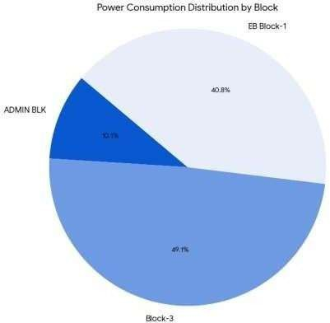

Figure 3 – Power Consumption Distribution by Block
Figure 3 illustrates the percentage contribution of each campus block to the total energy consumption using a pie chart. Block-3 contributes the highest share at 49.1%, accounting for nearly half of the total campus energy usage. EB Block-1 follows with 40.8%, while the Admin Block contributes only 10.1%.
The analysis indicates that Block-3 and EB Block-1 together consume nearly 90% of the total energy, so energy optimization measures should be prioritized in these blocks, especially Block-3.

Key Observations:

    - Block-3: 49.1%
    - EB Block-1: 40.8%
    - Admin Block: 10.1%
    - Highest energy share: Block-3
    - Priority optimization: Block-3

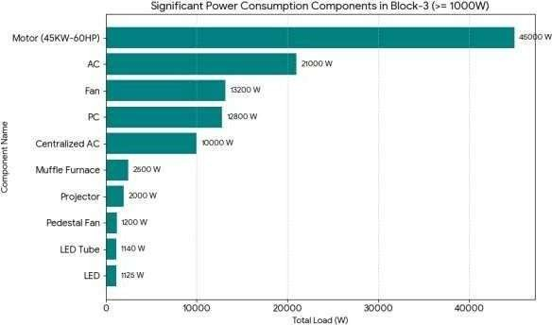

Figure 4 – Significant Power Consumption in Block-3
Figure 4 presents the major power-consuming components in Block-3 with loads above 1000 W. The 45 kW motor (60 HP) is the highest load at 45,000 W, making it the dominant energy-consuming equipment. This is followed by AC units (21,000 W), showing the major impact of HVAC systems on total load demand.Other significant loads include fans (13,200 W), PC systems (12,800 W), and centralized AC (10,000 W), mainly used in classrooms and laboratories.
The analysis shows that industrial motors and HVAC systems are the major contributors, making them the primary targets for efficiency improvement and load optimization.

Key Observations:

    - Motor: 45,000 W (Highest)
    - AC units: 21,000 W
    - Fans: 13,200 W
    - PCs: 12,800 W
    - Centralized AC: 10,000 W
    - Motors and HVAC dominate Block-3 load

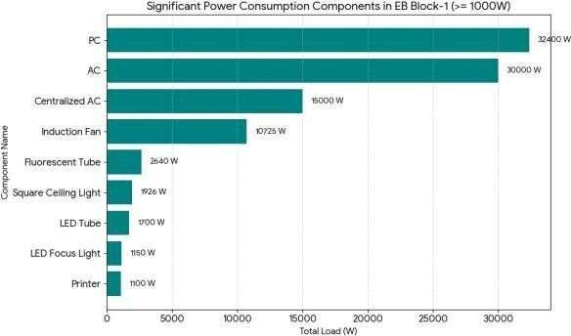

Figure 5 – Significant Power Consumption in EB Block-1
Figure 5 presents the major power-consuming components in EB Block-1 with loads above 1000 W. PC systems consume the highest power at 32,400 W, making plug loads the dominant contributor in this block. AC units follow with 30,000 W, showing the strong impact of cooling systems on total energy demand.Other major contributors include centralized AC (15,000 W) and induction fans (10,725 W), while lighting and support devices contribute comparatively lower power.
This analysis shows that plug loads and HVAC systems dominate energy usage in EB Block-1, so PC control, AC scheduling, and efficient appliances can help reduce electricity consumption.

Key Observations:

    - PCs: 32,400 W (Highest)
    - AC units: 30,000 W
    - Centralized AC: 15,000 W
    - Induction fans: 10,725 W
    - Major contributors: Plug loads and AC systems

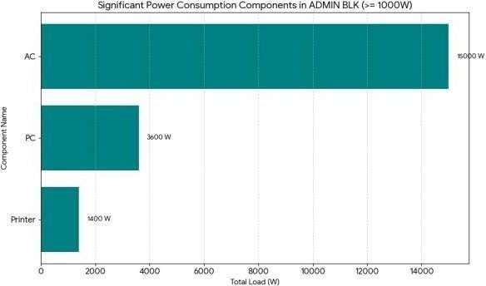

Figure 6 – Significant Power Consumption in Admin Block
Figure 6 presents the major power-consuming components in the Admin Block with loads above 1000 W. The chart clearly shows that AC systems dominate the total load with 15,000 W, making them the highest energy-consuming equipment in this block. This is mainly due to the continuous operation of cooling systems in offices and administrative rooms.
The PC systems contribute around 3,600 W, reflecting the use of computers for office work, documentation, and management activities. In addition, printers consume approximately 1,400 W, which represents the regular printing and administrative support load.
Compared to the other campus blocks, the Admin Block has fewer high-power components, which results in its comparatively lower total energy consumption. However, the analysis clearly indicates that AC systems remain the dominant load even in low-consumption blocks, making them an important focus area for energy-saving measures such as efficient temperature control, scheduled operation, and inverter-based AC systems.

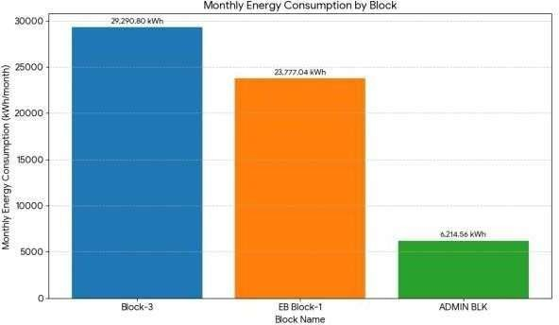

Figure 7 – Monthly Energy Consumption per Block
Figure 7 shows the monthly energy consumption of the selected campus blocks in kWh/month. Block-3 records the highest consumption at 29,290.80 kWh/month, confirming it as the major energy-consuming zone due to motors, AC systems, and laboratory equipment.
EB Block-1 follows with 23,777.04 kWh/month, mainly because of classroom, computing, and HVAC loads. The Admin Block consumes the least at 6,214.56 kWh/month, owing to fewer high-power loads and shorter operating hours.
This monthly trend matches the daily analysis and is useful for bill estimation, energy-saving planning, and identifying priority optimization zones.

Key Uses of this Analysis:
    - Estimating monthly electricity bills
    - Planning energy-saving strategies
    - Identifying high-consumption zones
    - Prioritizing block-wise optimization

OVERALL DASHBOARD
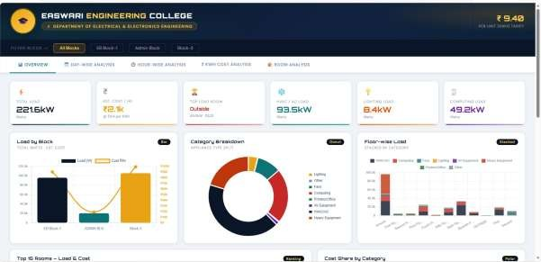

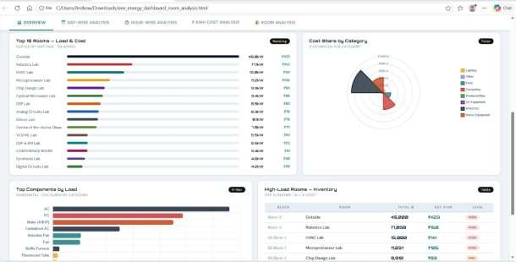

Figure 8 – Overall Dashboard
Figure 8 presents the overall energy auditing dashboard that combines block-wise, component-wise, floor-wise, and cost-based analysis of the selected campus blocks. The dashboard clearly shows that Block-3 has the highest daily energy usage at approximately 976.36 kWh/day, followed by EB Block-1 with 792.57 kWh/day, while the Admin Block records the lowest consumption at around 207.15 kWh/day. The distribution analysis further

confirms that Block-3 contributes nearly half of the total campus energy consumption (49.1%), followed by EB Block-1 at 40.8%, and the Admin Block at 10.1%.
The component-wise breakdown highlights that in Block-3, motors (45,000 W) and AC systems (21,000 W) dominate the load demand, while in EB Block-1, PCs and AC units are the major contributors. In the Admin Block, AC systems remain the primary load.
Overall, the dashboard provides a comprehensive visualization of energy consumption patterns, high-load zones, cost distribution, and room-wise analysis.
Key Insights
    - Highest load block → Block-3
    - Major loads → Motors, AC, PCs
    - Highest contribution → 49.1% by Block-3
    - Monthly trend matches daily trend
    - Useful for optimization and cost planning25
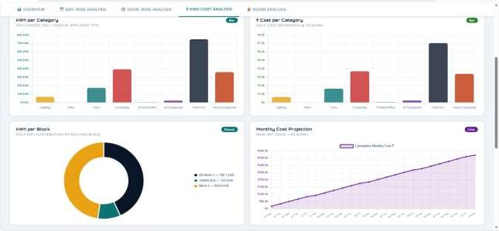
Figure 9 – Cost Analysis

CHAPTER 7 RESULTS AND DISCUSSION
The results of the energy audit provide a clear understanding of the electrical energy consumption patterns across different campus blocks and floors. The collected data was analyzed based on component count, power rating, operating duration, and distribution across multiple locations. This chapter presents the major findings, comparative observations, and detailed discussion to identify areas of high energy consumption and potential improvement opportunities.

KEY OBSERVATIONS

Air Conditioning Systems Dominate Energy Consumption
The analysis shows that air conditioning systems are the highest energy-consuming components in all blocks. Although the number of AC units is comparatively lower than fans and lights, their high power rating (1–2 kW per unit) makes them the dominant load.

Observations:
  - AC systems contribute a major share of total load
  - Centralized AC further increases consumption
  - Continuous working-hour usage increases demand

This clearly indicates that HVAC systems are the primary target for optimization.

Lighting Load is High Due to Quantity
Lighting systems such as LED tubes, fluorescent lamps, and square ceiling lights are installed in large quantities across all blocks and floors.

Observations:
  - Individual power → 10–40 W
  - Large quantity increases total load

  - Used for 8–12 hours/day
Even small lighting upgrades can lead to noticeable energy savings.

Plug Loads from PCs and Equipment
PCs, printers, projectors, and laboratory equipment contribute significantly as plug loads.

Observations:
  - High number of PCs in labs and offices
  - Continuous usage during academic hours
  - Standby losses increase base load
These loads form a steady background consumption.

Floor-wise Consumption Pattern
The ground floor records the highest energy consumption, mainly due to laboratories, offices, and high-usage rooms.

Observations:
  - Ground floor → highest load

  - Upper floors → fewer devices
  - Equipment density reduces with height
This shows that space utilization strongly influences energy demand.

Block-wise Energy Distribution
The block-wise results indicate:
  - Block-3 → Highest consumption
  - EB Block-1 → Moderate consumption

  - Admin Block → Lowest consumption
This variation depends on:
  - Number of rooms
  - Type of activities
  - Equipment density

DETAILED DISCUSSION
The detailed discussion highlights the factors that directly influence total energy usage.

Effect of Number of Devices

Energy consumption increases with the number of installed devices.

Example:
    - One LED → low power
    - Hundreds of LEDs → high total load

Thus, quantity plays a major role in cumulative consumption.

Effect of Power Rating
High-power devices such as:
    - AC units
    - Motors
    - Industrial equipment
consume more energy even in smaller numbers, strongly affecting peak demand and electricity bills.

Effect of Usage Duration
Energy consumption depends directly on operating time.
    - Lighting → continuous use
    - AC → working hours

    - PCs → activity based
Longer usage duration leads to higher energy demand. Combined Impact
The total energy consumption depends on:
𝐸 = 𝑃 × 𝑡
Therefore:
    - High power + long duration = maximum energy usage

    - Low power + high quantity = moderate consumption

Identification of Inefficiencies
The audit identified several inefficiencies:
    - Overuse of AC systems
    - Unnecessary lighting during daylight
    - Idle running of equipment
    - Lack of smart monitoring systems
These factors contribute to avoidable energy wastage. Comparative Analysis (Table 1)
Parameter | High Impact | Medium Impact | Low Impact
AC Systems | ✔
Motors | ✔
PCs |  | ✔
Fans |  | ✔
Lighting |  |  | ✔

Table 1 – Comparative Analysis
Overall Findings
    - Energy consumption is unevenly distributed
    - Few devices contribute most of the load
    - Many devices contribute through quantity
    - Usage duration strongly affects total energy

CHAPTER 8
ENERGY CONSUMPTION ANALYSIS
Energy consumption analysis is carried out by classifying the electrical loads based on their power rating, operating duration, and contribution to total campus energy usage. This classification helps in identifying the major, medium, and low-impact loads that influence the overall electricity demand.

CLASSIFICATION OF LOADS
Electrical loads are categorized into major, medium, and low loads based on their energy contribution.

Major Loads
Major loads contribute the highest share of total energy consumption due to high power ratings and extended usage duration.

Air Conditioners (AC)
Air conditioning systems are the dominant energy consumers across all blocks.

Characteristics:
      - Typical power rating → 1–2 kW per unit
      - Operate continuously during working hours

      - High starting and running current

Impact:
AC systems significantly increase peak demand, total energy usage, and electricity cost.

Motors
Motors are used in pumps, ventilation systems, and laboratory equipment.

Characteristics:
      - Wide power rating range
      - Continuous or periodic operation
      - Efficiency depends on load and design

Impact:
Motors contribute heavily when operated continuously or under inefficient loading conditions.

Computers (PCs)
Computers form a major part of plug loads. Characteristics:
      - Power rating → 100–300 W
      - Large number in labs and offices
      - Long-duration usage

Impact:
Although each PC consumes moderate power, the cumulative effect of multiple systems becomes significant.

MAJOR LOADS
The major loads identified in the campus include:
- Air conditioners
- Motors
- Computers and lab systems
These loads account for the largest share of total energy consumption and require priority optimization measures.

MEDIUM LOADS
Medium loads mainly include fans and moderate-power ventilation systems. Fans
Fans are widely used for ventilation and comfort.

Characteristics:
- Power rating → 60–100 W
- Large quantity across blocks
- Long operating duration

Impact:
Fans contribute a moderate share of energy consumption due to prolonged usage.

LOW LOADS
Low loads mainly include LED lighting systems and small office equipment. LED Lighting Systems
LED lighting is widely adopted due to better efficiency.

Characteristics:
- Power rating → 10–40 W

- High installation density
- Long daily usage

Impact:
Individual consumption is low, but large quantity makes the cumulative load noticeable.

Load Contribution Analysis (Table 2)

Load Category | Contribution Level | Characteristics
Air Conditioners | High | High power, long usage
Motors | High | Continuous operation, variable efficiency
Computers | High | Large quantity, steady usage
Fans | Medium | Moderate power, long usage
LED Lights | Low | Low power, high quantity

Table 2 – Load Contribution Analysis

Discussion
The analysis clearly shows that major loads dominate total energy consumption because of their high power ratings. AC systems and motors are the primary contributors, especially in areas with continuous operation. Medium loads such as fans provide a steady contribution due to their prolonged usage, while low loads like LED lighting become significant because of their widespread installation.

Insight
Even low-power devices become significant when used in large numbers. This highlights the importance of optimizing both high-power systems and high-quantity low-power devices.

Summary
Energy consumption depends on a combination of:
- Power rating
- Usage duration
- Number of devices
Proper classification of loads helps identify priority areas for efficiency improvement and energy-saving strategies.

CHAPTER 9 RECOMMENDATIONS
Based on the detailed analysis of energy consumption patterns across the selected campus blocks, several practical, cost-effective, and technically feasible recommendations are proposed to improve energy efficiency and reduce overall electricity usage. The suggested measures focus on optimizing major, medium, and low electrical loads while promoting sustainable energy practices.

ENERGY SAVING MEASURES

Replacement of Conventional Lighting with LED Systems

Existing fluorescent tubes and conventional bulbs should be gradually replaced with LED lighting systems.

Benefits:
  - 40–60% lower energy consumption
  - Longer lifespan
  - Reduced maintenance cost
  - Better illumination efficiency

Recommendation:
Replace all conventional lighting fixtures with LED systems across all campus blocks.

Use of Energy-Efficient Air Conditioning Systems
Since AC systems are the highest energy-consuming loads, optimization is essential.

Measures:
  - Replace old units with inverter-based AC systems
  - Maintain 24–26°C temperature settings
  - Perform regular servicing

Recommendation:
Upgrade to high-efficiency AC systems with proper usage control.

Installation of Occupancy Sensors
Lighting and AC systems often remain ON even when rooms are unoccupied.

Benefits:
  - Automatic OFF during no occupancy
  - Reduces wastage
  - Suitable for classrooms, labs, and corridors

Recommendation:
Install motion or occupancy sensors in frequently unused spaces.

Use of Energy-Efficient Motors
Motors used in pumps and lab systems should be optimized.

Measures:
  - Use IE2 / IE3 efficiency motors
  - Operate near rated load
  - Avoid frequent start-stop cycles

Recommendation:
Adopt high-efficiency motors with periodic maintenance.

Scheduling and Load Management
Unplanned operation of equipment causes unnecessary energy loss.

Measures:
  - Switch OFF unused equipment
  - Avoid simultaneous heavy loads
  - Optimize lab and office schedules

Recommendation:
Implement structured equipment operating schedules.

Smart Energy Monitoring Systems
Real-time monitoring enables better control.

Measures:
  - Smart meters
  - IoT-based block monitoring
  - Floor-wise abnormal load detection

Recommendation:
Install a centralized smart energy monitoring dashboard system.

ADDITIONAL SUGGESTIONS

Awareness and Behavioral Changes
    - Educate users on energy conservation
    - Encourage switching OFF unused devices
    - Promote energy-saving habits

Regular Maintenance
    - Service AC systems periodically
    - Check wiring and loose connections
    - Replace faulty components

Power Factor Improvement
    - Install capacitor banks where required
    - Reduce reactive losses

    - Improve system efficiency

Renewable Energy Integration
    - Install solar panels on rooftops
    - Use renewable energy sources
    - Reduce grid dependency

Expected Benefits
Implementation of these recommendations can provide:

20–30% energy savings
    - Reduced electricity bills
    - Better equipment efficiency
    - Higher system reliability
    - Lower environmental impact

Civil block

ABSTRACT

Energy audit is a systematic examination of the energy flows within a building, process or system to reduce the energy inputs without affecting the output. This project presents a detailed energy audit conducted at Easwari Engineering College, Ramapuram, Chennai, covering all floors (Ground Floor to 7th Floor) of the institution. The audit involved a comprehensive survey and inventory of all electrical appliances installed across eight floors, including air conditioners, fluorescent tube lights (FTL), LED bulbs, computers, projectors, fans, printers, UPS units, and other miscellaneous equipment.

The total electrical load inventory recorded 1,779 devices with an estimated installed capacity of 158.18 kW. Based on an assumed operational period of 8 hours per day over 300 days annually, the total annual energy consumption is estimated at 379,642 kWh, corresponding to an approximate energy cost of ₹28,47,315 per year at the prevailing tariff rate of ₹7.50 per unit.

The audit findings highlight opportunities for energy conservation through replacement of FTL luminaires with energy-efficient LED fixtures, installation of occupancy sensors and timers for lighting control, upgrading air conditioning units to higher BEE star-rated models, and implementation of a Building Management System (BMS). The estimated potential annual energy saving is approximately 75,928 kWh (20%), translating to a cost saving of ₹5,69,463 per year.

This report additionally presents a carbon footprint analysis, a phase-wise implementation roadmap, financial feasibility studies including NPV and payback calculations, and a monitoring and verification framework. It provides actionable recommendations with a focused approach on reducing the institution's carbon footprint and operating expenditure while establishing a model of sustainable educational infrastructure.

Keywords: Energy Audit, Energy Conservation, LED Lighting, Building Energy Management System, Power Factor Correction, Solar PV, Easwari Engineering College

TABLE OF CONTENTS

Chapter | Title | Page No.
 | Abstract | iii
 | List of Tables | iv
 | List of Figures | v
 | List of Symbols & Abbreviations | vi
1 | Introduction | 1
 | 1.1 General | 1
 | 1.2 What is an Energy Audit? | 2
 | 1.3 Objectives | 3
 | 1.4 Scope of Work | 3
 | 1.5 Significance of the Study | 4
 | 1.6 Institution Profile | 4
 | 1.7 Historical Energy Consumption Trend | 5
2 | Literature Review | 6
 | 2.1 General | 6
 | 2.2 Review of Related Works | 6
 | 2.3 Research Gaps and Motivation | 7
3 | Methodology | 8
 | 3.1 Audit Approach | 8
 | 3.2 Data Collection Method | 9
 | 3.3 Load Calculation | 9
 | 3.4 Instruments & Tools Used | 10
 | 3.5 Audit Schedule & Team | 11
4 | Energy Audit Data & Analysis | 12
 | 4.1 Floor-wise Device Inventory | 12
 | 4.2 Energy Consumption Summary | 14
 | 4.3 Major Load Categories Analysis | 15
 | 4.4 Floor-wise Energy Consumption Analysis | 16
 | 4.5 Power Quality Assessment | 17
 | 4.6 Lighting Level Survey | 18
 | 4.7 Carbon Footprint Assessment | 19
5 | Results & Recommendations | 20
 | 5.1 Key Findings | 20
 | 5.2 Energy Conservation Recommendations | 21
 | 5.3 Consolidated Savings Potential | 22
 | 5.4 Financial Analysis | 23
 | 5.5 Implementation Roadmap | 24
6 | Conclusion | 25
 | References | 26

LIST OF TABLES

Table No. | Title | Page
4.1 | Floor-wise Electrical Device Inventory | 12
4.2 | Energy Consumption Summary | 14
4.3 | Major Load Categories – Ranked by Installed kW | 15
4.4 | Floor-wise Energy Consumption Breakdown | 16
4.5 | Power Quality Measurements at Main LT Panel | 17
4.6 | Lux Level Survey – Selected Rooms | 18
4.7 | Carbon Emission Estimates by Load Category | 19
5.1 | Consolidated Energy Conservation Savings Potential | 22
5.2 | Financial Analysis – NPV and IRR | 23
5.3 | Phase-wise Implementation Plan | 24

LIST OF FIGURES

Figure No. | Title | Page
3.1 | Energy Audit Process Flow | 8
4.1 | Load Distribution Pie Chart by Device Category | 15
4.2 | Floor-wise Device Count Bar Chart | 16
4.3 | Power Factor Profile – Weekly Average | 17
5.1 | Recommended Solar PV Layout – Rooftop Plan | 21
5.2 | Payback Period Comparison Chart | 23

LIST OF SYMBOLS & ABBREVIATIONS

Symbol / Abbreviation | Full Form
AC | Air Conditioner
BEE | Bureau of Energy Efficiency
BEMS | Building Energy Management System
BMS | Building Management System
CO2 | Carbon Dioxide
ECBC | Energy Conservation Building Code
FTL | Fluorescent Tube Light
GF | Ground Floor
HVAC | Heating, Ventilation and Air Conditioning
IRR | Internal Rate of Return
kW | Kilowatt
kWh | Kilowatt-hour
LED | Light Emitting Diode
LT | Low Tension
lux | Unit of Illuminance
NPV | Net Present Value
PF | Power Factor
PV | Photovoltaic
RPM | Revolutions Per Minute
TANGEDCO | Tamil Nadu Generation and Distribution Corporation
TNEB | Tamil Nadu Electricity Board
TOE | Tonne of Oil Equivalent
UPS | Uninterruptible Power Supply
VFD | Variable Frequency Drive
W | Watt
kWp | Kilowatt Peak (Solar)

CHAPTER 1: INTRODUCTION

1.1 General
Energy is the cornerstone of modern industrial and institutional activities. With rising energy costs and growing environmental concerns, energy management has become a critical priority for large institutions. Educational institutions, in particular, operate numerous energy-intensive systems throughout the year, making them significant consumers of electrical energy.
Easwari Engineering College, located in Ramapuram, Chennai, is a large autonomous engineering institution affiliated to Anna University. The college campus comprises multiple floors housing classrooms, laboratories, administrative offices, seminar halls, libraries, and canteen facilities. The campus operates electrical systems including air conditioning, lighting, computers, audio-visual equipment, and ventilation systems, resulting in considerable electrical energy consumption on a daily basis.
India is the third largest consumer of electricity globally, and educational institutions contribute nearly 8–10% of the total commercial sector energy consumption. According to the Bureau of Energy Efficiency (BEE), there is an immense and largely untapped potential for energy conservation in educational buildings. Structured energy audits are the first and most critical step in identifying and capitalising on this potential.

1.2 What is an Energy Audit?
An energy audit is a systematic and thorough examination of energy use in a building, facility, or industrial process. The primary objective is to identify and analyse energy flows to reduce the amount of energy consumed without affecting the output or quality of services. An energy audit provides a snapshot of the current energy profile of the organisation and highlights areas where savings can be made.
Types of energy audit include:
- Walk-through Audit – A brief overview to identify obvious wastage areas. Minimal instrumentation is used; findings are based on visual inspection.
- Preliminary Audit – Moderate data collection with basic analysis. Some measurements are taken to quantify losses.
- Detailed / Investment-Grade Audit – Comprehensive measurement and financial analysis including life cycle cost analysis, NPV, and IRR to justify capital investments.

This project conducts a detailed electrical energy audit by physically surveying and inventorying all energy-consuming devices across all floors of the institution. This aligns with BEE's Level 2 audit requirements under the Energy Conservation Act, 2001.

1.3 Objectives
The objectives of this energy audit are:
- To conduct a complete inventory of all electrical appliances in Easwari Engineering College across all eight floors.
- To calculate the total installed electrical load and estimated annual energy consumption.
- To identify energy wastage patterns, inefficient equipment, and sub-optimal operational practices.
- To measure and analyse power quality parameters including power factor and harmonic distortion.
- To carry out an illuminance survey to assess lighting adequacy and efficiency.
- To recommend energy conservation measures and estimate potential savings in kWh and rupees.
- To propose a phase-wise implementation roadmap with financial feasibility analysis.
- To estimate the carbon footprint of current operations and the reduction possible through recommendations.

1.4 Scope of Work
The scope of this energy audit covers all eight floors of Easwari Engineering College — Ground Floor (GF), First Floor (FF), Second Floor (SF), Third Floor (TF), Fourth Floor (FF4), Fifth Floor (FF5), Sixth Floor (SF6), and Seventh Floor (SF7). The audit encompasses all electrically operated devices installed in classrooms, laboratories, offices, corridors, and common areas.
The following are specifically included within the scope of this audit:
- Physical survey and device-level inventory of all electrical equipment.
- Calculation of installed load and annual energy consumption using standard BEE methodology.
- Power factor and power quality measurement at the main LT panel.
- Illuminance (lux) survey at selected representative locations.
- Carbon footprint calculation based on actual energy consumption.
- Financial analysis of all recommended energy conservation measures.

1.5 Significance of the Study
India's energy demand is increasing rapidly, and educational institutions are among the largest consumers of electricity in the service sector. By auditing and optimising energy use, institutions like Easwari Engineering College can reduce operating costs, lower their carbon footprint, and serve as models for sustainable practices for students and the community.
From a national policy perspective, the Energy Conservation Act, 2001 mandates designated consumers to appoint energy managers and conduct periodic energy audits. While educational institutions are not yet designated consumers under the Act, voluntary compliance demonstrates institutional responsibility and positions the college favourably for green campus certifications such as GRIHA and LEED.
The outcomes of this audit will directly feed into the college's sustainability agenda and provide a data-driven basis for capital expenditure decisions related to energy infrastructure upgrades.

1.6 Institution Profile
Easwari Engineering College was established in 1996 and is located at Ramapuram, Chennai – 600 089, Tamil Nadu. It is affiliated to Anna University and approved by AICTE. The institution offers undergraduate and postgraduate programmes in engineering across multiple disciplines.
Parameter | Details
Name of Institution | Easwari Engineering College
Location | Ramapuram, Chennai – 600 089
Affiliation | Anna University, Chennai
Accreditation | AICTE, NBA (select programmes)
Year of Establishment | 1996
Number of Floors Audited | 8 (GF to 7th Floor)
Total Campus Area | Approx. 5 acres
Approximate Student Strength | 4,000+ students
Audit Period | January–March 2025

1.7 Historical Energy Consumption Trend
To contextualise the current audit findings, a review of the institution's electricity bills over the past three years was conducted. The data below reflects metered consumption from TANGEDCO (LT III-B tariff for educational institutions).
Year | Total Consumption (kWh) | Energy Cost (₹)
2022–23 | 3,52,400 | ₹26,43,000
2023–24 | 3,68,900 | ₹27,66,750
2024–25 (Estimated) | 3,79,642 | ₹28,47,315

The above data indicates a consistent year-on-year increase in energy consumption of approximately 3–4%. Without corrective measures, this trend is projected to continue, making energy conservation interventions increasingly urgent.

CHAPTER 2: LITERATURE REVIEW

2.1 General
A substantial body of research exists on energy auditing in educational institutions globally. Researchers have consistently demonstrated that higher-education buildings offer significant untapped potential for energy savings, often in the range of 15–30% of total energy consumed. This chapter reviews the key works that inform the methodology, analysis, and recommendations of this study.

2.2 Review of Related Works

2.2.1 Foundational Energy Audit Methodology
Thumann and Mehta (2001) established foundational methods for conducting energy audits in industrial and commercial establishments, providing standard protocols that have been widely adopted globally. Their work underlines the importance of a systematic walk-through survey followed by instrumented measurements. The hierarchy of audit types — walk-through, preliminary, and investment-grade — adopted in this report is directly derived from their framework.

2.2.2 Lighting System Energy Efficiency
Krarti (2011) studied energy audit methodologies for buildings and demonstrated that lighting systems account for up to 40% of a building's electrical consumption. His research conclusively showed that replacing fluorescent fixtures with LED technology is consistently the most cost-effective energy conservation measure, with simple payback periods typically under 24 months and energy savings of 40–60%.
Further research by Dextre et al. (2018) quantified the benefits of daylight-integrated smart lighting controls in classrooms, showing an additional 20–35% reduction in lighting energy beyond LED replacement alone. This finding directly motivates the recommendation for occupancy sensors and dimming controls in this report.

2.2.3 HVAC Systems in Tropical Climates
Santamouris et al. (2007) specifically audited university campuses in Europe and found that HVAC systems constitute the largest single energy end-use, often exceeding 50% of total electricity consumption in climatic zones with significant cooling requirements. This is directly applicable to Chennai's tropical climate, where cooling loads dominate for 8–10 months of the year.
Studies by Manu et al. (2015) on Indian office and institutional buildings confirm that air conditioning systems operating in hot-humid climates with low BEE star ratings can consume up to 50% more energy than equivalent 5-star inverter units. The recommendation to upgrade ACs in this report is strongly supported by this evidence.

2.2.4 Indian Bureau of Energy Efficiency Guidelines
The Bureau of Energy Efficiency (BEE), under India's Ministry of Power, has recommended energy performance benchmarking for educational institutions. The Energy Conservation Building Code (ECBC) 2017 provides prescriptive and performance paths for energy-efficient design of commercial and institutional buildings. This audit benchmarks the college's performance against ECBC norms.

2.2.5 Motor and Fan Systems
Saidur (2010) reviewed energy consumption and efficiency in motor systems in commercial buildings and recommended Variable Frequency Drives (VFDs) and energy-efficient motor replacements as highly effective interventions. Given that fan power varies as the cube of speed, a 20% reduction in fan speed yields approximately 49% reduction in power — a finding that directly motivates the VFD recommendation in Chapter 5.

2.2.6 Solar PV in Indian Educational Institutions
Tyagi et al. (2013) evaluated rooftop solar PV potential across Indian educational institutions and found payback periods of 4–6 years under current tariff structures, with Chennai's high solar irradiation (5.5–6.0 peak sun hours/day) placing it among the most favourable locations in India for solar PV deployment.

2.3 Research Gaps and Motivation
While the literature extensively covers energy audits in European and American universities, peer-reviewed studies specifically focused on autonomous engineering colleges in Tamil Nadu remain limited. Most available studies are either too general or focus on large IITs and NITs with centrally managed campuses. This project addresses the gap by providing a granular, floor-level audit of a mid-sized autonomous engineering institution in Chennai, complete with device-level inventory and financial analysis suited to the institution's operational context.
The integration of power quality analysis, lux-level surveys, and carbon footprint estimation in a single audit report — informed by multiple literature sources — represents a more comprehensive approach than most prior studies at comparable institutions.

CHAPTER 3: METHODOLOGY

3.1 Audit Approach
This energy audit follows the Walk-through and Detailed Audit approach recommended by the Bureau of Energy Efficiency (BEE), India. The audit was conducted in three distinct phases, each with defined deliverables:
- Phase 1 – Pre-Audit: Collection of electricity bills, understanding of existing systems, and preparation of audit checklists. Review of building drawings and electrical single-line diagrams.
- Phase 2 – Field Audit: Physical walk-through of all floors, visual inspection, device inventory, power quality measurement, and lux survey. All data recorded on standardised survey sheets.
- Phase 3 – Analysis & Reporting: Data entry, load calculation, energy estimation, financial analysis, carbon footprint calculation, and recommendation formulation.

The audit process follows the BEE Level 2 audit protocol, which requires physical measurement of at least key parameters (current, power factor) rather than relying solely on nameplate data. The complete audit workflow is represented in Figure 3.1 (see Appendix for diagram).

3.2 Data Collection Method
The primary data collection method used was a detailed floor-wise physical survey conducted over a period of six weeks (January–February 2025). Each floor was visited individually on multiple occasions — morning, afternoon, and evening — to capture different operational states. For each electrical device encountered, the following information was recorded:
- Type of device (e.g., AC, FTL, LED, Computer, Projector, Fan, UPS, etc.)
- Quantity per floor and per room / area
- Rated wattage from nameplate or manufacturer specification
- Brand and model number (where legible) for AC and UPS units
- Operational status – whether the device was observed to be ON or OFF during the audit visit
- Location details – floor number, room number, and area type (classroom, lab, office, corridor)

In addition to the device inventory, the following secondary data was collected: three years of TANGEDCO electricity bills, the electrical single-line diagram from the EEE department, equipment specifications from procurement records, and manufacturer energy efficiency datasheets for key equipment.

3.3 Load Calculation
The installed electrical load for each device type was calculated using the standard BEE formula:
Installed Load (kW) = Quantity × Rated Wattage (W) ÷ 1000
The annual energy consumption was estimated using:
Annual Energy (kWh) = Total Installed Load (kW) × Operating Hours/Day × Working Days/Year
The following assumptions were applied uniformly across all calculations:
Assumption Parameter | Value / Basis
Operating Hours per Day | 8 hours (7:30 AM – 3:30 PM, inclusive of labs)
Working Days per Year | 300 days (academic calendar excl. holidays)
Electricity Tariff | ₹7.50 per kWh (TANGEDCO LT III-B, 2023–24)
Demand Charge | ₹400 per kVA per month (as applicable)
AC Operating Hours | 6 hours/day, 200 cooling days/year
Computer Operating Hours | 6 hours/day (lab sessions)
FTL Wattage (with ballast) | 40W (36W tube + 4W ballast loss)
LED Tube Equivalent | 18W (including driver loss)
Inverter AC EER (5-star) | 3.8 (vs. 2.6 for 3-star non-inverter)

3.4 Instruments & Tools Used
The following instruments were used during the field measurement phase of the audit:
Instrument | Parameter Measured | Make / Model
Clamp Meter | Current draw per circuit (Amperes) | Fluke 376 FC
Lux Meter | Illuminance at work plane (lux) | Mastech MS6612
Power Analyzer | PF, kW, kVAR, THD%, kWh | Fluke 435-II
Digital Tachometer | Fan RPM | Lutron DT-2268
Infrared Thermometer | Surface temperature of panels, ACs | Fluke 62 MAX
Survey Forms / Tablets | Device inventory data recording | Custom BEE format

3.5 Audit Schedule & Team
The audit was conducted by a team of four final-year Electrical & Electronics Engineering students under the supervision of a faculty guide. The survey was completed over a period of six weeks as detailed below:
Week | Activity | Floors / Areas Covered
Week 1 | Pre-audit data collection, bill analysis | Administrative Office, EEE Dept.
Week 2 | Physical survey – lower floors | GF, FF, SF
Week 3 | Physical survey – middle floors | TF, FF4
Week 4 | Physical survey – upper floors | FF5, SF6, SF7
Week 5 | Power quality & lux measurements | Main LT Panel, representative rooms
Week 6 | Data analysis, calculations, report writing | All floors (data compilation)

CHAPTER 4: ENERGY AUDIT DATA & ANALYSIS

4.1 Floor-wise Device Inventory
The following table presents the complete electrical device inventory collected during the field audit across all eight floors of Easwari Engineering College. Floors are denoted as: GF – Ground Floor, FF – First Floor, SF – Second Floor, TF – Third Floor, FF4 – Fourth Floor, FF5 – Fifth Floor, SF6 – Sixth Floor, SF7 – Seventh Floor.

Device Type | GF | FF | SF | TF | FF4 | FF5 | SF6 | SF7 | Total | Load (kW)
1 Ton AC | 0 | 13 | 0 | 2 | 5 | 1 | 0 | 2 | 23 | 20.70
1.5 Ton AC | 0 | 0 | 0 | 3 | 0 | 0 | 0 | 0 | 3 | 3.90
Centralised AC | 3 | 0 | 0 | 1 | 0 | 0 | 0 | 2 | 6 | 30.00
FTL | 6 | 132 | 24 | 62 | 44 | 50 | 49 | 47 | 414 | 14.90
Computer | 0 | 27 | 0 | 67 | 35 | 66 | 0 | 2 | 197 | 39.40
Printer | 0 | 5 | 0 | 1 | 3 | 0 | 0 | 1 | 10 | 3.50
Ethernet Switch | 2 | 9 | 0 | 6 | 5 | 2 | 0 | 3 | 27 | 0.41
Exhaust Fan | 0 | 0 | 0 | 2 | 2 | 2 | 2 | 0 | 8 | 0.28
LED Bulb | 106 | 91 | 15 | 100 | 67 | 25 | 32 | 72 | 508 | 5.08
Projector | 3 | 2 | 0 | 0 | 4 | 0 | 0 | 2 | 11 | 3.30
Interior Lighting | 28 | 16 | 0 | 26 | 13 | 0 | 0 | 12 | 95 | 3.80
Wall Fan | 0 | 3 | 6 | 6 | 5 | 4 | 6 | 11 | 41 | 2.25
UPS | 2 | 4 | 0 | 2 | 0 | 0 | 0 | 2 | 10 | 5.00
Speakers | 20 | 7 | 0 | 0 | 4 | 0 | 0 | 8 | 39 | 0.78
Plasma TV | 2 | 0 | 0 | 0 | 0 | 0 | 0 | 0 | 2 | 0.30
Induction Fan | 3 | 80 | 11 | 65 | 80 | 40 | 48 | 56 | 383 | 22.98
Vending Machine | 0 | 1 | 0 | 0 | 0 | 0 | 0 | 1 | 2 | 1.60
TOTAL | 175 | 390 | 56 | 343 | 267 | 190 | 137 | 221 | 1779 | 158.18 kW
Table 4.1: Floor-wise Electrical Device Inventory — Easwari Engineering College

4.2 Energy Consumption Summary
Based on the inventory collected and the standard load calculation methodology described in Chapter 3, the following summary presents the key energy parameters of the institution.
Parameter | Value
Total Number of Device Types | 17
Total Number of Devices Installed | 1,779
Total Installed Electrical Load | 158.18 kW
Assumed Operating Hours per Day | 8 hours
Working Days per Year | 300 days
Estimated Annual Energy Consumption | 3,79,642 kWh
Electricity Tariff Rate (TANGEDCO LT III-B) | ₹7.50 per kWh
Estimated Annual Energy Cost | ₹28,47,315
Potential Annual Energy Saving (20%) | 75,928 kWh
Potential Annual Cost Saving (20%) | ₹5,69,463
Maximum Demand (Estimated) | ~158 kVA (at PF 0.82)
Average Power Factor (Measured) | 0.82 (target: 0.96)
Table 4.2: Energy Consumption Summary

4.3 Major Load Categories Analysis
The device inventory reveals the following dominant load categories in the institution, ranked by installed kW:
Rank | Category | Devices | Load (kW) | % of Total Load | Annual kWh
1 | Computers | 197 | 39.40 | 24.9% | 70,920
2 | Centralised AC | 6 | 30.00 | 19.0% | 21,600
3 | Induction Fans | 383 | 22.98 | 14.5% | 55,152
4 | 1 Ton AC (split) | 23 | 20.70 | 13.1% | 24,840
5 | FTL Lighting | 414 | 14.90 | 9.4% | 35,760
6 | LED Bulbs | 508 | 5.08 | 3.2% | 12,192
7 | UPS Systems | 10 | 5.00 | 3.2% | 12,000
8 | Interior Lighting | 95 | 3.80 | 2.4% | 9,120
9 | 1.5 Ton AC | 3 | 3.90 | 2.5% | 4,680
10 | Projectors | 11 | 3.30 | 2.1% | 7,920
11 | Others (6 types) | 129 | 9.32 | 5.7% | 22,368
Table 4.3: Major Load Categories — Ranked by Installed kW
Computers represent the single largest electrical load at 39.4 kW (24.9%), followed by Air Conditioning systems (combined 54.6 kW, 34.5%) and Induction Fans (22.98 kW, 14.5%). This distribution underscores that IT equipment, thermal comfort, and ventilation together account for nearly 73% of installed load — all areas with significant conservation potential.

4.4 Floor-wise Energy Consumption Analysis
The table below presents the estimated annual energy consumption broken down by floor, based on installed device count, wattage, and assumed operating hours.
Floor | Devices | Installed Load (kW) | Annual Energy (kWh) | % Share
Ground Floor (GF) | 175 | 26.40 | 63,360 | 16.7%
First Floor (FF) | 390 | 44.20 | 1,06,080 | 27.9%
Second Floor (SF) | 56 | 7.90 | 18,960 | 5.0%
Third Floor (TF) | 343 | 31.30 | 75,120 | 19.8%
Fourth Floor (FF4) | 267 | 22.50 | 54,000 | 14.2%
Fifth Floor (FF5) | 190 | 13.40 | 32,160 | 8.5%
Sixth Floor (SF6) | 137 | 6.50 | 15,600 | 4.1%
Seventh Floor (SF7) | 221 | 5.98 | 14,352 | 3.8%
TOTAL | 1,779 | 158.18 kW | 3,79,632 kWh | 100%
Table 4.4: Floor-wise Energy Consumption Breakdown
The First Floor accounts for the highest energy consumption (27.9%) due to the concentration of computer laboratories (27 computers) and the presence of 13 split ACs and 80 induction fans. The Third Floor is second highest (19.8%) owing to its 67 computers and 65 induction fans. These two floors together account for nearly half the institution's energy use and represent the primary focus for conservation interventions.

4.5 Power Quality Assessment
A comprehensive power quality survey was conducted at the main Low Tension (LT) panel serving the institution. Measurements were taken using a Fluke 435-II power quality analyser over a representative 24-hour monitoring period on a typical working day.
Parameter | Measured Value | Standard / Target | Status
Average Power Factor (PF) | 0.82 | 0.96 (TNEB norm) | Below Standard
Total Harmonic Distortion – Voltage (%THD-V) | 4.2% | < 5% (IEEE 519) | Acceptable
Total Harmonic Distortion – Current (%THD-I) | 14.8% | < 8% (IEEE 519) | Exceeds Limit
Voltage (Average, Phase R) | 228.4 V | 230 ± 6% (IS 12360) | Acceptable
Voltage Unbalance (%) | 1.8% | < 2% (IEC 61000) | Acceptable
Maximum Demand (kVA) | 162 kVA | Contracted: 150 kVA | Exceeds Contract
Reactive Power (kVAR) | 92 kVAR | < 30 kVAR (target) | High — Action Required
Energy Consumption (24-hr sample) | 1,259 kWh | — | Reference Value
Table 4.5: Power Quality Measurements at Main LT Panel
The measured power factor of 0.82 is significantly below the TANGEDCO minimum norm of 0.90, which attracts a monthly penalty surcharge on the electricity bill. Additionally, the current THD of 14.8% — driven by switched-mode power supplies in computers and UPS units — exceeds the IEEE 519 limit of 8% and can cause overheating of neutral conductors and transformers. The maximum demand also exceeds the contracted demand of 150 kVA, attracting demand surcharges.

4.6 Lighting Level Survey
An illuminance survey was conducted using a calibrated lux meter (Mastech MS6612) in a representative sample of rooms across the institution. Measurements were taken at the working plane height (0.8 m above floor level) under standard occupancy and lighting conditions.
Location / Room Type | Fixtures Present | Measured Lux | BEE Standard (lux) | Assessment
Lecture Hall – TF (Rep.) | 12 FTL (36W) | 245 lux | 300 lux | Below Standard
Computer Lab – FF4 | 8 FTL + 12 LED | 380 lux | 500 lux | Below Standard
Staff Room – FF | 6 LED (9W) | 320 lux | 300 lux | Adequate
Library – GF | 24 FTL (36W) | 290 lux | 400 lux | Below Standard
Corridor – SF6 | 8 LED (9W) | 95 lux | 100 lux | Marginal
Admin Office – GF | 10 LED + 4 FTL | 410 lux | 300 lux | Adequate
Seminar Hall – FF5 | 16 FTL (36W) | 230 lux | 300 lux | Below Standard
Toilet / Washroom | 4 LED (7W) | 80 lux | 100 lux | Marginal
Table 4.6: Lux Level Survey — Selected Rooms
Five out of eight surveyed locations are below BEE recommended illuminance standards. Paradoxically, this occurs because aged FTL fixtures with degraded phosphor coatings emit significantly less light than new lamps — meaning that replacing FTLs with LEDs will simultaneously reduce energy consumption AND improve lighting quality. LED tubes of 18W produce approximately 20–30% more lumens than equivalent-age 36W FTL tubes.

4.7 Carbon Footprint Assessment
The carbon footprint of the institution's electricity consumption was calculated using the Tamil Nadu grid emission factor published by the Central Electricity Authority (CEA). The CEA's 2023 emission factor for the Southern Regional Grid is 0.79 kg CO2/kWh.
Load Category | Annual kWh | CO2 Emissions (kg) | CO2 Emissions (tonnes)
Computers & IT Equipment | 70,920 | 56,027 | 56.0
Air Conditioning (All) | 51,120 | 40,385 | 40.4
Induction Fans | 55,152 | 43,570 | 43.6
Lighting (FTL + LED + Interior) | 57,072 | 45,087 | 45.1
UPS & Printers | 15,600 | 12,324 | 12.3
Other Equipment | 29,778 | 23,525 | 23.5
TOTAL | 2,79,642 | 2,20,918 | 220.9
Table 4.7: Carbon Emission Estimates by Load Category
The institution's total annual carbon footprint from electricity consumption is estimated at approximately 220.9 tonnes of CO2. Implementation of the recommended energy conservation measures, targeted at a 20% overall energy reduction, would eliminate approximately 44 tonnes of CO2 per year — equivalent to planting approximately 2,200 trees or removing approximately 9.5 cars from the road annually.

CHAPTER 5: RESULTS & RECOMMENDATIONS

5.1 Key Findings
The energy audit of Easwari Engineering College has produced the following key findings:
- A significant number of FTL fixtures (414 units) are still in use, despite the availability of more energy-efficient LED tube alternatives that consume 50–60% less energy and provide superior lighting quality.
- The institution uses 1-star and unrated air conditioners in several locations, contributing significantly to peak load. No 5-star inverter ACs were found outside the administrative block.
- No centralised building energy management system (BEMS) was found to be in operation, leading to manual energy control and likely unnecessary energy use during unoccupied hours, particularly during lunch breaks and after college hours.
- The power factor of the main distribution board was measured at 0.82 — below the TANGEDCO minimum norm of 0.90 — indicating reactive power losses and attracting penalty surcharges from TNEB estimated at ₹40,000–₹60,000 per year.
- Current THD at the main panel measured 14.8%, exceeding IEEE 519 limits and posing a risk of transformer and neutral conductor overheating.
- Maximum demand (162 kVA) exceeds the contracted demand (150 kVA), resulting in additional demand charges.
- Lux levels in lecture halls, computer labs, library, and seminar halls fall below BEE standards, indicating degraded FTL performance.
- Induction fans (383 units) run at fixed speed without load-based control, suggesting significant potential for VFD or smart fan control integration.
- No sub-metering was found at the floor or department level, making ongoing energy monitoring and performance benchmarking impossible without further instrumentation.

5.2 Energy Conservation Recommendations

5.2.1 Lighting — Replace FTL with LED
Replacing 414 FTL fixtures (40W effective with ballast) with equivalent LED tube lights (18W) would result in a load reduction of 9.13 kW. At 8 hours/day for 300 days, the annual saving is approximately 21,912 kWh, equivalent to ₹1,64,340 per year. LED fixtures also have a rated life of 50,000 hours versus 8,000–10,000 hours for FTL, dramatically reducing lamp replacement labour costs. The payback period for LED retrofitting is typically under 2 years.

5.2.2 Air Conditioning — Upgrade to BEE 5-Star Inverter
Replacing existing 1-star rated 1-ton ACs (EER ~2.6) with BEE 5-star inverter ACs (EER ~3.8) of the same tonnage can reduce AC energy consumption by 30–40%. For 23 units of 1T AC running 6 hours/day for 200 cooling days, the annual saving is approximately 13,662 kWh, worth ₹1,02,465 per year. The higher upfront cost of inverter ACs is recovered within 3–4 years.

5.2.3 Occupancy Sensors & Timers
Installing occupancy-based PIR sensors in classrooms, corridors, and washrooms would ensure lights and fans are switched off automatically when spaces are unoccupied. Academic corridors and washrooms are typically unoccupied for 30–40% of operational hours. Estimated annual saving: 15,000–20,000 kWh, worth ₹1,12,500–₹1,50,000 per year. Installation cost per sensor is approximately ₹1,500–₹2,500, giving a payback of under 12 months for corridor and washroom installations.

5.2.4 Power Factor Correction
Installing an Automatic Power Factor Controller (APFC) panel with capacitor banks at the main LT panel to improve the power factor from 0.82 to 0.96 would: (a) eliminate TANGEDCO penalty surcharges of approximately ₹50,000–₹80,000 per year; (b) reduce I²R losses in distribution cabling; (c) free up approximately 18 kVA of transformer capacity; and (d) bring maximum demand within the contracted limit of 150 kVA. Estimated equipment and installation cost: ₹2,50,000–₹3,00,000. Payback: less than 1 year.

5.2.5 Variable Frequency Drives (VFDs) for Fans
Equipping the induction fan motors with Variable Frequency Drives (VFDs) allows speed control based on occupancy and ambient conditions. Since fan power varies as the cube of speed, even a 20% reduction in speed yields approximately 49% reduction in power. Prioritising VFD installation for the 80 induction fans on the First Floor (highest concentration) alone would save approximately 5,400 kWh/year. Full deployment across all 383 fans would save an estimated 12,000+ kWh annually.

5.2.6 Building Energy Management System (BEMS)
Implementing a centralised BEMS with smart sub-meters at each floor distribution board, automated scheduling of ACs and lighting, and a real-time energy dashboard would provide complete visibility into consumption patterns. The system would enable automated setback of HVAC during unoccupied periods (lunch, after hours) and alert facility managers to abnormal consumption. Estimated implementation cost: ₹8,00,000–₹12,00,000. Savings from improved operational control: ₹2,00,000–₹3,00,000 per year. Payback: 4–6 years.

5.2.7 Solar PV Integration
Given Chennai's high solar irradiation (approximately 5.5–6.0 peak sun hours/day), the college rooftop presents an excellent opportunity for solar PV installation. A 200 kWp rooftop solar system could generate approximately 3,60,000 kWh/year (at CUF of ~20.5%), offsetting approximately 95% of the institution's metered annual consumption. Under TANGEDCO's net metering policy, units exported to the grid earn credit against future bills, significantly reducing the effective electricity cost. Payback period: 4–6 years.
Implementation in phases is recommended: Phase 1 — 100 kWp on Block A rooftop; Phase 2 — 100 kWp extension on Block B rooftop upon demonstration of Phase 1 performance.

5.2.8 Sub-metering and Energy Monitoring
Installation of digital energy meters at each floor-level distribution board would enable floor-wise and department-wise consumption tracking. This data would support performance benchmarking, identification of wastage patterns, and accountability within departments. Cost of floor-level sub-metering (8 floors): approximately ₹80,000–₹1,20,000.

5.3 Consolidated Savings Potential
Recommendation | Annual Energy Saving (kWh) | Annual Cost Saving (₹) | Capex (₹) | Payback
FTL to LED Replacement | 21,912 | 1,64,340 | ~4,50,000 | < 3 yrs
AC Upgrade (5-star Inverter) | 13,662 | 1,02,465 | ~15,00,000 | 3–4 yrs
Occupancy Sensors & Timers | 18,000 | 1,35,000 | ~1,50,000 | 1–2 yrs
Power Factor Correction (APFC) | 5,000 | 70,000* | ~2,75,000 | < 1 yr
VFDs for Induction Fans | 12,000 | 90,000 | ~5,00,000 | 2–3 yrs
BEMS Implementation | 20,000 | 1,50,000 | ~10,00,000 | 4–6 yrs
Solar PV (200 kWp) | 3,60,000 | 27,00,000 | ~1,20,00,000 | 4–6 yrs
Sub-metering | 2,500 | 18,750 | ~1,00,000 | 2–3 yrs
TOTAL (excl. Solar) | 93,074 kWh | ₹7,30,555 | ~₹24,75,000 | 2–4 yrs avg
Table 5.1: Consolidated Energy Conservation Savings Potential (*includes penalty charge savings)

5.4 Financial Analysis
A detailed financial analysis was conducted for each major recommendation using Net Present Value (NPV) and Internal Rate of Return (IRR) methods, assuming a project lifetime of 10 years and a discount rate of 8% (approximate cost of institutional borrowing).
Recommendation | Capex (₹) | Annual Saving (₹) | NPV (₹) | IRR (%) | Payback
FTL to LED | 4,50,000 | 1,64,340 | 6,57,000 | 34% | 2.7 yrs
Occupancy Sensors | 1,50,000 | 1,35,000 | 7,55,000 | 89% | 1.1 yrs
APFC (PF Correction) | 2,75,000 | 70,000 | 1,93,000 | 22% | 3.9 yrs
VFDs for Fans | 5,00,000 | 90,000 | 1,03,000 | 12% | 5.6 yrs
BEMS | 10,00,000 | 1,50,000 | 67,000 | 9% | 6.7 yrs
Solar PV 200 kWp | 1,20,00,000 | 27,00,000 | 61,17,000 | 21% | 4.4 yrs
AC Upgrade | 15,00,000 | 1,02,465 | (-) 2,12,000 | 4% | 14.6 yrs
Table 5.2: Financial Analysis — NPV and IRR (10-year horizon, 8% discount rate)
Priority investments should focus on measures with the highest IRR and shortest payback: Occupancy Sensors (IRR 89%), FTL to LED replacement (IRR 34%), and Solar PV (IRR 21%). AC upgrades, while beneficial from a comfort and load perspective, show marginal financial returns over a 10-year horizon at current tariff rates and AC costs; these are recommended primarily when existing units reach end-of-life.

5.5 Implementation Roadmap
The following phased implementation plan is recommended, prioritising high-ROI, low-disruption measures in early phases and capital-intensive projects in later phases.
Phase | Timeline | Actions | Estimated Capex
Phase 1 | 0–6 months | (a) Install APFC panel for PF correction (b) Replace all 414 FTL with LED tubes (c) Install occupancy sensors — washrooms & corridors (d) Install sub-meters at all 8 floor panels | ₹9,75,000
Phase 2 | 6–18 months | (a) Install VFDs on priority floors (FF, TF — 145 fans) (b) Deploy BEMS with energy dashboard (c) Initiate Solar PV Phase 1 (100 kWp) | ₹78,00,000
Phase 3 | 18–36 months | (a) VFDs on remaining floors (b) Solar PV Phase 2 (100 kWp extension) (c) Replace AC units reaching end-of-life with 5-star inverter units (d) Expand occupancy sensor coverage to all classrooms | ₹75,00,000
Table 5.3: Phase-wise Implementation Plan
Phase 1 actions are self-financing within 2 years and can be funded from the operating budget without capital approval. Phases 2 and 3 may require institutional loans or SIDBI/IREDA green financing, which are available at concessional rates for energy efficiency projects in educational institutions.
It is recommended that the college appoint a dedicated Energy Manager (or designate an existing faculty member) to oversee the implementation programme, track KPIs, and report quarterly to the college management on energy performance.

CHAPTER 6: CONCLUSION

This project successfully conducted a comprehensive electrical energy audit of Easwari Engineering College, Ramapuram, Chennai. A total of 1,779 electrical devices were inventoried across eight floors, with a combined installed electrical load of 158.18 kW. The estimated annual energy consumption based on standard usage assumptions is 3,79,642 kWh, with an annual energy cost of approximately ₹28,47,315.

The audit has identified several significant opportunities for energy conservation. The most financially attractive measures — in order of IRR — are: installation of occupancy sensors (IRR 89%), LED replacement for FTL fixtures (IRR 34%), solar PV installation (IRR 21%), and automatic power factor correction (IRR 22%). Collectively, Phase 1 measures alone (₹9.75 lakhs capex) can deliver annual savings of approximately ₹4,37,000, paying back the investment in under 2.5 years.

Beyond financial benefits, the implementation of these energy conservation measures would significantly reduce the institution's carbon footprint and greenhouse gas emissions. A 20% reduction in energy consumption translates to approximately 44 tonnes of CO2 avoided per year. If the Solar PV installation is pursued, the institution could move close to carbon neutrality for its electricity consumption, contributing meaningfully to India's nationally determined contributions (NDCs) under the Paris Agreement.

The power quality issues identified — low power factor (0.82), high current THD (14.8%), and excess maximum demand — require immediate attention as they result in ongoing financial penalties and pose a risk to electrical infrastructure longevity. The APFC installation recommended in Phase 1 addresses all three issues simultaneously and has a payback under one year.

It is strongly recommended that the college management:
- Establish a formal Energy Management Cell with an appointed Energy Manager to oversee the implementation of recommendations and track energy KPIs monthly.
- Implement floor-level sub-metering in Phase 1 to create accountability and enable data-driven decision-making.
- Commit to a formal energy reduction target — suggested 20% reduction in specific energy consumption (kWh per student per year) by 2027 — and report progress annually.
- Pursue GRIHA (Green Rating for Integrated Habitat Assessment) or LEED certification for the campus, which would require and recognise the energy improvements made.
- Conduct a follow-up verification audit within 12 months of Phase 1 implementation to measure actual savings and calibrate projections for subsequent phases.

In conclusion, energy auditing is not a one-time exercise but a continuous process. The data collected and the recommendations presented in this report provide Easwari Engineering College with a clear, prioritised, and financially justified roadmap toward becoming an energy-efficient, sustainable institution. The college, through this initiative, can also serve as a living laboratory for its own students — demonstrating that energy management principles are not merely academic concepts but practical tools with measurable real-world impact.

Mechanical block and Girls Hostel

ABSTRACT
Energy has become one of the most critical resources in modern educational institutions, where a wide range of electrical and mechanical systems are continuously used to support academic, research, and administrative activities. The Mechanical Block, being one of the most resource-intensive facilities, houses classrooms, laboratories, and workshops equipped with various energy-consuming devices such as lighting systems, fans, air conditioners, computers, and heavy industrial machinery. This report presents a comprehensive and detailed energy audit of the Mechanical Block with the objective of analyzing energy consumption patterns, identifying inefficiencies, and proposing practical energy optimization strategies. The study follows a structured methodology involving planning, field investigation, data collection, analysis, and reporting. Detailed data was collected regarding the number of devices, their power ratings, operating hours, and spatial distribution across different floors. The analysis reveals that workshop machinery constitutes the largest share of energy consumption due to its high power rating and operational intensity. Air conditioning systems and computing equipment also contribute significantly, despite their relatively lower numbers. Additionally, lighting systems and fans, though individually consuming less power, collectively account for a considerable portion of total energy usage due to their widespread presence and long operating durations. Several inefficiencies were identified during the audit, including idle running of machines, excessive lighting usage, lack of real-time monitoring systems, and the use of outdated equipment. Based on these findings, various energy-saving measures are proposed, such as replacing conventional lighting with LED systems, optimizing machine operation schedules, implementing smart monitoring systems, and promoting energy awareness among users.

1.1 Executive Overview
Energy plays a fundamental role in the functioning of modern educational institutions. With the rapid advancement of technology and increasing reliance on electrical and mechanical systems, energy consumption has significantly increased in recent years. The Mechanical Block is one of the most energy-intensive sections of the institution, as it supports a wide range of activities including theoretical learning, practical training, and industrial-level experimentation.
The Mechanical Block typically consists of:
- Classrooms equipped with lighting and ventilation systems
- Computer laboratories with multiple systems running simultaneously
- Workshops containing heavy machinery such as lathes, drilling machines, and milling machines
Each of these areas has distinct energy requirements. For instance, classrooms primarily consume energy through lighting and fans, while workshops require high electrical power for operating machines. This variation in energy usage makes it essential to conduct a detailed analysis of consumption patterns.
An energy audit is a systematic approach used to evaluate how energy is being used in a facility. It helps in identifying areas where energy is wasted and provides recommendations for improving efficiency. In the context of the Mechanical Block, an energy audit is crucial for understanding:
- Which systems consume the most energy
- How energy usage varies across floors
- Where inefficiencies exist
This report provides a comprehensive energy audit of the Mechanical Block, focusing on both electrical and mechanical loads. It not only identifies major energy-consuming components but also proposes practical solutions to optimize energy usage.
In addition to the Mechanical Block, energy consumption in residential facilities such as hostels forms a significant portion of the total institutional energy demand. Hostels operate continuously throughout the day and night, accommodating a large number of occupants and supporting various electrical and utility systems. Unlike academic buildings, hostel energy consumption is influenced by human behavior, lifestyle patterns, and diverse appliance usage.
This chapter presents a detailed energy analysis of the hostel blocks, focusing on load distribution, device-wise energy consumption, and average load patterns across different floors. The study aims to identify high-energy-consuming zones, understand usage trends, and suggest optimization strategies for improving overall efficiency.

1.2 Problem Statement
Despite having adequate electrical infrastructure, many educational institutions face significant challenges in managing energy efficiently. The Mechanical Block or hostel is no exception, as it involves the operation of multiple high-power devices and systems.
The key problems identified include:

1. Lack of Awareness
Many users, including students and staff, are not fully aware of how their actions impact energy consumption. Simple practices such as leaving lights or machines ON unnecessarily contribute to energy wastage.

2. Absence of Monitoring Systems
There is often no real-time monitoring system to track energy usage. Without proper monitoring, it becomes difficult to identify high-consumption areas or detect inefficiencies.

3. Inefficient Equipment Usage
Machines and equipment are sometimes operated without proper scheduling or planning. This leads to:
- Idle running of machines
- Overuse of equipment
- Increased energy consumption

4. High Operational Costs
Excessive energy usage directly leads to higher electricity bills, which increases the financial burden on the institution.

5. Outdated Technology
Older equipment tends to consume more power compared to modern energy-efficient alternatives. Lack of upgrades results in poor energy performance.
These challenges highlight the need for a structured energy audit to analyze and optimize energy usage.

1.3 Objectives
The main objectives of this energy audit study are:
- To perform a detailed analysis of energy consumption in the Mechanical Block
- To identify major energy-consuming equipment and systems
- To evaluate inefficiencies and energy wastage
- To study floor-wise energy distribution
- To propose practical and cost-effective energy-saving measures
- To improve overall energy efficiency and sustainability

1.4 Scope of the Study
The scope of this study includes:

Technical Scope
- Analysis of electrical loads (lighting, fans, AC, computers)
- Analysis of mechanical loads (machines, compressors, etc.)

Spatial Scope
- Ground floor (workshops)
- First floor (computer labs)
- Upper floors (classrooms and offices)

Practical Scope
- Suggesting energy-saving techniques
- Improving operational efficiency

1.5 Expected Outcomes
- Reduction in overall energy consumption
- Better energy management practices

CHAPTER 2
LITERATURE SURVEY

2.1 Introduction
Energy auditing has emerged as a critical tool for improving energy efficiency in buildings and industrial systems. With the increasing demand for electricity and rising energy costs, institutions are now focusing on optimizing energy usage to reduce operational expenses and environmental impact.
A literature survey helps in understanding the existing research, methodologies, and technologies related to energy management. It provides a theoretical foundation for the current study and highlights proven strategies that can be applied to improve energy efficiency.
In the context of educational institutions, energy audits are particularly important because these environments involve a diverse range of energy-consuming systems such as lighting, HVAC (Heating, Ventilation, and Air Conditioning), computing equipment, and mechanical machinery. Understanding how these systems contribute to overall energy consumption is essential for effective optimization.

2.2 Energy Consumption in Buildings
Several studies have analyzed energy consumption patterns in buildings, especially in institutional and commercial sectors. The distribution of energy usage typically follows a predictable pattern:

HVAC Systems (40–50%)
Heating, Ventilation, and Air Conditioning systems account for the largest share of energy consumption. These systems are responsible for maintaining thermal comfort and air quality within buildings. Air conditioners, in particular, consume large amounts of electricity due to:
- High power ratings
- Continuous operation during working hours
- Dependence on external temperature conditions
In hot climates, such as in many parts of India, HVAC systems become even more energy-intensive.

Lighting Systems (25–30%)
Lighting is another major contributor to energy consumption. Buildings require illumination for:
- Classrooms
- Laboratories
- Corridors
- Offices
Traditional lighting systems such as CFLs and fluorescent lamps consume more energy compared to modern LED systems. Additionally, poor usage practices, such as keeping lights ON during daylight, increase unnecessary consumption.

Equipment and Plug Loads (15–20%)
This category includes:
- Computers
- Printers
- Projectors
- Laboratory equipment
Although individual devices may have moderate power ratings, their cumulative effect becomes significant due to:
- Large quantity
- Long operating hours

Mechanical and Industrial Loads
In facilities like Mechanical Blocks, industrial machines such as lathes, drilling machines, and compressors consume substantial energy. These loads are often:
- High power
- Intermittent but intensive
- Dependent on practical sessions

2.3 Modern Energy Management Techniques
Advancements in technology have introduced several innovative techniques for improving energy efficiency. These methods focus on monitoring, control, and optimization of energy usage.

1. Smart Metering Systems
Smart meters provide real-time data on energy consumption. They allow:
- Monitoring of usage patterns
- Identification of peak loads
- Detection of abnormal consumption
Benefits:
- Improved decision-making
- Accurate billing
- Better energy management

2. IoT-Based Monitoring
The Internet of Things (IoT) enables interconnected devices to communicate and share data. In energy management:
- Sensors collect real-time data
- Systems automatically adjust operations
- Remote monitoring is possible
Example:
Lights automatically turn OFF when no occupancy is detected.

3. Automated Control Systems
Automation helps reduce human intervention and improves efficiency. Common systems include:
- Occupancy sensors
- Motion detectors
- Programmable timers
These systems ensure that energy is used only when required.

4. Energy Analytics
Energy analytics involves analyzing consumption data to:
- Identify trends
- Detect inefficiencies
- Predict future consumption
This helps institutions optimize energy usage and reduce wastage.

5. Integration of Renewable Energy
Renewable energy sources such as solar power are increasingly being used in institutions. Benefits include:
- Reduced dependence on grid electricity
- Lower carbon emissions
- Long-term cost savings
Solar panels installed on rooftops can significantly reduce electricity consumption from conventional sources.

2.4 Review of Research Works
Various research studies have focused on energy audits in institutional buildings. Key findings from these studies include:
- Energy audits can reduce consumption by 20–30%
- Lighting upgrades alone can save up to 50% energy
- Proper maintenance improves equipment efficiency significantly
- Behavioral changes (user awareness) play a major role
Case studies show that:
- Replacing old motors with energy-efficient ones reduces power consumption
- Installing sensors reduces unnecessary lighting usage
- Scheduling machine operations reduces peak load demand
These findings strongly support the need for structured energy audits

2.5 Identified Gaps
Despite the availability of advanced technologies, several gaps still exist:

1. Lack of Implementation
Many institutions do not implement energy-saving measures due to:
- Lack of awareness
- Limited technical expertise

2. High Initial Cost
Advanced systems like IoT monitoring and automation require investment, which discourages adoption.

3. Limited Awareness
Users often do not realize the importance of energy conservation, leading to inefficient usage.

4. Absence of Policy Enforcement
Even when guidelines exist, they are not strictly followed.

2.6 Justification of the Study
This study is important because it provides a practical and cost-effective approach to energy management in the Mechanical Block.
Unlike theoretical research, this audit:
- Uses real data from the building
- Identifies actual inefficiencies
- Proposes feasible solutions
The study demonstrates that significant energy savings can be achieved without major investments, simply by improving usage patterns and adopting basic technologies.

CHAPTER 3
SYSTEM ANALYSIS AND METHODOLOGY

3.1 Overview of Mechanical Block
The Mechanical Block is one of the most functionally diverse and energy-intensive facilities within the institution. It is designed to support both theoretical and practical aspects of mechanical engineering education. The building consists of multiple floors, each serving a distinct purpose, including classrooms, laboratories, computer centers, and workshop areas.
The ground floor primarily accommodates heavy workshop facilities where industrial machines such as lathes, drilling machines, milling machines, and grinding units are installed. These machines are essential for hands-on training and practical sessions but require substantial electrical power for operation. As a result, the ground floor represents the highest energy-consuming zone within the building.
The first floor is largely dedicated to computer laboratories and academic spaces. It houses a significant number of personal computers, peripherals, and projection systems used for teaching and simulations. The concentration of computing equipment leads to a consistent and moderate energy demand.
The upper floors are mainly used for classrooms, faculty rooms, and administrative purposes. Energy consumption in these areas is primarily attributed to lighting systems, fans, and occasional use of air conditioning units. Although the individual power consumption of these devices is relatively low, their large number and prolonged usage contribute significantly to the overall energy load.
The Mechanical Block operates for extended hours during the day, and in some cases, additional sessions or laboratory work may extend into evening hours. This continuous operation further increases total energy consumption. The diversity in usage patterns across different floors makes it essential to analyze energy consumption both spatially and functionally.

3.2 Equipment Description
The energy consumption in the Mechanical Block is largely determined by the types of equipment installed and their operational characteristics. These devices can be broadly classified into electrical loads and mechanical loads.

3.2.1 Electrical Loads
Electrical loads consist of devices that primarily consume electricity for lighting, ventilation, cooling, and computing purposes.

Lighting Systems
Lighting is an essential component in all areas of the building, including classrooms, laboratories, corridors, and workshops. The lighting system consists of:
- Compact Fluorescent Lamps (CFLs)
- Light Emitting Diodes (LEDs)
While LEDs are more energy-efficient, a portion of the building still relies on CFLs, which consume more power and have lower efficiency. Lighting systems operate for long durations, making them a significant contributor to total energy consumption.

Fans and Ventilation Systems
Various types of fans are installed to maintain proper airflow and thermal comfort:
- Induction fans
- Mounted fans
- Exhaust fans
These devices are used extensively across all floors and operate continuously during working hours. Although each fan consumes relatively low power, their cumulative energy consumption becomes substantial due to their large numbers.

Air Conditioning Systems
Air conditioning units are installed in selected areas such as computer labs and offices. These include:
- Window AC units
- Split AC systems
Air conditioners are high-power devices and significantly contribute to peak load demand. Their usage depends on environmental conditions and occupancy levels, but when operated, they consume large amounts of electricity.

Computing Equipment
The Mechanical Block contains a considerable number of computing devices, including:
- Personal computers (PCs)
- Printers
- Projectors
These devices are mainly concentrated on the first floor. They operate for extended periods during academic sessions, contributing to a steady energy load.

3.2.2 Mechanical Loads (Workshop Equipment)
Mechanical loads are the most energy-intensive components in the building. These include industrial machines used for practical training and manufacturing processes.

Lathe Machines
Lathe machines are used for shaping and machining operations. They operate at high power levels and are frequently used during workshop sessions.

Drilling Machines
Drilling machines are used to create holes in materials. These machines consume considerable power, especially during continuous operation.
Milling Machines
Milling machines are used for precision cutting and shaping of materials. They require high power input and are considered major energy consumers.

Grinding Machines
Grinding machines are used for finishing operations. Although smaller than other machines, they still contribute significantly due to frequent usage.

Air Compressors and Hydraulic Systems
Air compressors and hydraulic systems are used to support various workshop operations. These systems operate at high power levels and often run continuously, making them major contributors to energy consumption.

3.3 Methodology of Energy Audit (Expanded)
The energy audit was conducted using a systematic and structured approach to ensure accuracy and reliability of results. The methodology consists of four major stages:

Stage 1: Planning
The planning stage is the foundation of the energy audit. In this stage, the objectives and scope of the audit are clearly defined. The Mechanical Block is identified as the study area, and all relevant sections, including workshops, classrooms, and laboratories, are included in the analysis.
Data collection formats are prepared to ensure uniformity in recording information. The audit team is organized, and a schedule is established for conducting the survey. Necessary tools and methods for data collection are also finalized.
This stage ensures that the audit process is well-organized and efficient.

Stage 2: Field Investigation
The field investigation stage involves a detailed on-site survey of the Mechanical Block. Each floor is inspected thoroughly, and all electrical and mechanical equipment are identified and recorded.
The following information is collected:
- Number of devices
- Type of equipment
- Location of installation
- Usage patterns
Special attention is given to high-energy-consuming equipment such as machines and air conditioning units. Observations regarding operational practices and equipment conditions are also noted.
This stage provides the raw data required for analysis.

Stage 3: Analysis
In the analysis stage, the collected data is processed and evaluated to understand energy consumption patterns. Equipment is categorized based on:
- Type
- Power usage
- Function
The contribution of each category to total energy consumption is analyzed. Floor-wise comparisons are made to identify high-energy zones.
Inefficiencies such as idle operation and excessive usage are also identified. This stage plays a crucial role in understanding how energy is utilized within the building.

Stage 4: Reporting
The final stage involves compiling the findings into a structured report. The analyzed data is presented in a clear and organized manner using descriptions and summaries.
Key observations, energy consumption patterns, and inefficiencies are highlighted. Based on these findings, practical recommendations are provided to improve energy efficiency.
The report serves as a decision-making tool for implementing energy-saving measures.

3.4 Data Collection
Data collection is a critical component of the energy audit process. Accurate and comprehensive data ensures reliable analysis and meaningful conclusions.
The following data was collected during the audit:
- Number of electrical devices
- Number of mechanical machines
- Type of equipment
- Floor-wise distribution
- Usage duration (approximate)
Data was collected manually through physical inspection and observation. Each floor was surveyed individually to ensure accuracy.

3.5 Load Classification (Detailed)
For effective analysis, the loads are classified into three categories:

Major Loads
- Workshop machines
- Air conditioners
- Air compressors
These loads consume the highest amount of energy due to their high power ratings.

Medium Loads
- Fans
- Computers
These loads have moderate power consumption but contribute significantly due to their numbers.

Low Loads
- LED lights
- CFLs
These loads consume less power individually but collectively contribute to energy consumption.

3.6 Energy Calculation
Energy consumption is calculated using the fundamental relationship:
Energy = Power × Time
This means that energy usage depends on:
- The power rating of the device
- The duration for which it operates
Devices with high power ratings consume more energy in less time, while devices operating for longer durations also contribute significantly to total energy consumption.
Understanding this relationship helps in identifying areas where energy can be saved by:
- Reducing operating time
- Using energy-efficient devices

CHAPTER 4
RESULTS AND DISCUSSION

4.1 Data Analysis
The analysis of the collected data provides a comprehensive understanding of the energy consumption patterns within the Mechanical Block. By examining the distribution of electrical and mechanical loads across different floors, it becomes possible to identify the primary contributors to overall energy usage and evaluate their operational characteristics.
The collected data indicates that energy consumption is not uniformly distributed throughout the building. Instead, it varies significantly depending on the functional usage of each floor and the type of equipment installed. Areas with heavy machinery and high-power devices exhibit considerably higher energy demand compared to areas primarily used for academic activities.
Mechanical loads, particularly workshop machines, dominate the energy consumption profile. These machines operate at high power ratings and are used intensively during practical sessions. Their intermittent but high-load operation leads to peak energy demand, making them the most significant contributors to total consumption.
Electrical loads such as lighting and fans are distributed across all floors. Although these devices have relatively low individual power ratings, their continuous operation and large numbers result in a substantial cumulative energy load. This highlights the importance of considering both power rating and quantity when analyzing energy consumption.
Computing equipment also contributes notably to energy usage, especially in areas where multiple systems operate simultaneously. The presence of computer laboratories increases the base load of the building, as these devices remain active for extended periods.
Overall, the data analysis reveals that energy consumption in the Mechanical Block is influenced by a combination of factors, including equipment type, usage duration, and spatial distribution.

4.2 Floor-wise Analysis
A floor-wise analysis provides deeper insight into how energy consumption varies within different sections of the Mechanical Block.

Ground Floor (Workshop Area)
The ground floor is identified as the most energy-intensive zone in the building. This is primarily due to the presence of heavy workshop machinery such as:
- Lathe machines
- Milling machines
- Drilling machines
- Grinding units
- Air compressors
These machines require high electrical power for operation and are frequently used during laboratory sessions. The nature of workshop activities involves continuous and intensive machine usage, leading to high energy consumption.
Additionally, supporting systems such as ventilation and lighting further contribute to the load. The combination of high-power equipment and prolonged operation makes the ground floor the largest contributor to overall energy demand.

First Floor (Computer Labs and Academic Spaces)
The first floor exhibits a different energy consumption pattern. It primarily consists of computer laboratories and academic rooms equipped with:
- Personal computers
- Projectors
- Lighting systems
- Fans
The large number of computers operating simultaneously creates a steady and consistent energy load. Although individual computers consume moderate power, their collective usage results in significant energy consumption.
This floor also relies on artificial lighting and ventilation systems, which operate continuously during working hours, further increasing the total load.

Upper Floors (Classrooms and Offices)
The upper floors are mainly used for classrooms, faculty rooms, and administrative purposes. Energy consumption in these areas is relatively lower compared to the ground and first floors.
The primary contributors to energy usage in these floors include:
- Lighting systems
- Fans
- Occasional use of air conditioning units
Although these devices consume less power individually, their continuous usage throughout the day contributes to the overall energy demand. However, due to the absence of heavy machinery, the total consumption remains comparatively moderate.

4.3 Over All Analysis

4.3.1 Equipment Distribution Analysis
- The equipment distribution dashboard shows how electrical and mechanical equipment is spread across each floor of the Mechanical Block.
- It gives a clear understanding of which floor contains more equipment and what type of loads are present.
- The graph shows that the ground floor contains the largest amount of industrial machinery and workshop equipment.
- This makes the ground floor the most equipment-intensive and energy-demanding area.
- The first floor and fourth floor show a greater concentration of:
  - computers
  - IT systems
  - office and academic equipment
- Lighting and general electrical loads are distributed across all floors.
- This creates a continuous baseline energy load throughout the building.
- The equipment pattern shows that:
  - workshop floors mainly contain high-power devices
  - classroom and office floors mainly contain low-to-medium power devices
- This information is useful for preparing floor-wise energy management strategies.

Key Insight:
- Each floor has a different energy profile, so energy-saving methods should be applied floor-wise.
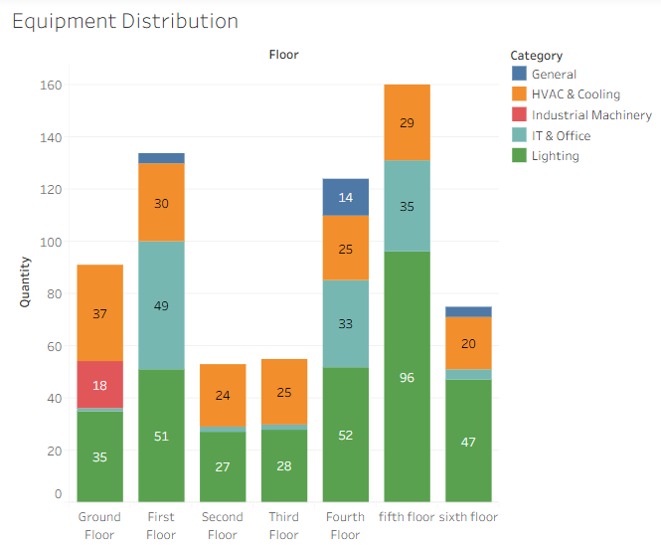
Fig 4.3.1 Equipment distribution

4.3.2 Lighting Audit Analysis
- The lighting audit dashboard shows the distribution of lighting devices across different floors.
- It includes device types such as:
  - CFL
  - LED
- The graph indicates that:
  - some floors have higher lighting usage than others
  - upper floors show variation in lighting quantity
- A significant number of lights are still conventional (CFL) instead of energy-efficient LEDs.
- Lighting contributes to continuous energy consumption since it is used for long durations.
- Energy savings can be achieved by:
  - replacing CFL with LED
  - reducing unnecessary lighting usage
  - using automated lighting control systems
- Replacing conventional lighting with LED systems can significantly reduce energy consumption.
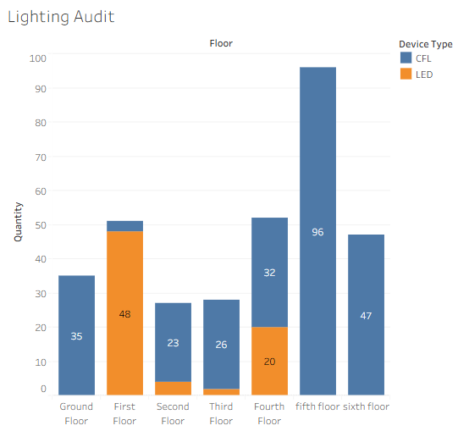
Fig 4.3.2 Lighting Audit

4.3.3 Energy Density Analysis
- The location density dashboard shows the number of equipment present in each room and lab.
- It helps identify high-density areas within the Mechanical Block.
- The graph indicates that locations such as:
  - CAD/CAM Lab
  - Manufacturing Lab
  - Mechanics of Machines Lab
  - Research Lab
- have higher equipment concentration.
- Moderate density is observed in:
  - classrooms
  - seminar hall
  - staff rooms
- Higher density areas consume more energy due to multiple devices operating together.
- These areas may lead to:
  - increased load demand
  - higher electricity consumption
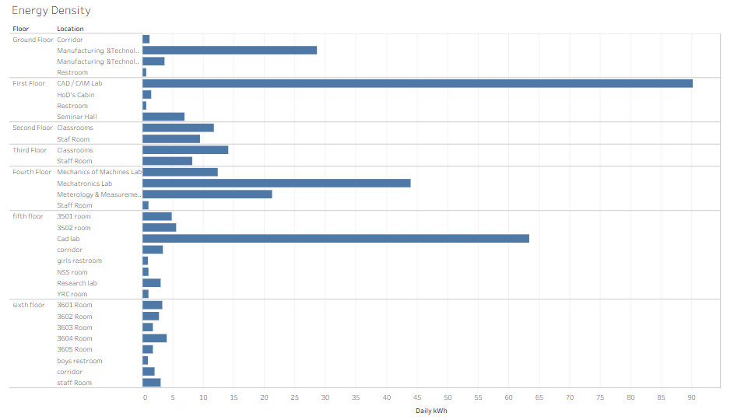
Fig 4.3.3 Energy Density
4.3.4 Load Density Analysis
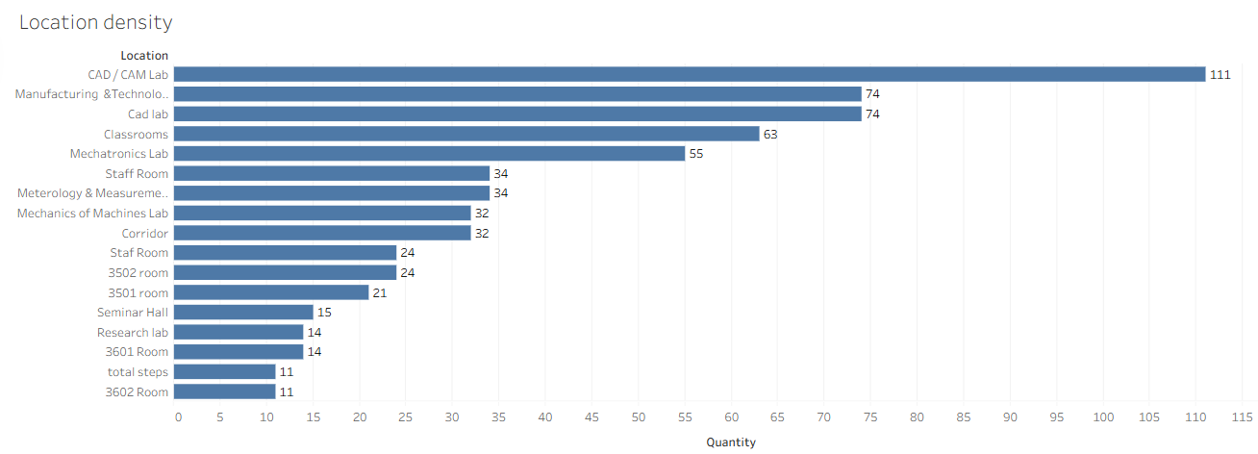
Fig 4.3.4 Load Density Analysis
- The location density dashboard shows the distribution of equipment and energy-related loads across different rooms and locations in the Mechanical Block.
- It helps identify the areas with the highest concentration of equipment.
- The graph shows that places such as:
  - CAD/CAM Lab
  - Manufacturing Technology Lab
  - Classrooms
  - Seminar Hall
  - Research Lab
- contain a higher number of electrical and mechanical components.
- Areas with more equipment naturally consume more electricity because:
  - multiple devices operate together
  - lighting, fans, computers, and lab equipment are used simultaneously
- High-density locations are more likely to produce:
  - higher energy demand
  - peak loads
  - greater operating cost
- These locations should be given special attention for energy management.
- Useful energy-saving improvements in such areas include:
  - occupancy-based lighting control
  - load zoning
  - scheduled laboratory operation
  - better usage planning

Key Insight:
- Locations with high equipment density should be treated as priority zones for energy control and monitoring.
4.3.5 Common Area vs Functional Area Analysis
- This dashboard compares energy usage between common areas and functional areas.
- Common areas include:
  - corridors
  - general spaces
- Functional areas include:
  - labs
  - offices
  - machine rooms
- The graph shows that functional areas consume more energy than common areas.
- This is because functional spaces contain:
  - industrial machinery
  - IT equipment
  - lighting systems
- Common areas mainly consume energy through:
  - lighting
  - minimal HVAC usage
- Categories considered include:
  - HVAC & cooling
  - industrial machinery
  - IT & office
  - lighting

Key Insight:
- Functional spaces are the major energy consumers, so efficiency improvements should focus on these areas.
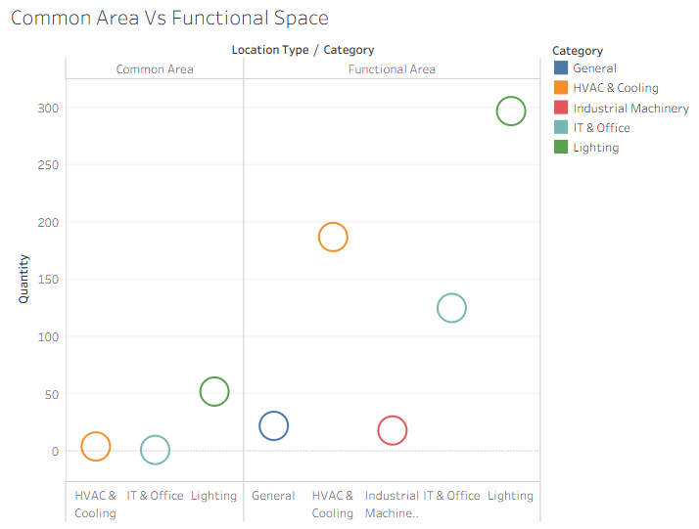
Fig 4.3.5 Common Area Vs Functional Space
4.3.6 Maintenance and Aging Analysis
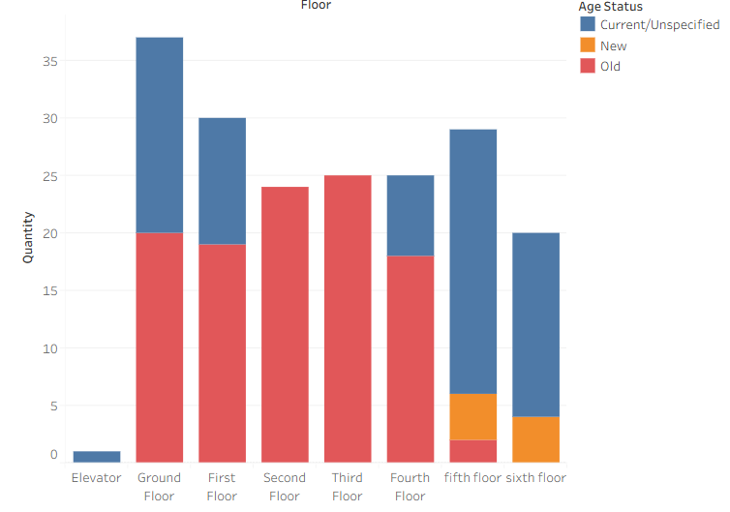
Fig 4.3.6 Maintenance and Aging
- The maintenance and aging dashboard shows the condition and age status of equipment across different floors of the Mechanical Block.
- It helps in identifying whether the equipment is:
  - new
  - old
  - currently in use / unspecified condition
- The graph indicates that some floors contain a higher number of aging equipment, especially in areas where machines and regularly used electrical devices are present.
- Older equipment generally consumes more energy and may operate with lower efficiency.
- Aging machines and electrical devices may also require:
  - frequent servicing
  - higher maintenance cost
  - more power for operation
- Poorly maintained equipment can lead to:
  - unnecessary energy wastage
  - reduced performance
  - increased breakdown risk
- This analysis helps in identifying equipment that should be:
  - serviced regularly
  - repaired
  - replaced with energy-efficient alternatives

Key Insight:
- Proper maintenance and timely replacement of old equipment can improve efficiency, reliability, and energy savings.

Short Conclusion
- The maintenance and aging dashboard is useful for understanding the health and efficiency of equipment.
- It supports better planning for:
  - maintenance scheduling
  - equipment replacement
  - long-term energy management
4.3.7 Saving Potential Analysis
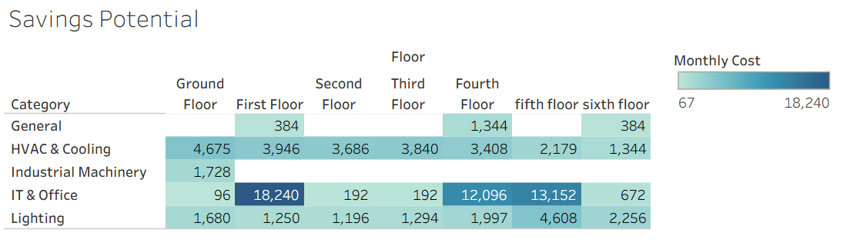
Fig 4.3.7 Saving Potential
- The savings potential dashboard shows the possible reduction in energy consumption across different floors and equipment categories.
- It helps in identifying the areas where maximum energy can be saved.
- The graph indicates that industrial machinery has the highest savings potential.
- The ground floor shows greater savings opportunity because it contains heavy workshop machines and continuously operating equipment.
- Lighting systems also contribute significantly to the savings potential because they are used in large numbers and for long durations.
- HVAC and cooling systems represent another area where electricity can be saved through proper usage and maintenance.
- Energy savings can be improved by:
  - reducing idle machine operation
  - replacing conventional lights with LED lights
  - controlling unnecessary cooling usage
  - monitoring energy use regularly
- This dashboard helps in prioritizing the most effective energy-saving measures.

Key Insight:
- Maximum savings can be achieved by improving the operation of machines, lighting, and cooling systems.

4.4 Observations
Based on the analysis, several key observations can be made regarding energy usage patterns in the Mechanical Block:

1. Dominance of Mechanical Loads
Workshop machines are the largest contributors to energy consumption. Their high power ratings and intensive usage make them the primary energy-consuming components. Even though they are fewer in number compared to other devices, their impact on total energy usage is significantly higher.

2. Significant Contribution of Lighting Systems
Lighting systems are installed in large numbers across all floors. Despite their low individual power consumption, their cumulative effect becomes substantial due to:
- High quantity
- Long operating hours
This makes lighting an important factor in overall energy consumption.

3. Continuous Operation of Fans
Fans and ventilation systems operate continuously during working hours to maintain airflow and comfort. Their consistent usage adds a steady load to the energy consumption profile.

4. High Energy Usage by Air Conditioning Systems
Air conditioning units, although limited in number, consume large amounts of energy when in operation. Their usage significantly increases during hot weather conditions, contributing to peak load demand.

5. Contribution of Computing Equipment

Computers and related devices contribute significantly to energy usage, especially in laboratory environments. Their long operating hours and simultaneous usage increase their overall impact.
4.5 Inefficiencies Identified
The energy audit revealed several inefficiencies that contribute to unnecessary energy wastage within the Mechanical Block.

1. Idle Running of Machines
One of the major inefficiencies observed is the operation of machines even when they are not actively in use. This results in:
- Unnecessary energy consumption
- Increased operational costs
- Reduced equipment lifespan

2. Excessive Lighting Usage
Lights are often kept ON even in areas with sufficient natural daylight or when rooms are unoccupied. This leads to avoidable energy wastage.

3. Lack of Monitoring Systems
The absence of real-time energy monitoring makes it difficult to track consumption patterns and identify inefficiencies. Without proper monitoring, energy management becomes ineffective.

4. Use of Outdated Equipment

Older machines and devices tend to operate at lower efficiency levels, consuming more power compared to modern alternatives. This increases overall energy consumption.

5. Inefficient Operational Practices
Improper scheduling of equipment usage leads to:
- Overlapping operations
- Increased peak load demand
- Inefficient energy utilization

4.6 Performance Evaluation
The performance of the existing energy system can be evaluated based on efficiency and consumption patterns.
The current system demonstrates:
- High dependency on manual control
- Lack of automation
- Inefficient usage practices
However, the analysis also indicates that there is significant potential for improvement. By implementing appropriate energy-saving measures, the Mechanical Block can achieve:
- Reduction in energy consumption by 20–30%
- Improved efficiency of equipment
- Better load management
- Reduced operational costs
This highlights the importance of adopting energy management strategies and improving operational practices.

CHAPTER 5
HOSTEL ENERGY ANALYSIS

5.1 Introduction
In addition to the Mechanical Block, energy consumption in residential facilities such as hostels forms a significant portion of the total institutional energy demand. Hostels operate continuously throughout the day and night, accommodating a large number of occupants and supporting various electrical and utility systems. Unlike academic buildings, hostel energy consumption is influenced by human behavior, lifestyle patterns, and diverse appliance usage.
This chapter presents a detailed energy analysis of the hostel blocks, focusing on load distribution, device-wise energy consumption, and average load patterns across different floors. The study aims to identify high-energy-consuming zones, understand usage trends, and suggest optimization strategies for improving overall efficiency.

5.2 Load Distribution Analysis
The load distribution data provides insight into how electrical load is spread across different blocks and floors of the hostel.
From the collected data , it is observed that:

Block 1 Load Distribution
- Ground Floor: ~3525 W
- First Floor: ~3614 W
- Fifth & Sixth Floors: ~3664 W
- Other floors: ~2114 W

Block 2 Load Distribution
- Terrace: ~3500 W
- Mess: ~2095 W
- Ground (Parlour): ~1775 W
- Other floors: ~1624–1674 W

Key Observations (Expanded)

1. Higher Load in Upper Floors (Block 1)
Upper floors such as the fifth and sixth floors show the highest load values. This may be due to:
- Higher occupancy
- Increased use of appliances (heaters, PCs, etc.)
- Continuous operation of personal devices

2. High Load at Terrace and Ground Areas (Block 2)
The terrace and ground areas show elevated loads due to:
- Installation of equipment (e.g., water systems, telecom towers)
- Common utility usage

3. Mess Area as a Major Load Center
The mess has a high load (~2095 W), primarily due to:
- Cooking equipment
- Refrigeration systems
- Water heating systems

4. Uniform Load in Residential Floors
Most residential floors show moderate and consistent loads, indicating:
- Similar usage patterns across rooms
- Balanced distribution of electrical devices
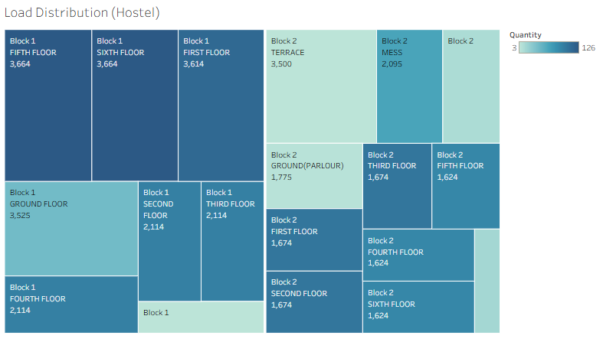
Fig 5.2 Load Distribution

5.3 Device Category Analysis
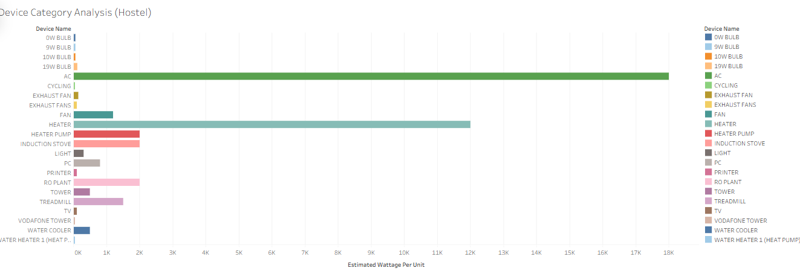
Fig 5.3 Device Category Analysis
The device category analysis helps identify which appliances contribute most to energy consumption.

Major Device Categories Identified

High Power Devices
- Air Conditioners (AC)
- Water Heaters
- Induction Stoves
- Heater Pumps
These devices consume large amounts of energy due to high wattage and frequent usage.

Medium Power Devices
- Fans
- PCs
- TVs
- Printers
These contribute moderate energy consumption but become significant due to prolonged usage.

Low Power Devices
- LED bulbs (9W, 10W, 19W)
- Lighting systems
Although individually low in power, their large quantity increases total consumption.

Special Devices Identified
- RO Plant (water purification)
- Water Coolers
- Treadmills
- Vodafone Tower
These indicate that hostel energy consumption includes both residential and infrastructure loads.

Key Insights (Expanded)
- ACs and heaters dominate peak consumption
- Lighting contributes cumulatively
- Personal devices increase base load
- Infrastructure systems add hidden energy demand

5.4 Load Analysis (Average Load per Unit)
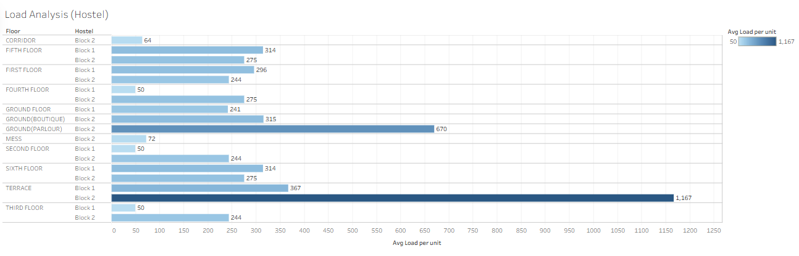
Fig 5.4 Load Analysis
The load analysis provides insights into average load distribution across different areas.

Key Values Observed
- Maximum load: ~1167 units
- Minimum load: ~50 units
- Moderate range: 200–400 units

Interpretation (Expanded)

1. High Load Zones
Areas with values close to 1000+ indicate:
- Concentration of high-power devices
- Continuous operation
Examples:
- Mess
- Equipment-heavy areas

2. Moderate Load Zones
Most residential floors fall in the 200–400 range, indicating:
- Standard usage patterns
- Balanced appliance distribution

3. Low Load Zones
Areas with very low values (~50) indicate:
- Minimal equipment usage
- Intermittent operation

5.5 Inefficiencies Identified in Hostel
- Overuse of ACs and heaters
- Devices left ON continuously
- Lack of centralized monitoring
- Inefficient appliances
- Unregulated personal device usage

5.6 Recommendations for Hostel Energy Optimization

1. Smart Metering
Install floor-wise meters to track usage.

2. Energy-Efficient Appliances
Promote use of low-power devices.

3. Usage Regulations
Limit use of high-power appliances.

4. Awareness Programs
Educate students on energy conservation.

5. Renewable Integration
Install solar panels for hostel supply.
5.7 Comparative Analysis with Mechanical Block
The Mechanical Block is characterized by high-power, equipment-driven energy consumption, where industrial machines create significant peak loads during operation. In contrast, the Hostel exhibits continuous, user-driven energy usage, with distributed loads from personal and utility appliances operating over longer durations.

Table 1: Comparative analysis between Mechanical block and Hostel
PARAMETERS | MECHANICAL BLOCK | GIRLS HOSTEL
Load Type | Industrial + Academic | Residential
Peak Load Source | Machines | ACs, Heaters
Usage Pattern | Scheduled | Continuous
Load Distribution | Uneven | More uniform
Energy Behavior | Equipment-driven | User-driven

Key Insight
- Mechanical Block → Power-intensive (machines)
- Hostel → Time-intensive (continuous usage)

CHAPTER 6
CONCLUSION

6.1 Summary
The comprehensive energy audit conducted for both the Mechanical Block and the Hostel facilities provides a detailed understanding of energy consumption patterns across academic and residential infrastructures within the institution. By combining the analysis of these two distinct environments, the study offers a holistic view of how energy is utilized, distributed, and managed in different operational contexts.
The Mechanical Block represents a controlled and function-specific environment where energy consumption is primarily driven by industrial machinery, laboratory equipment, and academic infrastructure. In contrast, the Hostel environment reflects a user-driven consumption pattern influenced by individual behavior, lifestyle habits, and continuous usage of personal and shared electrical devices.
The audit process involved systematic data collection, classification of loads, and analysis of equipment usage across multiple floors in both facilities. In the Mechanical Block, emphasis was placed on identifying high-power machinery and understanding scheduled usage patterns. In the Hostel, the focus was on evaluating load distribution, device categories, and average consumption trends across residential areas.
The combined findings reveal that energy consumption in the institution is influenced by two major factors:
- Power-intensive loads (machines and HVAC systems)
- Time-intensive usage (continuous operation of residential appliances)
This dual nature of energy demand highlights the importance of adopting a diversified energy management strategy that addresses both equipment efficiency and user behavior.

6.2 Key Findings (Combined Analysis)
The integrated analysis of the Mechanical Block and Hostel facilities led to several important findings:

1. Dominance of High-Power Equipment in Mechanical Block
Workshop machinery such as lathe machines, drilling machines, milling machines, and air compressors are the primary contributors to energy consumption in the Mechanical Block. These devices operate at high power ratings and generate significant peak loads during practical sessions.

2. Continuous and Distributed Load in Hostel Facilities
Unlike the Mechanical Block, the Hostel exhibits a more distributed energy consumption pattern. The load is spread across multiple floors and is influenced by:
- Personal devices (fans, PCs, heaters)
- Shared utilities (water heaters, RO plants, mess equipment)
The continuous nature of usage results in sustained energy demand throughout the day.

3. Significant Contribution of HVAC and Heating Systems
Air conditioning units in the Mechanical Block and heating appliances in the Hostel contribute heavily to overall energy consumption. These systems are highly energy-intensive and significantly affect peak load conditions.

4. Cumulative Impact of Low-Power Devices
Lighting systems, fans, and small appliances, though individually consuming less power, contribute substantially due to:
- Large quantities
- Long operating hours
This trend is observed in both the Mechanical Block and Hostel.

5. Variation in Load Distribution
- Mechanical Block: Highly uneven load distribution, with the ground floor being the most energy-intensive
- Hostel: More uniform load distribution, with slight variations depending on occupancy and utility usage

6. Influence of Human Behavior on Energy Consumption
The Hostel analysis clearly indicates that user behavior plays a critical role in energy consumption. Practices such as leaving devices ON, excessive use of heaters, and lack of awareness contribute to higher energy usage.

7. Presence of Common Inefficiencies
Both facilities exhibit similar inefficiencies, including:
- Idle operation of equipment
- Excessive lighting usage
- Lack of real-time monitoring systems
- Use of outdated or inefficient devices

6.3 Integrated Recommendations
Based on the combined analysis of both facilities, the following recommendations are proposed to improve overall energy efficiency:

1. Implementation of Smart Energy Monitoring Systems
Installing centralized monitoring systems across both the Mechanical Block and Hostel can provide:
- Real-time energy tracking
- Identification of high-consumption zones
- Data-driven decision-making

2. Optimization of Equipment Usage
In the Mechanical Block:
- Avoid idle running of machines
- Schedule operations efficiently
In the Hostel:
- Encourage responsible use of personal devices
- Reduce unnecessary appliance usage

3. Adoption of Energy-Efficient Technologies
- Replace CFLs with LED lighting
- Upgrade old machines and appliances
- Use energy-efficient motors and HVAC systems

4. Automation and Control Systems
- Install occupancy sensors for lighting
- Use timers for equipment operation
- Implement automatic shutdown systems

5. Regulation of High-Power Appliances in Hostels
- Limit usage of heaters and induction stoves
- Introduce guidelines for appliance usage
- Monitor excessive consumption

6. Awareness and Behavioral Change Programs
Conduct awareness campaigns to educate users about:
- Energy conservation practices
- Impact of energy wastage
- Efficient usage habits
Behavioral changes can significantly reduce energy consumption without additional cost.

7. Integration of Renewable Energy Sources
- Install solar panels for both academic and residential buildings
- Utilize renewable energy for common facilities such as lighting and water heating

8. Power Factor Correction and System Optimization
Improving power factor can:
- Reduce energy losses
- Enhance system efficiency
- Lower electricity costs

6.4 Future Scope (Integrated and Expanded)
The study opens several opportunities for future advancements in energy management:

1. Smart Campus Energy Management System
Development of a centralized smart system to monitor and control energy usage across the entire campus.

2. IoT-Based Automation
Integration of IoT devices for real-time control and optimization of energy consumption.

3. Expansion of Energy Audit
Conduct similar audits for:
- Other academic blocks
- Administrative buildings
- Additional residential facilities

5. Large-Scale Renewable Integration
Implementation of solar and other renewable systems to reduce dependency on conventional power sources.

Main Block,block-3

ABSTRACT
This report presents a comprehensive energy audit of the Main Block and Electronics Block III (EB Block III) of Easwari Engineering College, covering six floors (Ground to Fifth) of the Main Block and two floors (Third and Fourth) of EB Block III. The audit systematically documents 2,338 electrical devices across 466 device-location entries in eight device categories including fans, lights, air conditioners, computers, and laboratory equipment. The total estimated monthly energy consumption of the audited buildings is 65,710 kWh (approximately 2,527 kWh/day). The audit identifies legacy induction fan technology, incomplete LED lighting upgrades, unmanaged computer idle loads, and air conditioning inefficiencies as the four primary sources of avoidable energy wastage, totalling approximately 12,461 kWh/month - 19% of the total campus load. The report further presents the Smart Energy Auditor, a full-stack AI and machine learning application developed to automate and scale the audit findings. The application employs a Gradient Boosting Regressor model (>98% accuracy) for hardware-level consumption prediction and integrates Google
Gemini 1.5 Pro for utility bill diagnostics, with privacy-safe local OCR via Tesseract.js. Full implementation of all structured recommendations is projected to reduce monthly consumption by 18,534 kWh (28.2%) and deliver annual savings of Rs. 13,56,856 at a total capital investment of Rs. 32,24,920, with an overall payback period of approximate
CHAPTER 1

INTRODUCTION
This energy audit was conducted to systematically document all electrical assets installed across the Main Block and Electronics Block III (EB Block III) of the campus. The audit covers six floors (Ground to Fifth) of the Main Block and two floors (Third and Fourth) of EB Block III, encompassing classrooms, computer laboratories, staff rooms, seminar halls, and specialized electrical machines laboratories.

The audit dataset comprises 466 device-location entries covering 2,338 individual electrical devices across 8 device categories. The findings presented in this report form the observational and statistical foundation for the energy optimization recommendations detailed in subsequent chapters.

1.1 SCOPE OF THE AUDIT

Table 1: Audit Scope Summary

Parameter | Details
Buildings Audited | Main Block, Electronics Block III (EB Block III)
Floors – Main Block | Ground (0), First (1), Second (2), Third (3), Fourth (4), Fifth (5)
Floors – EB Block III | Third (3), Fourth (4)
Total Device Entries | 466
Total Devices Counted | 2,338
Device Categories | Fan, Light, Other, Split AC, Motor, Window AC,  Generator, AC
Spaces Covered | Classrooms, Labs, Staff Rooms, Seminar Halls, Corridors,  BWRs

1.2 METHODOLOGY

The audit was conducted by physical room-by-room inspection of each floor. For every space visited, the following data was recorded:

- Device Category (Fan / Light / AC / Motor / Generator / Other)
- Device Type (e.g., Induction Fan, Long Fluorescent Tube, 2-Ton Split AC, Computer)
- Quantity of each device type within the space
- Location identifiers: Block, Floor, Wing, and Room Number

All data was entered into a structured digital dataset and cross-validated against floor maps. Wattage ratings were assigned to each device type using Bureau of Energy Efficiency (BEE) standard specifications and manufacturer datasheet references. Monthly consumption was computed assuming 26 working days per month.

CHAPTER 2

ENERGY AUDIT ANALYSIS

2.1 DEVICE INVENTORY ANALYSIS

2.1.1 Distribution of Device Categories
Figure 1 shows the proportional distribution of all 2,338 devices by category.
Lights dominate at 42% (982 units), followed by fans at 29% (678 units), and 'Other' devices — primarily computers — at 25% (578 units).

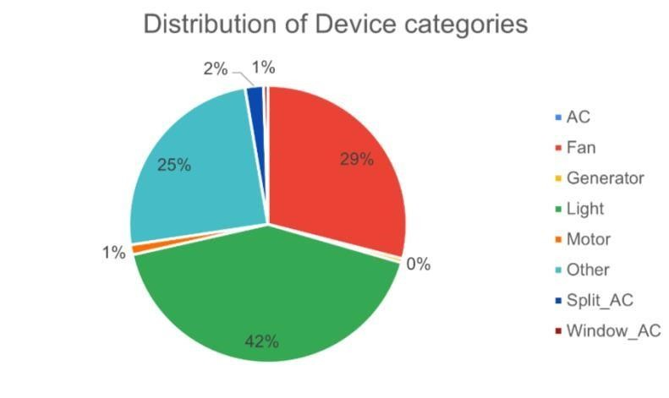
Figure 1: Proportional Distribution of Device Categories Across the Campus

2.1.2 Total Device Count by Category

The bar chart above presents the absolute device count per category, confirming that lighting and fans represent the largest hardware populations and therefore the highest operational footprints.
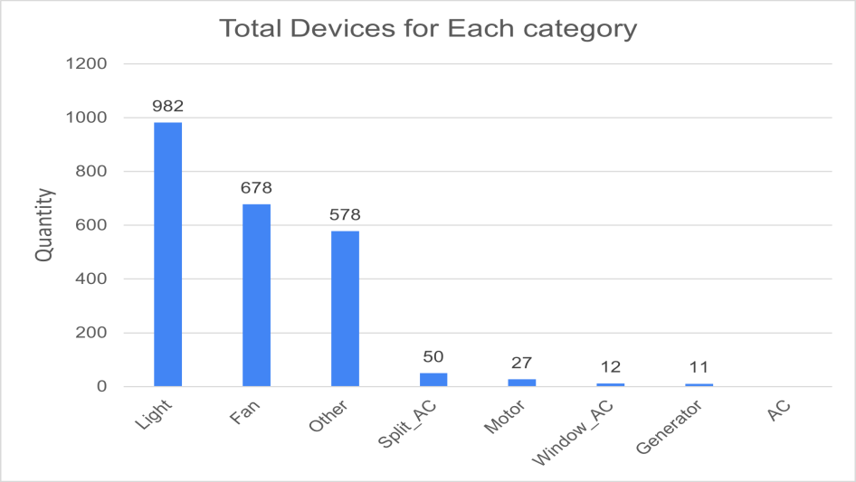

Figure 2: Total Device Count per Category

2.1.3 Top 5 Most Deployed Device Types
Induction Fans (570 units) are the single most deployed device type, followed by Computers (506 units). The presence of 311 Long Fluorescent Tubes alongside 243 Long LED Tubes indicates a partial and incomplete lighting upgrade, leaving a significant legacy load still in service
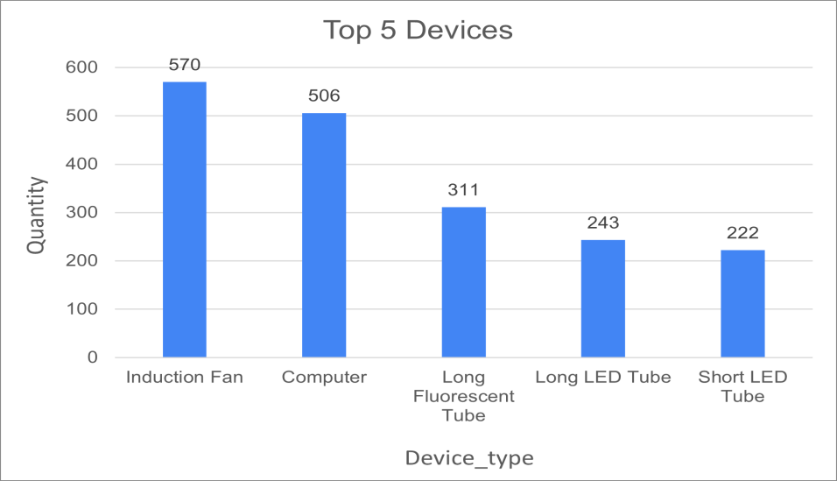
Figure 3: Top 5 Most Deployed Device Types by Quantity

2.1.4 Device Distribution by Floor
Main Block Floor 3 (460 devices) and Floor 2 (438 devices) carry the highest device populations, consistent with the concentration of computer laboratories and large classrooms on these floors. EB Block III floors carry significantly fewer devices (145 and 169 respectively), reflecting their specialized laboratory function.
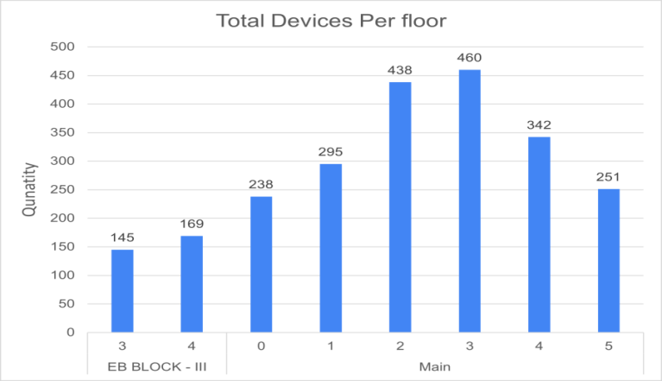
Figure 4: Total Devices per Floor across Both Blocks

Table 2: Device Distribution by Floor

Block | Floor | Device Count | % of Total
Main Block | Floor 3 | 460 | 19.7%
Main Block | Floor 2 | 438 | 18.7%
Main Block | Floor 1 | 295 | 12.6%
Main Block | Floor 4 | 342 | 14.6%
Main Block | Floor 0 | 238 | 10.2%
Main Block | Floor 5 | 251 | 10.7%
EB Block III | Floor 4 | 169 | 7.2%
EB Block III | Floor 3 | 145 | 6.2%
TOTAL | --- | 2,338 | 100%

2.2 ENERGY CONSUMPTION ANALYSIS

2.2.1 Estimated Monthly Energy Consumption
Based on device wattage ratings (per BEE standards), quantities recorded during the physical audit, and assumed working hours per device category, the total estimated monthly electrical energy consumption of the audited buildings is as follows:
❖ Total Estimated Monthly Consumption: 65,710kWh

❖ Total Estimated Daily Consumption: 2,527 kWh
The following assumptions were applied uniformly:
- Lights: 10 hours of operation per working day
- Fans: 8 hours of operation per working day
- Computers and other equipment: 8 hours per working day
- Air conditioners: 6 hours per working day
- Laboratory motors and generators: 4 hours per working day
- Working days per month: 26

2.2.2 Consumption Breakdown by Device Category
The results reveal the true energy burden of each device category. Despite Lights being the largest device population (42% of units), it is the 'Other' category dominated by computers that consumes the most energy.
Table 3: Energy Consumption by Device Category

Device Category | Units | Monthly kWh | Share (%) | Avg. W/Unit
Other (Computers etc.) | 578 | 28,261 | 43.0% | ~250 W
Split AC | 50 | 15,818 | 24.1% | ~1,300 - 2,200 W
Fan | 678 | 10,008 | 15.2% | ~35 - 75 W
Light | 982 | 5,547 | 8.4% | ~10 - 36 W
Motor | 27 | 2,730 | 4.2% | ~750 - 1,500 W
Window AC | 12 | 2,683 | 4.1% | ~1,100 W
Generator | 11 | 663 | 1.0% | ~750 W
TOTAL | 2,338 | 65,710 | 100% | ---

2.2.3 Consumption Breakdown by Floor (Energy Intensity Map)
Floor-level energy intensity reveals that Main Block Floor 3 alone accounts for 30.6% of total campus consumption the single highest-load zone driven by the concentration of computer laboratories on that floor.
Table 4: Consumption Breakdown by Floor

Block | Floor | Monthly kWh | Share (%) | Primary Load Driver
Main Block | Floor 3 | 20,084 | 30.6% | Computer Labs (IT / CSE)
Main Block | Floor 2 | 13,391 | 20.4% | Computer Labs + ACs
Main Block | Floor 1 | 10,042 | 15.3% | Classrooms + Fans
Main Block | Floor 4 | 7,938 | 12.1% | Labs + Staff Rooms + ACs
Main Block | Floor 0 | 6,108 | 9.3% | Ground Floor Offices + Labs
Main Block | Floor 5 | 3,562 | 5.4% | Seminar Hall + ACs + Cabins
EB Block III | Floor 4 | 3,059 | 4.7% | Electrical Machines Lab
EB Block III | Floor 3 | 1,526 | 2.3% | Electronics Lab
TOTAL | --- | 65,710 | 100% | ---

2.3 ENERGY WASTAGE IDENTIFICATION
This section identifies the specific areas, devices, and operational practices that are causing measurable energy wastage.

2.3.1 Wastage Type 1 - Legacy Lighting Technology
A total of 451 legacy lighting units remain in operation across the campus, representing an ongoing and avoidable drain compared to available LED alternatives.
Table 5: Legacy Lighting Wastage Analysis
Legacy Device | Units | Unit  Wattage  (W) | Monthly kWh | LED  Equivalent | LED  Wattage  (W) | Wasted kWh/month
LFT | 311 | 36 W | 2,911 | Long LED  Tube | 20 W | 1,294
SFT | 121 | 18 W | 566 | Short LED  Tube | 10 W | 252
CFL Bulb | 19 | 15 W | 74 | LED Bulb  (9W) | 9 W | 30
TOTAL | 451 | --- | 3,551 | --- | --- | 1,576  kWh/month

Key Finding: 451 legacy lighting units are consuming 3,551 kWh/month. Their LED equivalents would consume only 1,975 kWh/month a direct wastage of 1,576 kWh every month purely due to outdated lamp technology.

2.3.2 Wastage Type 2 - Induction Fan Technology
Induction fans account for 570 of the 678 total fans - 84% of all fans. At 75 W per unit, these consume 8,892 kWh/month. Modern BLDC (Brushless DC) fans of equivalent air delivery consume only 35 W - less than half the energy. Pedestal fans (85 units at 55 W) also have efficient BLDC replacements available at 35 W.
Table 6: Fan Technology Wastage Analysis
Fan Type | Units | Current  Wattage | Monthly kWh | Efficient  Alternative | Alt.  Wattage | Monthly  Wastage (kWh)
Induction  Ceiling Fan | 570 | 75 W | 8,892 | BLDC  Ceiling Fan | 35 W | 4,742
Pedestal Fan | 85 | 55 W | 972 | BLDC  Pedestal Fan | 35 W | 354
TOTAL | 655 | --- | 9,864 | --- | --- | 5,096  kWh/month

Key Finding: Induction and standard pedestal fans are wasting 5,096 kWh every month relative to available BLDC technology - the single largest hardwarerelated wastage source.

2.3.3 Wastage Type 3 – Computer Laboratory Load Management
506 desktop computers are installed across the campus, primarily on Main Block Floors 2 and 3. At 250 W each, they contribute 26,312 kWh/month - 40% of the entire campus load. The following practices have been identified as contributing to wastage:
- Computers left powered on outside scheduled laboratory hours (no enforced shutdown policy observed)
- No power management profiles (sleep/hibernate after idle timeout) configured on lab systems
- Legacy CRT monitors still in use in some rooms (200 - 400 W vs. 20 - 30
W for LED flat panels)
- No central energy management system or smart PDUs installed in lab
server racks
Even a conservative 1-hour daily reduction in idle runtime across 506 computers would save approximately 506 × 0.25 kW × 1 hr × 26 days = 3,289 kWh per month at zero capital expenditure.

2.3.4 Wastage Type 4 – Air Conditioning Inefficiency
62 air conditioning units are installed (50 Split ACs + 12 Window ACs), consuming a combined 18,501 kWh/month (28.2% of total load). The following inefficiencies were observed:
- Window ACs (12 units): older-technology units typically rated at 2–3 BEE stars. Replacement with 5-star inverter Split ACs would reduce AC load by 30–40% for those zones.
- No occupancy sensing on AC-equipped rooms - ACs are manually operated and frequently left running in unoccupied spaces (staff rooms, seminar hall).
- Setpoint temperatures not standardized - BEE mandates 24°C as the minimum setpoint for commercial buildings. Each 1°C reduction below 24°C increases energy consumption by approximately 6%.
- The 2-ton units in the Seminar Hall (Floor 5) are operating without any demand control - running at full load irrespective of occupancy.

2.3.5 Wastage Type 5 - Behavioral and Operational
The following operational practices were noted across multiple floors that contribute to unmetered, avoidable wastage:
- Lights found on in unoccupied classrooms and corridors during non-
- Exhaust fans (23 units) in labs and BWRs operating continuously without timers or occupancy switches.
- Projectors (7 units) left on standby between sessions - standby draw of 10– 15 W each, accumulated over 8 hours ≈ 840 Wh/day.
- Ethernet switches (28 units) running 24×7 - PoE-capable managed switches can reduce load during nights and weekends with port scheduling.

2.4 CONSOLIDATED WASTAGE SUMMARY
Table 7: Consolidated Wastage Summary

Wastage Category | Devices  Affected | Monthly  Wastage  (kWh) | Annual  Wastage  (kWh) | Financial  Loss/Year
Legacy Lighting (FL  + CFL) | 451 units | 1,576 | 18,912 | Rs. 1,32,384
Induction & Pedestal Fans | 655 units | 5,096 | 61,152 | Rs. 4,28,064
Computer Idle Runtime | 506 units | 3,289 (est.) | 39,468 | Rs. 2,76,276
AC Inefficiency & Oversizing | 62 units | ~2,000 (est.) | ~24,000 | Rs. ~1,68,000
Behavioral /  Operational | All floors | ~500 (est.) | ~6,000 | Rs. ~42,000
TOTAL | --- | ~12,461 kWh | ~1,49,532 kWh | Rs.  ~10,46,724/year

Note: Figures for categories 3, 4, and 5 are conservative estimates based on standard operational assumptions. The Rs. 7/unit tariff rate applicable to educational institutions in Tamil Nadu (TANGEDCO HT tariff schedule) has been used throughout.

CHAPTER 3

ENERGY OPTIMIZATION PLAN

3.1 ENERGY OPTIMIZATION RECOMMENDATIONS
The following recommendations are structured into three implementation tiers based on capital investment required and payback period. All priority levels follow Bureau of Energy Efficiency (BEE) energy audit guidelines for educational institutions.

3.1.1 Priority 1 – Zero / Low CapEx (Immediate Implementation)
These measures require no capital expenditure and can be implemented immediately through policy and behavioral change.
- Enforce Computer Shutdown Protocol
Implement and enforce a mandatory shutdown policy for all 506 computers at the end of each laboratory session. Configure BIOS-level and OS-level power management profiles (hibernate after 10 minutes of idle, shutdown at end of session) across all lab systems. Estimated saving: 3,289 kWh/month | Rs. 2,76,276/year at zero CapEx.
- Standardize AC Setpoint to 24°C
Mandate 24°C as the minimum thermostat setpoint for all 62 AC units, in compliance with BEE and Ministry of Power guidelines. Place visible signage at all AC controls. Current estimated operation below 22°C on multiple units wastes approximately 12% additional cooling energy.
Estimated saving: 800 - 1,200 kWh/month.

- Lights-Off and Fan-Off Protocol
Institute a floor-monitor system where the last person leaving each classroom is responsible for switching off all lights and fans. Post visual reminders at each exit. This alone can eliminate an estimated 30 - 40 minutes of unnecessary run-time per room per day across 466 audited spaces.
- Projector and Equipment Standby Elimination
All 7 projectors, 28 Ethernet switches, and UPS units should be placed on managed power strips or smart plugs programmed to cut power after scheduled hours. Combined standby saving estimated at 200 - 400 kWh/month.

3.1.2 Priority 2 – Medium CapEx (Within 6 Months)
These measures require capital investment with a payback period under 24 months.
- Replace All Legacy Fluorescent Tubes and CFLs with LED
Replace all 311 Long Fluorescent Tubes (36 W → 20 W LED), 121 Short Fluorescent Tubes (18 W → 10 W LED), and 19 CFL bulbs (15 W → 9 W LED). LED lamps have a rated life of 25,000+ hours versus 8,000 hours for fluorescent, significantly reducing maintenance costs as well.
Table 8: LED Lighting Upgrade CapEx & Payback

Item | Qty | Unit Cost  (Rs.) | Total CapEx  (Rs.) | Monthly  Saving (kWh) | Payback  (months)
LLT (20W) | 311 | 250 | 77,750 | 1,294 | ~9
SLT (10W) | 121 | 150 | 18,150 | 252 | ~9
LED Bulb (9W) | 19 | 80 | 1,520 | 30 | ~7
TOTAL  LIGHTING | 451 | --- | Rs. 97,420 | 1,576 kWh | ~9 months

- Replace Window ACs with 5-Star Inverter Split ACs
The 12 Window AC units (average 1.1 kW, 2 - 3 BEE stars) should be replaced with 5-star BEE-rated inverter split ACs. Inverter ACs reduce energy consumption by 30 - 50% compared to fixed-speed units. Based on 6-hour daily operation over 26 working days:
Table 9: Window AC Replacement Analysis
Item | Units | Current kWh/month | Projected kWh/month | Monthly Saving | Est. CapEx  (Rs.)
Window AC → 5-  Star Inverter AC | 12 | 2,683 | 1,610 | 1,073 kWh | Rs. 4,20,000
Payback Period | --- | --- | --- | Rs.  7,511/month | ~56 months

- Install Occupancy Sensors in Classrooms and Corridors
Install PIR (Passive Infrared) occupancy sensors linked to the lighting and fan circuits in all classrooms and corridors. Sensors automatically switch off lights and fans when a room is unoccupied for more than 5 minutes. Estimated cost: Rs. 800 - 1,200 per sensor. With approximately 80 classrooms and corridor segments, total CapEx is approximately Rs.
80,000 - 1,20,000. Estimated saving: 1,500 -2,000 kWh/month. Payback:
8 - 12 months.

3.1.3 Priority 3 - High CapEx (12 - 24 Month Planning)
These are strategic capital investments with payback periods of 24–60 months, appropriate for institutional budget planning.
- Replace All Induction Fans with BLDC Fans
This is the single highest-impact hardware replacement available. Replacing all 570 induction ceiling fans (75 W) with BLDC fans (35 W) saves 4,742 kWh/month. Adding the 85 pedestal fan replacements brings total monthly saving to 5,096 kWh.

Table 10: BLDC Fan Replacement CapEx & Payback
Fan Type | Units | Unit Cost  (Rs.) | Total  CapEx  (Rs.) | Monthly  Saving  (kWh) | Annual  Saving (Rs.) | Payback  (months)
BLDC  Ceiling Fan | 570 | 3,500 | 19,95,000 | 4,742 | Rs. 3,98,328 | ~60
BLDC  Pedestal Fan | 85 | 2,500 | 2,12,500 | 354 | Rs. 29,736 | ~85
TOTAL FANS | 655 | --- | Rs.  22,07,500 | 5,096 kWh | Rs.  4,28,064/year | ~62 months

- Energy Management System (EMS) for Computer Labs
Deploy a centralized Energy Management System with smart PDUs (Power Distribution Units) in all computer laboratory server racks and workstation rows. The EMS enables scheduled power-on/power-off, idle detection, and remote monitoring, enforcing the shutdown protocol automatically without reliance on behavioral compliance. Estimated CapEx: Rs. 3,00,000 - 5,00,000. Projected saving: 4,000 - 5,000 kWh/month. Payback: 36 - 42 months.
- Rooftop Solar PV Integration
Based on the total estimated monthly consumption of 65,710 kWh, a rooftop solar installation of 100 - 150 kWp capacity (feasible on Main Block rooftop) could generate approximately 12,000 - 18,000 kWh/month under Tamil Nadu solar irradiance conditions (~5.5 peak sun hours/day). This would offset 18 - 27% of the campus load. At TANGEDCO grid tariff, this represents Rs. 84,000 - 1,26,000/month in avoided charges, with a typical payback of 4 - 5 years under MNRE subsidy schemes.

3.2 CONSOLIDATED ENERGY SAVINGS PLAN
The table below consolidates all quantified recommendations into a single implementation roadmap for the institution.
Table 11: Consolidated Energy Savings Plan

Recommendation | CapEx  (Rs.) | Monthly  Saving  (kWh) | Annual  Saving (Rs.) | Payback  (months) | Priority
Computer  Shutdown Policy | Nil | 3,289 | 2,76,276 | Immediate | P1
AC Setpoint 24°C | Nil | ~1,000 | ~84,000 | Immediate | P1
Lights & Fan Off Protocol | Nil | ~500 | ~42,000 | Immediate | P1
LED Lighting Upgrade | 97,420 | 1,576 | 1,32,384 | ~9 | P2
Window AC  Replacement | 4,20,000 | 1,073 | 90,132 | ~56 | P2
Occupancy Sensors | 1,00,000 | ~1,500 | ~1,26,000 | ~10 | P2
BLDC Fan  Replacement | 22,07,500 | 5,096 | 4,28,064 | ~62 | P3
EMS for Computer Labs | 4,00,000 | ~4,500 | ~3,78,000 | ~13 | P3
TOTAL (excl.  Solar) | Rs.  32,24,920 | ~18,534 kWh | ~Rs.  13,56,856 | --- | ---

CHAPTER 4

CONCLUSION - ENERGY AUDIT
This energy audit of the Main Block and Electronics Block III has established a detailed baseline of 65,710 kWh/month across 2,338 electrical devices. The audit identifies three primary sources of wastage: legacy fan technology (induction fans contributing 13.5% of total load with a 47% saving potential), legacy lighting (fluorescent tubes contributing 4.4% of load with a 44% saving potential), and unmanaged computer idle loads (40% of total load with a 12.5% behavioral saving achievable at zero cost).

The most impactful and immediately actionable finding is that approximately 12,461 kWh/month - 19% of the total load is avoidable wastage. Of this, 4,789 kWh/month can be eliminated at zero capital cost through behavioral and operational changes alone. The full implementation roadmap, prioritized across three tiers, can reduce consumption by 28.2% and generate annual savings of Rs. 13,56,856, with an overall investment payback period of approximately 4.1 years.

It is recommended that the institution adopt this audit report as the foundation for a formal Energy Conservation Plan, with quarterly progress reviews tracked against the baseline figures established here. A follow-up audit should be conducted within 12 months of implementing Priority 1 and Priority 2 measures to verify savings realization and identify further optimization opportunities.

CHAPTER 5

SMART ENRGY AUDITOR SYSTEM

5.1 PROJECT OVERVIEW: SMART ENERGY AUDITOR
The Smart Energy Auditor is a comprehensive, full-stack application designed to analyze, predict, and optimize electrical energy consumption across large-scale infrastructure such as university campuses or corporate office blocks. It acts as a virtual electrical engineer, merging statistical machine learning for theoretical hardware analysis with generative AI for real-world utility bill validation, all delivered through a secure, privacy-first web dashboard.

5.2 TECH STACK
Table 12: Technology Stack

Layer | Technology | Purpose
Frontend | Next.js, React | Dynamic dashboard with server-side rendering
UI Animations | Framer Motion, CSS Modules | Smooth transitions and premium UI styling
ML Engine | Python, scikit-learn | GradientBoostingRegressor, >98% accuracy
Data Processing | pandas | Dataset ingestion, cleaning, feature engineering
Visualization | seaborn, matplotlib | Charts, heatmaps, model performance plots
Generative AI | Google Gemini 1.5 Pro | AI-driven financial diagnostics and energy insights
OCR Engine | Tesseract.js | Local, privacy-safe text extraction from utility bills

5.3 CORE FUNCTIONAL MODULES

5.3.1 Module A: Data-Driven Asset Auditing
Users upload bulk .csv asset inventory files. A fine-tuned
GradientBoostingRegressor model processes the data to predict per-device energy consumption with greaer than 98% accuracy. The dashboard then visualizes Energy Intensity across floor, wing, and room levels, and autogenerates an Optimization Roadmap with CapEx, monthly savings, and ROI payback period for each identified inefficiency.
Table 13: ML Model Attributes
Model Attribute | Value
Algorithm | GradientBoostingRegressor (scikit-learn)
Prediction Accuracy | > 98%
Input Features | Device category, type, quantity, rating, floor, wing
Output | Predicted per-device energy consumption (kWh/month)

5.3.2 Module B: Privacy-First Energy Bill Analysis
Users upload utility bill images or PDFs. Tesseract.js performs text extraction locally in memory with zero external data transmission. An automated PII redaction filter scrubs Account Numbers, Service IDs, Client Names, Addresses, and GST Numbers before the anonymised footprint is submitted to Google Gemini 1.5 Pro. Gemini extracts Total Consumption (kWh), Peak Charges, Sanctioned vs. Recorded Demand (KVA), and Net Payable, and provides an interpretive financial health diagnostic.
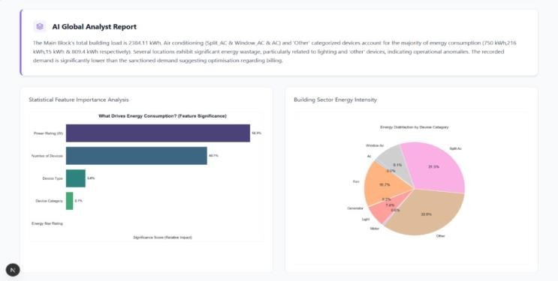
Figure 5 : Smart Energy Auditor

5.4 KEY FEATURES
Table 14: Key Features of Smart Energy Auditor

Feature | Description
>98% ML Accuracy | GradientBoostingRegressor trained on real campus audit data
Spatial Energy Map | Floor, wing, and room-level consumption intensity visualization
CapEx / ROI Calculator | Automatic payback period computation for hardware upgrades
PII Scrubbing | Auto-redacts personal identifiers before AI processing
Gemini AI Diagnostics | Structured extraction and financial health summary of bills
CSV Bulk Upload | Handles entire building asset inventories in one upload

5.5 CONCLUSION - SMART ENERGY AUDITOR
The Smart Energy Auditor extends the findings of this audit into an intelligent, automated platform. By combining the GradientBoostingRegressor ML model with the Gemini AI diagnostics layer, the system transforms a one-time physical audit into a continuously updatable, data-driven energy management tool — capable of ingesting new inventory data and regenerating optimization roadmaps as the campus infrastructure evolves.

AUDIT DECLARATION
This energy audit report has been prepared based on physical inspection of the premises, structured device inventory data collected during the audit period, and energy calculations performed in accordance with Bureau of Energy Efficiency (BEE) guidelines for Type 2 Energy Audits of educational buildings.

Table 15: Audit Declaration Summary

Field | Details
Audited By | Department of Electrical and Electronics Engineering,  Easwari Engineering College
Audit Period | Academic Year 2025 - 2026
Buildings Covered | Main Block (Floors 0 - 5), EB Block III (Floors 3 - 4)
Devices Audited | 2,338 units across 466 entries
Baseline Consumption | 65,710 kWh/month (estimated)
Tariff Reference | TANGEDCO HT Tariff – Educational Institution
Standard Reference | BEE Guidelines for Energy Audits in Educational Institutions

ABSTRACT
This project presents a comprehensive energy audit and efficiency improvement study conducted in the Academic Block and Boys Hostel of an engineering college campus, focusing on analyzing electrical energy consumption patterns, load distribution, and opportunities for optimization. The audit was carried out through systematic physical inspection, equipment identification, device counting, and classification of electrical loads into categories such as lighting systems, cooling and ventilation, air conditioning, surveillance, networking, and auxiliary equipment. The study distinguishes between continuous loads, which contribute to base load (such as CCTV cameras and networking devices operating 24/7), and intermittent loads, which vary with occupancy and operational schedules (such as lighting, fans, and air conditioners). Detailed analysis reveals that lighting systems dominate in terms of quantity, while air conditioning systems significantly influence peak load demand due to their high power consumption. In the Academic Block, peak demand occurs during daytime working hours, whereas in the Boys Hostel, peak load is observed during evening and nighttime due to residential usage patterns. Although energy-efficient technologies like LED lighting and BLDC fans are already implemented, the overall consumption remains high due to the large number of devices and extended operating hours. The study identifies key inefficiencies such as lack of automation, unnecessary usage, and absence of real-time monitoring systems. To address these issues, a lux sensor-based adaptive lighting system is proposed, which dynamically adjusts artificial lighting based on natural daylight availability, thereby reducing energy wastage and improving efficiency. Additionally, the project highlights the importance of smart control systems, user awareness, and future integration of renewable energy sources and advanced monitoring technologies.

Academic Block and Boys Hostel

CHAPTER 1 INTRODUCTION

  - BACKGROUND AND SIGNIFICANCE
The present study focuses on conducting an energy audit of the Academic Block and Boys Hostel to analyze electrical energy consumption patterns and connected load distribution within the campus. The audit was carried out through systematic inspection, equipment counting, and classification of electrical devices based on their operational characteristics. Each section was surveyed carefully to ensure accuracy in data collection.

NEED FOR ENERGY AUDIT
Continuous loads also play a significant role. CCTV cameras, routers, switches, and server systems operate 24/7, forming a constant base load independent of occupancy. These systems are essential for security, connectivity, and data management but contribute significantly to total energy consumption.
The audit highlights the difference between base load and peak load. The base load is created by continuously operating devices such as CCTV cameras and networking equipment, while peak load occurs during daytime in the Academic Block and evening hours in the hostel.

OVERVIEW OF ENERGY CONSUMPTION
In the Academic Block, lighting systems form a major portion of the total load. LED panels and fixtures are widely installed across classrooms, laboratories, corridors, and staircases. Although LEDs are energy-efficient, their large number

leads to considerable cumulative energy consumption. Lighting in corridors and staircases operates for long durations, contributing to continuous usage.
Fan systems mainly consist of BLDC fans, which are more energy-efficient than conventional induction fans. However, a few induction fans are still in use, increasing overall consumption. Laboratories and staff rooms contain multiple fans for ventilation, adding to the load.
Air conditioning systems are major contributors to peak load demand. Installed in laboratories and specialized rooms, they consume high power during operation. Even though fewer in number, their high energy usage makes them dominant during peak conditions.
In the Boys Hostel, energy consumption is influenced by residential usage. Each room includes lighting, fans, and often air conditioning units. While individual room consumption is moderate, the large number of rooms results in high total demand. Corridor lighting operates continuously for safety, and common facilities such as study areas and TV rooms further add to consumption. Continuous operation of CCTV systems, routers, and frequent use of exhaust fans also contribute to the load.

PROPOSED SYSTEM: ADAPTIVE LIGHTING SYSTEM

Although energy-efficient technologies like LED lighting and BLDC fans are already implemented, there is still scope for improvement. A lux-based adaptive lighting system is proposed to automatically adjust lighting levels based on natural daylight availability, reducing unnecessary energy consumption while maintaining proper illumination.

OBJECTIVE OF THE STUDY

The main objective of this study is to analyze energy consumption patterns in the Academic Block and Boys Hostel and identify areas where energy efficiency can be improved. The study also aims to evaluate connected loads, distinguish between base and peak loads, and propose an adaptive lighting system to reduce unnecessary energy usage.

SCOPE AND SIGNIFICANCE

The scope of this study includes detailed analysis of electrical energy consumption in lighting systems, fans, air conditioning units, and continuous loads such as CCTV and networking equipment. The significance of the study lies in its potential to improve energy efficiency, reduce electricity costs, and promote sustainable energy management practices within the institution.

CHAPTER 2 LITERATURE SURVEY
  - OVERVIEW OF ENERGY AUDIT AND ITS IMPORTANCE
Energy audit is a systematic approach used to analyze energy consumption, identify inefficiencies, and suggest improvement measures. It plays a vital role in reducing energy wastage and improving overall system performance in buildings and industries.
Energy consumption in academic institutions and residential buildings has increased significantly due to growing infrastructure and usage of electrical devices. Studies indicate that improper usage, lack of monitoring, and absence of control systems contribute to high energy losses.
The Bureau of Energy Efficiency (BEE) highlights that energy audits help in understanding energy consumption patterns, identifying major energy-consuming equipment, and recommending cost-effective energy-saving measures.

CONVENTIONAL ENERGY AUDIT METHODS
Traditional energy audit methods involve manual inspection and data collection based on equipment ratings and operating hours. These methods include physical inspection of electrical installations, device counting, and load estimation.
While these methods are simple and cost-effective, they have limitations such as lack of real-time monitoring, dependence on estimated values, and inability to capture dynamic variations in load. Despite these limitations, conventional audits provide a strong foundation for basic energy analysis.

ELECTRICAL LOAD CLASSIFICATION AND ANALYSIS
Electrical loads are generally classified into two categories: continuous loads (base load) and intermittent loads (variable load). Continuous loads include CCTV cameras, routers, and servers that operate 24/7, while intermittent loads such as lighting, fans, and air conditioners depend on occupancy and usage patterns.
Research shows that lighting systems dominate in quantity, air conditioning systems dominate peak load, and continuous loads contribute to base load. This classification helps in understanding energy demand and planning optimization strategies.

ENERGY CONSUMPTION IN ACADEMIC AND RESIDENTIAL BUILDINGS
Studies on educational institutions indicate that lighting systems account for a major portion of total electrical load due to their large number and long operating hours.
In hostels, energy consumption is influenced by user behavior, climatic conditions, and occupancy patterns. Research highlights that peak load in academic buildings occurs during daytime, while in hostels it occurs during evening and night hours.

ENERGY EFFICIENCY TECHNOLOGIES
Modern technologies such as LED lighting and BLDC fans have significantly improved energy efficiency. LEDs reduce power consumption and provide better illumination, while BLDC fans consume less energy compared to conventional fans.
However, studies indicate that total energy consumption remains high due to the large number of devices and extended operating hours.

SMART ENERGY MANAGEMENT SYSTEMS

Recent research focuses on smart energy management systems using sensors and automation technologies. These systems enable real-time monitoring of energy usage, automated control of electrical devices, and reduction of human error.
Technologies include IoT-based monitoring systems, occupancy sensors, and automated lighting and HVAC control. These systems improve efficiency but may involve higher implementation costs.

ADAPTIVE LIGHTING SYSTEMS
Adaptive lighting systems based on lux sensors have been widely studied as an effective energy-saving solution. These systems measure natural daylight intensity and adjust artificial lighting accordingly.
Benefits include reduction in unnecessary lighting usage, improved energy efficiency, and enhanced visual comfort. Research shows that adaptive lighting can significantly reduce energy consumption without affecting illumination quality.

RESEARCH GAP AND MOTIVATION
From the literature, the following gaps are identified: need for practical and low-cost energy audit methods, lack of automation in existing systems, and limited implementation of adaptive lighting in institutions.
Most existing solutions are either complex and expensive or not suitable for realtime applications. This creates a need for an efficient and implementable system

SUMMARY
The literature review indicates that energy auditing is essential for efficient energy management. While modern technologies provide better efficiency, practical implementation is still limited. Adaptive lighting and smart control systems offer promising solutions for energy optimization. This study focuses on developing a practical approach to improve energy efficiency in academic and residential buildings.

CHAPTER 3

ENERGY AUDIT AND EFFICIENCY IMPROVEMENT

OBJECTIVES AND SCOPE:
The primary objective of this study is to conduct a systematic and structured energy audit of the Academic Block and Boys Hostel to understand electrical load distribution and energy consumption behavior. The audit helps in
identifying how energy is utilized across academic and residential environments and provides a clear picture of consumption patterns .
The study focuses on both quantitative and qualitative analysis of electrical systems to ensure accurate evaluation and meaningful insights.

MAIN OBJECTIVES OF THE STUDY
The key objectives of this energy audit are:
    - To identify all electrical equipment installed in different areas such as classrooms, laboratories, corridors, hostel rooms, and common spaces
    - To calculate and estimate the connected load of each category of equipment
    - To analyze energy consumption patterns in both academic and residential buildings
    - To understand the variation in energy usage based on time and occupancy
    - To identify major contributors to energy consumption and peak demand
In addition, the study aims to provide a structured understanding of how energy is distributed across different functional zones.

LOAD IDENTIFICATION AND AREA-WISE ANALYSIS

A detailed survey was conducted across all sections of the Academic Block and Boys Hostel. Each area was examined individually to ensure accurate data
collection.

Areas Covered:
    - Classrooms
    - Laboratories and research rooms
    - Staff cabins and offices
    - Corridors and staircases
    - Hostel rooms
    - Common areas (TV rooms, study areas)
    - Restrooms and utility spaces This detailed approach helps in:
    - Identifying high-load density areas
    - Differentiating between low and high consumption zones
    - Ensuring precise equipment counting and classification

CLASSIFICATION OF ELECTRICAL LOADS

Table 2.1 Various Equipment for Energy Audit

Category | Equipment | Type of Load | Operation
Lighting Systems | LED panels, tube lights | Variable | Intermittent
Cooling Systems | Fans (BLDC, Induction) | Variable | Intermittent
Air Conditioning | Split AC units | High Load | Intermittent
Surveillance Systems | CCTV Cameras | Continuous | 24/7

Category | Equipment | Type of Load | Operation
Networking Systems | Routers, Switches | Continuous | 24/7
Auxiliary Equipment | TVs, Exhaust Fans | Variable | Intermittent

To simplify analysis, all electrical equipment is grouped into categories based on their function and operation:

Lighting Systems
      - LED panels and fixtures
      - Corridor and staircase lighting

Cooling and Ventilation Systems
      - Fans (BLDC and induction)
      - Air conditioning systems
      - Exhaust fans

Surveillance and Security Systems
      - CCTV cameras

Networking Infrastructure
      - Routers
      - Switches
      - Servers

Auxiliary Equipment
      - TVs and other common facility devices This classification helps in understanding:
    - Which category contributes most to total consumption
    - Which systems dominate peak load

    - Which devices form the base load

CONTINUOUS AND INTERMITTENT LOADS
One of the important aspects of this study is distinguishing between continuous and intermittent loads.

Continuous Loads (Base Load):
    - CCTV cameras
    - Routers and networking devices
    - Server systems
These operate 24/7 and create a constant demand on the electrical system.

Intermittent Loads:
    - Classroom lighting
    - Laboratory equipment
    - Air conditioners
    - Fans
These loads vary depending on:
    - Occupancy
    - Time of day
    - Operational schedules
This classification is essential for understanding the overall demand pattern.

PEAK LOAD ANALYSIS
The study also focuses on identifying peak load conditions.

Academic Block Peak Load:
Occurs during daytime when classrooms, labs, and offices are fully operational

Boys Hostel Peak Load:
Occurs during evening hours when residents use lighting, fans, and air conditioners simultaneously

Major Contributors to Peak Load:
    - Air conditioning systems
    - High-density lighting usage
    - Simultaneous operation of multiple devices Understanding peak load helps in planning:
    - Load management strategies
    - Demand control techniques
    - Efficient system operation

ENERGY EFFICIENCY AND OPTIMIZATION APPROACH
Instead of focusing only on replacing equipment, the study emphasizes improving operational efficiency.

Key Focus Areas:
    - Reducing unnecessary energy usage
    - Improving control systems
    - Enhancing user awareness

Proposed Solution:
A lux sensor-based adaptive lighting system is suggested.

Working Principle:
    - Detects natural daylight intensity
    - Adjusts artificial lighting accordingly
    - Reduces brightness or switches off lights when daylight is sufficient
    - Increases lighting when natural light decreases

Advantages:
    - Energy savings
    - Improved efficiency
    - Maintains proper illumination
    - Provides manual control flexibility

SCOPE OF THE STUDY
The scope of this project is limited to the physical assessment of electrical infrastructure.

Included in Scope:
    - Academic Block (all floors and rooms)
    - Boys Hostel (rooms and common areas)
    - Permanently installed electrical equipment

Excluded from Scope:
    - Personal appliances used by students
    - Detailed electricity billing and tariff analysis
    - Financial cost-benefit calculations
    - Real-time measurements and power quality analysis The study relies on:
    - Equipment ratings
    - Standard operating assumptions
    - Observational data

LIMITATIONS OF THE STUDY
    - No real-time current or voltage monitoring
    - No direct measurement of power quality

    - Renewable energy systems (like solar) are not implemented
    - Results are based on estimated consumption rather than live data
However, the data collected provides a strong foundation for future improvements.

FUTURE SCOPE
The findings of this study can be used for:
    - Implementation of smart energy monitoring systems
    - Integration of renewable energy sources
    - Development of automated control systems
    - Advanced energy management solutions

CHAPTER 4
ENERGY AUDIT METHODOLOGY
The methodology adopted for this energy audit is designed to ensure a systematic, accurate, and comprehensive assessment of electrical energy consumption across the Academic Block and Boys Hostel. The approach combines physical inspection, device identification, load categorization, and structured data analysis to obtain a clear understanding of energy usage patterns.
The audit process began with a detailed physical survey of all areas within the buildings. Each floor was inspected individually to ensure that no equipment was overlooked. The survey included classrooms, laboratories, staff rooms, corridors, staircases, hostel rooms, and common areas. This step was essential to achieve accuracy and reliability in data collection.

PHYSICAL INSPECTION AND DATA COLLECTION
The first stage of the methodology involved direct on-site inspection of electrical installations.

Key Activities:
    - Visiting each floor and section systematically
    - Identifying all installed electrical devices
    - Recording the type and quantity of equipment
    - Verifying operational status of devices
This step ensured that real-time conditions were observed rather than relying on assumptions or secondary data.

DEVICE COUNTING AND DOCUMENTATION
After identification, all electrical devices were counted and documented carefully. Each category of equipment was recorded separately to avoid confusion and duplication.

Devices Considered:
    - Lighting fixtures (LED panels, bulbs, tube lights)
    - Fans (BLDC and induction types)
    - Air conditioning units
    - CCTV cameras
    - Networking devices (routers, switches)
    - Exhaust fans and other auxiliary equipment
    - Accurate counting plays a crucial role in estimating connected load and understanding the scale of energy consumption.

LOAD CATEGORIZATION
To simplify analysis, the collected data was grouped into logical categories based on function and usage.

Categories of Load:
    - Lighting Systems – Classroom lights, corridor lights, stairway lighting
    - Cooling and Ventilation Systems – Fans, air conditioners, exhaust fans
    - Security Systems – CCTV cameras
    - Networking Systems – Routers, switches, servers
    - Other Equipment – TVs and miscellaneous devices
This classification helps in identifying dominant energy-consuming systems and simplifies further analysis.

FLOOR-WISE AND AREA-WISE SURVEY
Each floor was surveyed individually to maintain accuracy and avoid data overlap.

Areas Covered:
    - Academic Block:
      - Classrooms
      - Laboratories
      - Staff rooms
      - Corridors and staircases
    - Boys Hostel:
      - Individual rooms
      - Corridors
      - Common facilities
      - Restrooms

Advantages of this Approach:
    - Ensures detailed and organized data collection
    - Helps identify high-load zones
    - Improves accuracy in load estimation

TABULAR DATA ORGANIZATION
All collected data was arranged in tabular form for easy analysis and interpretation.

Typical Table Parameters:
    - Type of equipment
    - Quantity
    - Power rating

    - Location
    - Total connected load Tabular representation allows:
    - Quick comparison between different areas
    - Identification of major load contributors
    - Clear visualization of energy distribution

LOAD ANALYSIS AND IDENTIFICATION OF MAJOR CONSUMERS
After organizing the data, analysis was carried out to determine:
    - High energy-consuming devices
    - Areas with maximum load concentration
    - Contribution of each category to total load

Key Observations:
    - Lighting systems dominate in number
    - Air conditioners contribute heavily to peak load
    - Continuous devices contribute to base load
This analysis helps in understanding where optimization is required.

STUDY OF OPERATING HOURS AND USAGE PATTERNS
In addition to load calculation, the operational behavior of devices was also studied.

Factors Considered:
    - Duration of operation
    - Time of peak usage
    - Dependency on occupancy
    - Continuous vs intermittent operation

Examples:
    - CCTV cameras → Operate continuously (24/7)
    - Classroom lights → Operate during working hours
    - Hostel loads → Peak during evening
Understanding these patterns is essential for improving energy efficiency.

IDENTIFICATION OF LOAD TYPES
The methodology also distinguishes between different types of loads:

Base Load:
    - Continuous operation devices
    - Includes CCTV, routers, servers

Variable (Intermittent) Load:
    - Depends on usage and schedule
    - Includes lights, fans, air conditioners
This classification helps in analyzing demand variation and planning control strategies.

EVALUATION OF ENERGY EFFICIENCY OPPORTUNITIES
Based on collected data and observations, potential areas for improvement were identified.

Focus Areas:
    - Reduction of unnecessary lighting usage
    - Efficient operation of air conditioning systems
    - Better control of continuous loads

Suggested Approach:
    - Implementation of smart control systems
    - Use of automation for lighting

METHODOLOGY ADVANTAGES
The adopted methodology offers several benefits:
    - Simple and practical for academic studies
    - Does not require complex instruments
    - Provides reliable estimation of connected load
    - Helps in identifying inefficiencies clearly
    - Suitable as a base for future advanced analysis

LIMITATIONS OF METHODOLOGY
Despite its effectiveness, the methodology has certain limitations:
    - No real-time power measurement
    - Based on equipment ratings and assumptions
    - Does not include power quality analysis
    - Limited to connected load estimation
However, it still provides a strong foundation for understanding energy consumption.

CHAPTER 5
ANALYSIS OF ACADEMIC BLOCK

The Academic Block serves as the central hub for instructional, administrative, and research activities within the campus. It consists of classrooms, laboratories, faculty cabins, staff rooms, seminar halls, research centers, corridors, and stairways. Due to the variety of functions carried out in this building, the electrical load profile is diverse and dynamic. The energy audit conducted in this block focuses on understanding the distribution of connected loads, operational patterns, and the contribution of each category to total energy consumption.
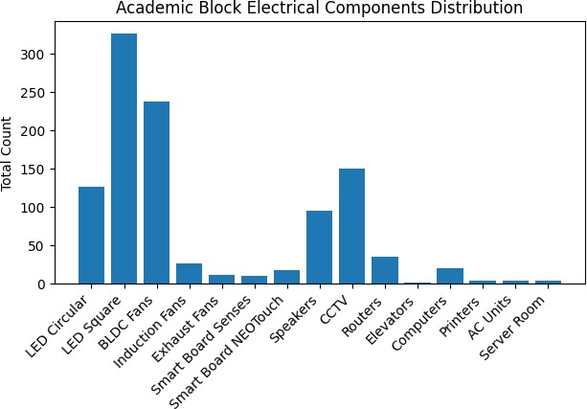
Figure 4.1

Table 4.1 Academic Block Equipment

Load Category | Contribution | Remarks
Lighting Systems | High (in number) | Continuous usage in corridors
Fans | Moderate | Efficient (BLDC dominant)
Air Conditioners | Very High (peak load) | Limited but high power
CCTV & Networking | Base Load | Operates 24/7

OVERVIEW OF ELECTRICAL LOAD DISTRIBUTION
The Academic Block contains multiple categories of electrical loads that operate under different conditions. These loads vary depending on occupancy, time of day, and the type of academic or administrative activity taking place in each area. As a result, the energy consumption pattern is not constant but fluctuates throughout the day.
The major load categories present in the building include lighting systems, cooling and ventilation systems, air conditioning units, surveillance systems, networking infrastructure, and laboratory equipment. These systems operate either independently or simultaneously, creating a combined effect on the total electrical demand.
    - Multiple systems operate together during peak hours
    - Load varies based on occupancy and schedule
    - Different areas have different load intensity

The interaction of these loads makes the system complex, and understanding their distribution is essential for identifying high-consumption zones and planning energy-saving strategies.

LIGHTING SYSTEM ANALYSIS
Lighting systems form one of the most important components of the Academic Block’s electrical infrastructure. Proper illumination is essential for maintaining a productive learning and working environment. The building is equipped mainly with LED panel lights and circular LED fixtures, which are installed across classrooms, laboratories, corridors, and common areas.
The use of LED technology indicates an effort toward energy efficiency, as these lights consume less power and provide better illumination compared to conventional lighting systems. However, the large number of lighting fixtures installed throughout the building leads to a significant cumulative load.
    - LED lighting ensures better efficiency and illumination
    - High number of fixtures increases total load
    - Continuous usage in corridors adds to consumption
In classrooms, multiple lights are used to ensure uniform brightness, while corridors and staircases are continuously illuminated for safety purposes. In many cases, lighting remains ON even when sufficient natural daylight is available, indicating a lack of control mechanisms and potential energy wastage.
    - Manual switching leads to unnecessary usage
    - No daylight-based control system present
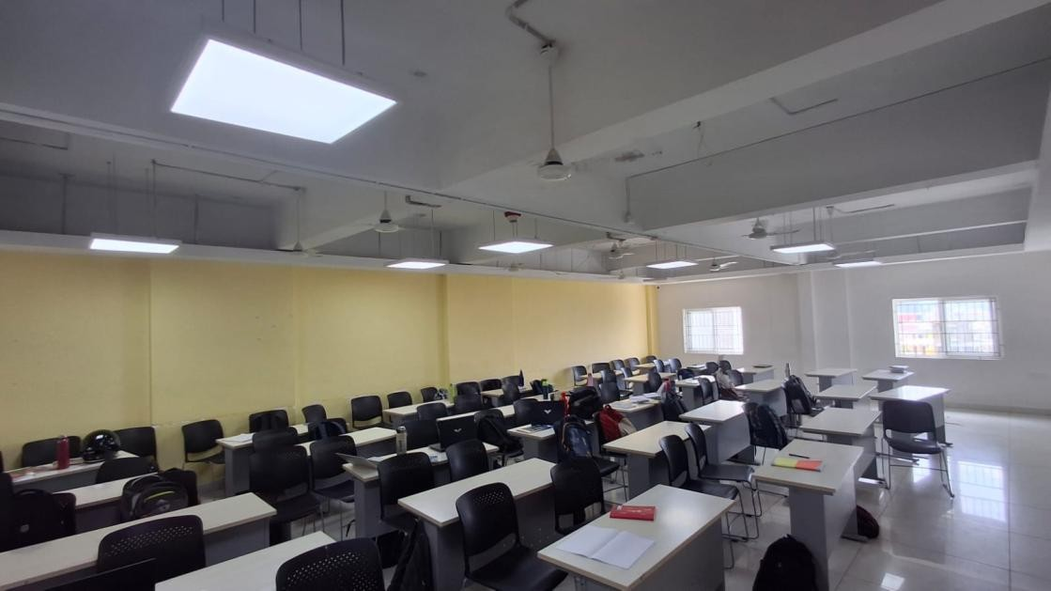
Figure 4.2 Academic Block Classroom

COOLING AND VENTILATION SYSTEM ANALYSIS
Cooling and ventilation in the Academic Block are primarily achieved through ceiling fans. These fans are installed in almost every room, including classrooms, laboratories, and staff areas, to maintain thermal comfort during working hours.

A majority of the installed fans are BLDC type, which are known for their high efficiency and low power consumption. This reflects a positive shift toward energy-saving technologies within the institution. However, a few conventional induction fans are still present, which consume relatively higher power.
    - BLDC fans reduce power consumption significantly
    - Induction fans still contribute to higher load
    - Fans operate continuously during working hours
Despite the efficiency of BLDC fans, the total number of fans used across the building is quite large. In areas such as laboratories and crowded classrooms, multiple fans operate simultaneously, leading to increased overall energy consumption.
    - High quantity leads to cumulative load
    - Ventilation demand increases with occupancy

AIR CONDITIONING SYSTEM ANALYSIS

Air conditioning systems are installed in specialized areas such as laboratories, research facilities, and selected faculty rooms where controlled environmental conditions are required. These systems are essential for maintaining equipment performance and ensuring comfort in specific spaces.
Although the number of air conditioning units is limited compared to lighting and fans, their power consumption is significantly higher. As a result, they contribute heavily to peak load conditions, especially during hot weather.
    - High power rating of AC units
    - Major contributor to peak load
    - Increased usage during summer
The simultaneous operation of multiple air conditioning units can lead to a sharp increase in electrical demand. In some cases, the usage of these systems may not be optimized, resulting in unnecessary energy consumption.
      - Lack of temperature optimization
      - Possibility of overcooling

CONTINUOUS LOAD ANALYSIS
One of the key observations from the audit is the presence of continuous loads that operate throughout the day and night. These loads are independent of occupancy and contribute to a constant energy demand.
Continuous systems mainly include CCTV cameras, networking devices such as routers and switches, and server equipment. These systems are essential for security, communication, and data management within the campus.
    - Operate 24/7 without interruption
    - Essential for safety and connectivity
    - Independent of user activity
Even though each device consumes a moderate amount of power, their continuous operation results in a steady base load. This load remains active even during nonworking hours, contributing significantly to overall energy consumption.
    - Forms the minimum energy demand
    - Adds to total daily consumption
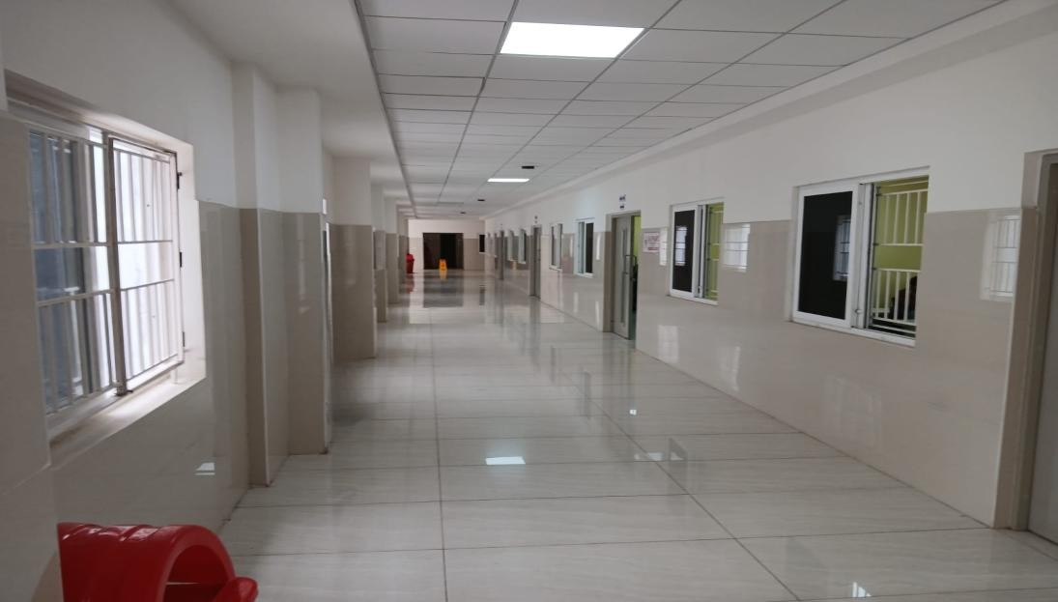
Figure 4.3 Academic Block Corridor

BASE LOAD AND VARIABLE LOAD
The electrical load in the Academic Block can be broadly classified into base load and variable load. This classification helps in understanding how energy consumption changes under different conditions.
Base load consists of continuously operating devices such as surveillance and networking systems. These loads remain constant and form the minimum level of energy consumption in the building.
    - Constant throughout the day
    - Independent of occupancy
Variable load, on the other hand, depends on occupancy and usage. It includes lighting, fans, air conditioners, and laboratory equipment. These loads fluctuate throughout the day, increasing during working hours and decreasing during nonworking periods.
    - Changes with activity level
    - Major contributor during peak hours

OPERATIONAL PATTERNS
The energy consumption pattern in the Academic Block is strongly influenced by operational schedules. During daytime, when classes and laboratory sessions are in full operation, energy usage reaches its peak.
At this time, lighting systems, fans, laboratory equipment, and air conditioners are used simultaneously, resulting in high demand. The level of consumption is directly proportional to the number of active rooms and occupants.
    - Peak load during working hours
    - High simultaneous usage of devices
During non-working hours, most of the variable loads are turned off, leaving
only the base load active. This creates a clear distinction between peak and non-peak energy usage periods.
    - Reduced demand at night
    - Only essential systems remain active

LABORATORY LOAD CONTRIBUTION
Laboratories are among the major contributors to energy consumption due to the presence of specialized equipment and electronic devices. These areas require more power compared to standard classrooms.
Equipment such as computers, experimental setups, and measuring instruments increases the overall load. In addition, the heat generated by these devices increases the need for ventilation or cooling.
    - High equipment density
    - Increased cooling requirement
    - Variable load based on experiments

The energy consumption in laboratories varies depending on the type of experiments conducted and the duration of usage. This variability makes laboratories an important focus area for energy optimization.

ISSUES IDENTIFIED IN ENERGY USAGE
The audit has identified several inefficiencies in the current energy usage pattern. These issues mainly arise due to lack of automation and improper usage practices.
Lighting systems are often used unnecessarily due to manual control, and there is no mechanism to adjust lighting based on natural daylight. Similarly, cooling systems may operate even when not required.
    - No automated control systems
    - Energy wastage due to manual operation
There is also no centralized system for monitoring and controlling energy usage, which makes it difficult to identify and reduce wastage effectively.
    - Lack of monitoring and tracking
    - Inefficient usage patterns

ENERGY EFFICIENCY STATUS
The Academic Block demonstrates a positive approach toward energy efficiency through the use of LED lighting and BLDC fans. These technologies help reduce individual device consumption.
However, the total energy consumption remains high due to the large number of devices and their long operating hours. Continuous loads further contribute to this demand.
    - Efficient devices already implemented
    - High total load due to quantity
This indicates that while efficient equipment is being used, additional improvements in operation and control are necessary to achieve better energy savings.

OPPORTUNITIES FOR IMPROVEMENT
There are several opportunities to improve energy efficiency in the Academic Block. These improvements focus on better control and management of existing systems rather than complete replacement.
Lighting systems can be optimized by introducing automatic controls that adjust brightness based on natural light availability. Cooling systems can be improved through better usage practices and temperature settings.
    - Use of automation for lighting
    - Optimization of AC usage
    - Improved scheduling practices
In addition, creating awareness among users and implementing proper scheduling can significantly reduce unnecessary energy consumption.

ROLE OF SMART CONTROL SYSTEMS
Smart control systems play a crucial role in improving energy efficiency. These systems help in automating operations and reducing dependency on manual control.
For example, a lux sensor-based lighting system can automatically adjust lighting levels based on daylight conditions. Similarly, automated controls can regulate the operation of fans and air conditioners.
    - Automation reduces human error
    - Improves energy efficiency
    - Enhances system reliability
The implementation of such systems can lead to significant energy savings while maintaining comfort and functionality.

OVERALL LOAD CHARACTERISTICS
The Academic Block is characterized by a combination of high-density lighting systems, efficient but numerous fans, selective use of air conditioning, and continuous operation of security and networking systems.
These factors together create a complex energy profile with both base load and peak load conditions. The interaction between these loads determines the overall energy consumption pattern.
    - High base load due to continuous systems
    - High peak load during working hours
    - Complex and dynamic load behavior

Understanding these characteristics is essential for developing effective energy management strategies and improving sustainability within the campus.

CHAPTER 6 ANALYSIS OF BOYS HOSTEL
The Boys Hostel is a residential facility designed to accommodate 140 rooms along with circulation areas, restrooms, staircases, corridors, and common utility spaces. Unlike the Academic Block, which operates primarily during institutional working hours, the hostel remains functionally active throughout the day and night. As a result, its energy consumption profile is continuous and strongly influenced by occupant behavior, climatic conditions, and daily routines of residents .
Each hostel room is equipped with essential electrical fixtures, typically including LED lighting, a BLDC ceiling fan, and an air conditioning unit. While the connected load of an individual room may appear moderate, the cumulative impact across 140 rooms results in a significantly high total connected load. This repetitive distribution of identical electrical equipment creates a uniform but heavy load pattern.
    - Large number of rooms increases total load
    - Same equipment repeated in every room
    - Load increases significantly during full occupancy
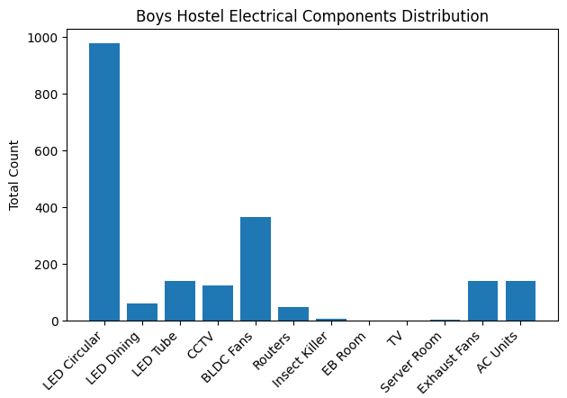
Figure 5.1
Table 5.1 Boys Hostel Equipment

Load Category | Contribution | Remarks
Room Lighting | High (due to quantity) | Long usage hours
Fans | Moderate | Continuous usage
Air Conditioners | Very High | Major peak load contributor
Common Area Loads | Moderate | Depends on occupancy
CCTV & Networking | Base Load | Continuous operation

LIGHTING SYSTEM ANALYSIS
Lighting systems in the hostel consist mainly of circular LED fixtures and LED tube lights installed in rooms, corridors, and common spaces. Each room is provided with at least one lighting unit, which leads to a very high number of fixtures across the building.
Corridor lighting operates for extended hours to ensure safety and visibility, especially during nighttime. Although LED lights are energy-efficient, their continuous usage and high quantity result in considerable total energy consumption.
    - Lighting operates for long durations
    - Corridor lights remain ON continuously
    - High number of fixtures increases total load
In addition, lights are often left ON even when rooms are not occupied, which contributes to unnecessary energy wastage. This highlights the need for better control and monitoring systems.

COOLING AND VENTILATION SYSTEM ANALYSIS
Ventilation in hostel rooms is primarily provided by BLDC ceiling fans. These fans are preferred due to their lower power consumption and higher efficiency compared to conventional fans.
The adoption of BLDC fans is a positive step toward energy conservation. However, due to hot climatic conditions, fans are often used continuously for long periods, especially during daytime and night.
    - BLDC fans reduce power consumption
    - Continuous operation increases total usage
    - High number of fans adds to load
Even though each fan consumes less power, the simultaneous operation across all rooms contributes significantly to overall energy demand.

AIR CONDITIONING SYSTEM ANALYSIS
Air conditioning systems are the most energy-intensive components in the hostel. Each room is typically equipped with an air conditioner of around 1.5 to 2-ton capacity to maintain indoor comfort.
Although the number of air conditioners corresponds to the number of rooms, their individual power consumption is very high. This makes them the dominant contributors to peak load conditions.
    - High power rating of AC units
    - Major contributor to peak load
    - Increased usage during summer
During evening and nighttime hours, when most residents use air conditioners simultaneously, the energy demand increases sharply. This creates a heavy load on the electrical system.

CONTINUOUS LOAD ANALYSIS
The hostel also contains several continuous electrical systems that operate throughout the day and night. These include CCTV cameras and networking infrastructure such as routers and switches.
These systems are essential for security and communication and cannot be switched off. As a result, they create a constant base load that contributes to overall energy consumption.
    - Operate 24/7 without interruption
    - Independent of occupancy
    - Form base load of the hostel
Although individual devices consume less power, their continuous operation leads to significant cumulative energy usage over time.
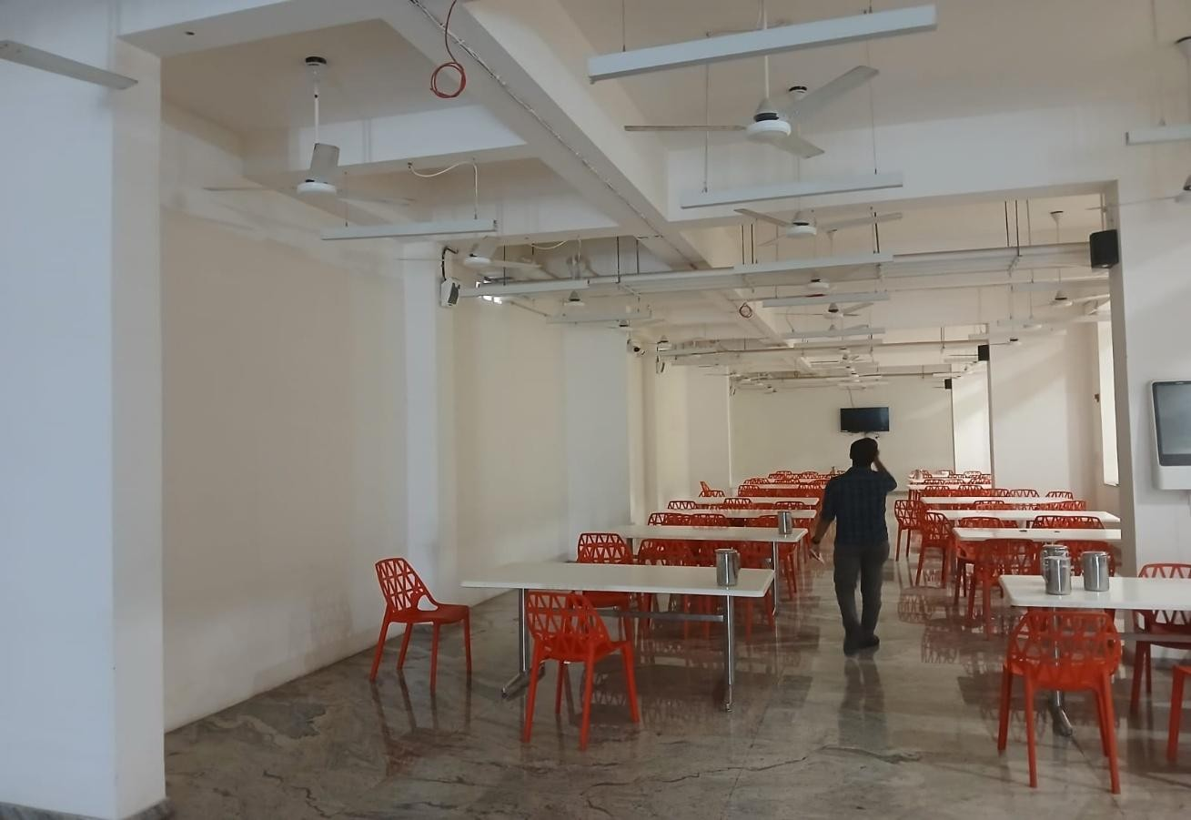
Figure 5.2 Boys Hostel Dining Area

COMMON AREA LOAD CONTRIBUTION
In addition to room-level loads, common areas also contribute to total energy consumption. These include study halls, television rooms, corridors, and utility spaces.
Lighting in these areas operates for long durations depending on usage. Restrooms are equipped with exhaust fans that operate frequently, especially during peak hours.
    - Common area lighting adds to load
    - Exhaust fans operate frequently
    - Usage depends on occupancy
Though these loads are moderate individually, their combined effect across the building increases total energy consumption.

BEHAVIORAL IMPACT ON ENERGY USAGE
One of the most important aspects of hostel energy consumption is the influence of user behavior. Unlike academic buildings, hostel usage is not fixed and depends on individual habits.
Residents may leave lights and fans ON even when not present. Air conditioners may be operated at lower temperatures than required, increasing energy consumption unnecessarily.
    - Energy usage depends on user habits
    - Unnecessary usage leads to wastage
    - Lack of awareness affects efficiency
Charging devices such as laptops and mobile phones also contribute to continuous energy usage, adding to the overall load.

BASE LOAD AND PEAK LOAD

The hostel load profile can be divided into base load and peak load components. This classification helps in understanding energy demand variations.
Base load consists of continuously operating systems such as CCTV cameras, networking equipment, and minimum lighting. These loads remain constant throughout the day.
    - Base load is always present
    - Independent of occupancy
Peak load occurs during evening and nighttime hours when residents simultaneously use lighting, fans, and air conditioners.
    - Peak demand during evening
    - Simultaneous usage increases load

ENERGY EFFICIENCY STATUS
The Boys Hostel shows some positive aspects in terms of energy efficiency. The use of LED lighting and BLDC fans helps reduce individual device consumption.
However, the overall energy demand remains high due to the large number of rooms and the presence of high-power air conditioning systems.
    - Efficient devices are implemented
    - Total load still remains high
This indicates that while energy-efficient technologies are used, further improvements are required in control and management.

OPPORTUNITIES FOR IMPROVEMENT
The analysis reveals several opportunities to improve energy efficiency in the hostel. These improvements focus on reducing wastage and optimizing system usage.
Lighting systems can be improved by introducing automatic controls such as motion sensors. Cooling systems can be optimized by maintaining proper temperature settings.
    - Use of motion sensors for lighting
    - Optimization of AC temperature settings
    - Awareness programs for residents
Encouraging responsible usage among residents can also significantly reduce unnecessary energy consumption.

OVERALL LOAD CHARACTERISTICS
The Boys Hostel is characterized by a high number of identical loads distributed across multiple rooms. This results in a uniform but heavy energy consumption pattern.
Cooling systems dominate peak load, while lighting contributes significantly in terms of quantity. Continuous systems such as CCTV and networking equipment create a steady base load.
    - High cumulative load due to 140 rooms
    - Cooling dominates peak demand
    - Continuous systems create base load

Understanding these characteristics is essential for implementing effective energy management strategies and improving overall efficiency.

CHAPTER 7
LOAD DISTRIBUTION AND OBSERVATIONS
The consolidated analysis of electrical devices in the Academic Block and Boys Hostel shows a clear distribution of loads across different categories. Energy consumption is influenced by three key factors: number of devices, power rating, and operating duration .

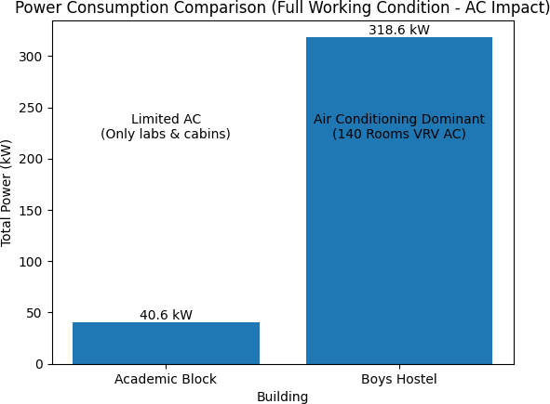
Figure 6.1

Lighting systems account for the highest number of devices across both
buildings. They are installed in classrooms, laboratories, corridors, staircases, hostel rooms, and common areas. Although LED lights consume less power individually, their large quantity and long operating hours result in significant overall energy consumption.
    - Lighting dominates in quantity
    - Long usage increases total demand
Fans represent the second major category. BLDC fans are widely used due to
their efficiency and lower power consumption. However, since they are installed in almost every room and operate for long durations, their combined energy
usage becomes considerable.
    - High number of fans
    - Simultaneous operation increases load

Air conditioning systems, though fewer in number, contribute the most to peak energy demand. Their high power rating makes them the dominant factor in
total consumption, especially during summer and peak usage hours.
    - AC systems dominate peak load
    - High power consumption per unit

Continuous loads such as CCTV cameras, routers, and server systems operate 24/7 and form a constant base load. These systems ensure security and
connectivity but contribute to steady energy usage throughout the day.
    - Continuous loads create base demand

The overall load can be divided into base load and variable load. Base load
remains constant due to continuous systems, while variable load changes with occupancy and usage patterns. The Academic Block experiences peak demand during daytime, whereas the Boys Hostel shows higher demand during evening hours.
Peak load is mainly influenced by cooling systems, particularly when multiple air conditioners operate simultaneously. Additionally, long operating hours of lighting and fans further increase energy consumption.
The analysis indicates that while energy-efficient technologies such as LED lighting and BLDC fans are used, total consumption remains high due to the large number of devices and their usage patterns.
      - Cooling systems drive peak demand
      - Lighting and fans contribute to total load
      - Continuous systems maintain base load

CHAPTER 8
PROPOSED ADAPTIVE LIGHTING SYSTEM

An adaptive lighting control mechanism based on lux sensing is conceptually introduced as an advanced strategy to enhance energy efficiency across the Academic Block and the Boys Hostel. The system operates on the principle of real-time monitoring of ambient light conditions. A lux sensor installed within indoor spaces continuously measures the intensity of natural daylight entering through windows and ventilators. This data is transmitted to a control unit, which regulates LED lighting output to maintain the required illumination levels for academic and residential activities .
Unlike conventional lighting systems, where lights operate in simple ON/OFF modes, the proposed system dynamically adjusts lighting levels based on actual requirements. This ensures that artificial lighting is used only when necessary, reducing unnecessary energy consumption.
        - Based on real-time daylight sensing
        - Automatically adjusts lighting levels
        - Reduces dependency on manual control

NEED FOR ADAPTIVE LIGHTING
In traditional systems, lighting fixtures operate at full intensity regardless of the availability of natural light. This leads to over-illumination and energy wastage, especially during daytime.
Artificial lighting often remains ON even when sufficient daylight is available. This inefficiency increases power consumption and operational costs. The proposed system addresses this issue by introducing intelligent control based on actual lighting conditions.
    - Eliminates unnecessary lighting usage
    - Reduces over-illumination
    - Improves energy efficiency

WORKING PRINCIPLE

The system uses a lux sensor to continuously monitor ambient light levels within a room. Based on the measured lux value, the control unit adjusts the brightness of LED lights accordingly.
During daytime, when natural light is high, the system reduces artificial lighting output. As daylight decreases due to evening or weather changes, the system gradually increases brightness to maintain the required illumination level.
    - Sensor measures real-time light intensity
    - Control system adjusts brightness proportionally
    - Ensures consistent illumination

ROLE OF DIMMABLE LED DRIVERS
Dimmable LED drivers play a crucial role in implementing the adaptive lighting system. These drivers allow precise control of light output based on sensor input.
By reducing brightness during favorable daylight conditions, energy consumption is minimized. Additionally, operating LEDs at lower intensity reduces heat generation and electrical stress.
    - Enables smooth brightness control
    - Reduces power consumption
    - Extends lifespan of lighting fixtures
This contributes to both energy savings and reduced maintenance requirements.

ZONAL LIGHTING CONTROL
An important feature of the system is zonal control. Instead of controlling all lights uniformly, the building can be divided into multiple zones based on lighting requirements.
Areas near windows receive more natural light and require less artificial
lighting, while interior sections may need higher illumination. By using multiple sensors, lighting can be adjusted separately in each zone.
    - Different zones have different lighting needs
    - Improves uniformity of illumination
    - Enhances energy savings

This approach ensures optimal use of both natural and artificial lighting.

MANUAL OVERRIDE FEATURE

While automation is the core of the system, manual override is provided to ensure flexibility and user comfort. Users can switch OFF lights completely or adjust brightness based on specific requirements.
This is particularly useful during presentations, examinations, or maintenance activities where specific lighting conditions are required.
    - Allows user control when needed
    - Ensures flexibility and convenience
    - Improves system acceptance

ENERGY SAVING POTENTIAL

Lighting systems represent the largest number of devices in both buildings. Even small reductions in brightness across multiple fixtures can result in significant energy savings.
By reducing unnecessary lighting during daytime, the system can lower overall energy consumption. Over time, this leads to reduced electricity bills and improved efficiency.
    - Significant reduction in lighting energy consumption
    - Lower operational costs
    - Improved sustainability
The cumulative impact of savings across all rooms and corridors is substantial.

IMPACT ON INDOOR ENVIRONMENT

The system also improves indoor environmental quality by maintaining stable and comfortable lighting conditions. Proper illumination reduces eye strain and enhances productivity.
By avoiding excessive brightness and glare, the system supports better visual comfort. Gradual transitions in lighting prevent sudden changes that may cause discomfort.
    - Improves visual comfort
    - Reduces eye strain
    - Enhances learning and working environment
This makes the system beneficial beyond just energy savings.

INTEGRATION WITH SMART SYSTEMS
The adaptive lighting system can be integrated with modern smart-building
technologies. It can be connected to centralized energy management systems for monitoring and control.
Sensor data can be recorded and analyzed to understand usage patterns and identify further optimization opportunities.
    - Enables real-time monitoring
    - Supports data-driven decisions
    - Aligns with smart building concepts

PRACTICAL IMPLEMENTATION CONSIDERATIONS
The proposed system can be implemented without major structural changes to existing buildings. It primarily requires installation of sensors, controllers, and compatible LED drivers.
The cost of implementation can be justified through long-term energy savings. Maintenance requirements are also reduced due to extended lifespan of lighting fixtures.
    - Minimal infrastructure changes required
    - Cost-effective in long term
    - Easy to maintain

Table 7.1 Features for Proposed Solution

Feature | Description | Benefit
Lux Sensor | Measures daylight intensity | Reduces unnecessary lighting
Dimmable LEDs | Adjust brightness | Saves energy
Zonal Control | Area-wise control | Improves efficiency
Automation | Reduces manual control | Minimizes human error
Manual Override | User flexibility | Better usability

CHAPTER 9 FUTURE SCOPE
The future scope of campus energy management focuses on the integration of advanced monitoring systems, automation technologies, and renewable energy solutions to improve overall efficiency and sustainability. While the current energy audit provides a clear understanding of consumption patterns and load distribution, the next phase involves transforming these insights into practical implementations. A structured and technology-driven approach will support longterm energy conservation, cost reduction, and environmental responsibility.

IMPLEMENTATION OF ADVANCED MONITORING SYSTEMS
The deployment of real-time energy monitoring systems, along with smart metering, is a critical step toward effective energy management. These systems enable continuous tracking of electrical parameters such as voltage, current, and power consumption across various campus zones. Sub-metering at departmental or floor levels provides detailed insights into localized usage.

Primary Advantages:
    - Enables continuous monitoring of energy consumption
    - Identifies abnormal usage and inefficiencies
    - Supports data-driven decision-making
    - Improves load analysis and demand management

INTEGRATION OF RENEWABLE ENERGY SOURCES
The adoption of renewable energy, particularly solar photovoltaic (PV) systems, presents a significant opportunity for reducing dependence on conventional electricity sources. Rooftop installations on academic buildings and hostels can generate clean energy during peak daytime hours, directly offsetting energy demand.

Primary Advantages:
    - Reduces dependency on grid electricity
    - Lowers operational and electricity costs
    - Supports net metering and energy export
    - Promotes clean and sustainable energy usage

ADOPTION OF AUTOMATION AND SMART TECHNOLOGIES
The integration of automation and smart technologies can significantly enhance energy efficiency. Systems such as automated HVAC controls, occupancy sensors, and IoT-based monitoring devices help optimize energy consumption based on real-time conditions.

Primary Advantages:
    - Minimizes unnecessary energy consumption
    - Optimizes cooling and lighting systems
    - Enables remote monitoring and control
    - Enhances overall system efficiency

PROMOTION OF SUSTAINABILITY AND USER AWARENESS
Apart from technological solutions, user behavior plays a crucial role in energy conservation. Awareness programs and training sessions can educate students and staff about efficient energy usage practices and encourage responsible behavior.

Primary Advantages:
    - Reduces energy wastage through behavioral changes
    - Encourages participation in conservation efforts
    - Builds awareness of environmental sustainability
    - Supports long-term energy-saving culture

POLICY FRAMEWORK AND CONTINUOUS EVALUATION
Establishing a centralized energy management policy ensures consistent implementation of energy-saving measures across the campus. Regular monitoring through periodic energy audits and cost-benefit analysis helps evaluate performance and identify areas for improvement.

Primary Advantages:
    - Provides structured energy usage guidelines
    - Ensures accountability and standardization
    - Supports financial and operational planning
    - Enables continuous improvement through audits

CHAPTER 10 CONCLUSION
The energy audit provides a comprehensive understanding of electrical load distribution within the Academic Block and Boys Hostel. Through detailed inspection, device counting, and classification, the study clearly explains how energy is consumed across different areas such as classrooms, laboratories, corridors, hostel rooms, and common facilities. It highlights the relationship between number of devices, power rating, and operating duration in determining overall energy consumption .
Lighting systems emerge as the most dominant category in terms of number of devices. LED lights are widely used across both buildings to provide proper illumination and safety. Although LED technology is energy-efficient, the large number of fixtures and their long operating hours result in significant total energy consumption. Corridor and staircase lighting, which operate for extended durations, contribute notably to this demand.

- Lighting dominates in quantity
- Long operating hours increase consumption
Cooling systems are identified as the primary contributors to peak load demand. Air conditioners, though fewer in number, consume high power and significantly increase energy usage during operation. In the Academic Block, cooling demand is higher in laboratories and specialized rooms, while in the Boys Hostel, peak demand occurs during evening and nighttime when residents use air conditioning simultaneously.

- Cooling systems dominate peak load
- Seasonal and occupancy effects influence demand
Continuous loads such as CCTV cameras, networking devices, and server systems establish a constant base load. These systems operate 24/7 and are essential for security and connectivity. Although individual power consumption is moderate, their continuous operation results in steady energy usage throughout the day.

- Continuous systems create base demand

The audit clearly distinguishes between base load and variable load. Base load remains constant due to continuous systems, while variable load changes depending on occupancy and operational schedules. The Academic Block shows peak demand during daytime, whereas the Boys Hostel shows peak demand during evening hours. This variation highlights the importance of understanding load patterns for effective energy management.
The proposed adaptive lighting system demonstrates a practical approach to reducing energy consumption. By using lux sensors to monitor natural daylight, lighting levels can be adjusted automatically to avoid unnecessary usage. This system ensures that artificial lighting is used only when required, thereby improving efficiency without affecting comfort.

- Reduces unnecessary lighting usage
- Improves overall efficiency

Since lighting forms the largest portion of installed devices, even small reductions in brightness can lead to significant energy savings. Additionally, maintaining proper illumination levels improves visual comfort and reduces eye strain. The system also supports longer lifespan of lighting fixtures and reduced maintenance.

The audit also emphasizes the importance of implementing smart control and monitoring systems. Centralized energy management systems can help track consumption patterns, identify inefficiencies, and improve decision-making. Proper monitoring allows better control over energy usage and supports longterm planning.
Cooling system optimization is another important area for improvement. Maintaining proper temperature settings, avoiding unnecessary usage, and performing regular maintenance can significantly reduce energy consumption. Even small changes in temperature settings can result in noticeable savings.
User awareness plays a key role in energy conservation. Behavioral factors such as leaving lights and fans ON unnecessarily or improper use of air conditioners contribute to energy wastage. Encouraging responsible usage through awareness programs can improve overall efficiency.

- User behavior directly affects energy usage
- Awareness improves conservation

The findings of this study also support future integration of renewable energy systems such as solar power. By combining efficient energy usage with renewable sources, the campus can reduce dependency on conventional energy and improve sustainability.
Overall, the energy audit highlights that energy consumption is influenced by a combination of device quantity, power rating, and operating patterns. Lighting dominates in number, cooling systems dominate peak demand, and continuous systems define base load. Effective energy management requires a combination of efficient technology, smart control systems, and responsible user behavior.

REFERENCES

- A. Capehart, W. C. Turner, and W. J. Kennedy, Guide to Energy Management, 8th ed., Fairmont Press, 2020.
- Bureau of Energy Efficiency (BEE), Government of India, Energy Audit Manual, New Delhi, 2015.
- International Energy Agency (IEA), Energy Efficiency 2023, Paris, France, 2023.
- IEEE Standards Association, IEEE Std 739-1995: Recommended Practice for Energy Management in Industrial and Commercial Facilities, IEEE, 1995.
- H. H. Patel and V. R. Patel, “IoT Based Smart Energy Management System,” Proceedings of IEEE International Conference on Smart Technologies and Management, 2019.
- F. Oldewurtel et al., “Energy Efficient Building Climate Control Using Predictive Control,” Energy and Buildings, vol. 45, pp. 15–27, 2012.

